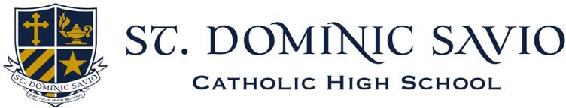
Forming Servant Leaders in the Image of Christ

Now Accepting Applications for the 2026-2027 school year
- Current 8th Graders can Apply Here (saviochs.org/admission/how-to-apply)
- Online applications are due January 16, 2026
- All supplemental documents are due January 30, 2026

Visiting Opportunities for Students and Parents:

JOIN US ON OCTOBER 16TH for our next PARENT INFORMATION SESSION
Interested parents are invited to attend one of our parent-only Information Sessions. During these sessions, parents will learn about our school from members of the Savio community, enjoy a student-led tour of our
beautiful campus, meet current parents, and hear about our admissions process. Registration requested.

JOIN THE SAVIO COMMUNITY for an EVENING WITH EAGLES FALL OPEN HOUSE
Wednesday, November 6th, 5:30 – 8:00 pm
Prospective families (parents and students) are invited to our Fall Open House to discover and experience what makes Savio a unique and engaging place for inquisitive minds. Registration requested.

“MAKERS MARKET” sponsored by the SAVIO NATIONAL ART HONOR SOCIETY
Saturday, November 8th 10 am – 2 pm (In the Savio Gym)
Looking for some unique one-of-a-kind Christmas gifts? Join us for our annual “Makers Market” where you can find wonderful hand-crafted items from local artists and crafters. Jewelry, candles, greeting cards, and artwork are just a few of the items you’ll find.
To register for any of the events requesting RSVP visit our website:
saviochs.org > Admission > Visit St. Dominic Savio




For all admission inquiries please contact Mrs. Holly Bologna, Director of Admission Email: hbologna@saviochs.org or phone: 512-388-8846 ext. 5504

