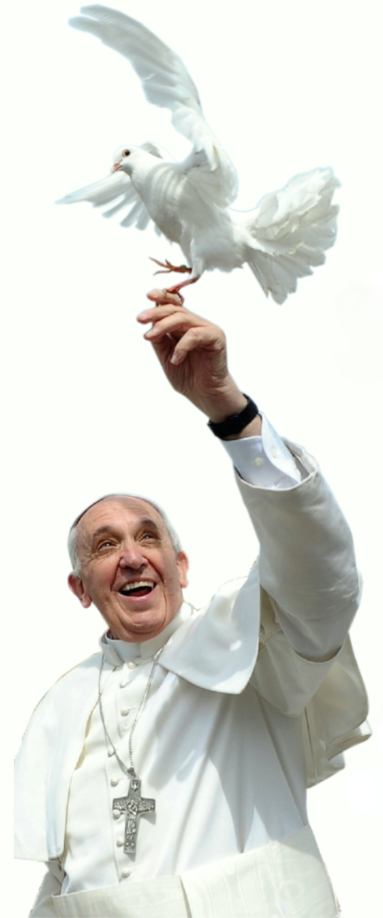
The Welcome Ministry would be very pleased to welcome you! We are always looking for new members and new ideas to help us with our efforts!

The Welcome Ministry’s goal is to provide a warm welcome to families and adults who are new to our parish and encourage current members to become active and involved at St. Lawrence in countless ways. Every parishioner is qualified and is encouraged to be part of this ministry. All you need is a smile.
We seek to foster a sense of community within the parish, a sense of evangelization to those outside the parish and a sense of service on the part of our parish community.
All Are Welcome and we hope you will find our parish environment supportive and loving... a place to grow spiritually... a place to put your faith in action... a place where parishioners are encouraged to use their stewardship gifts of time, talent and treasure as disciples of Jesus Christ.
St. Lawrence Welcome Committee
- Supports monthly Welcome Weekend during the school year. Coffee and donuts are served after each mass giving parishioners and visitors a chance to meet and build community.
- Plans special events at particular times of the year.
- Calls to each newly registered family or individual, assembles “Welcome Packets” for all, and meets with new parishioners to answer their questions and provide them with information about the many things St. Lawrence has to offer them.
- Strives to ensure that all who visit experience a sincere welcome.

