Social Hall Use Only
Name of Event/Group: __________________
______________________________________
Date submitted: ____/___/____
ONE TIME USE: Date: ____/____/_____
ON GOING USE:
Start Date: ___/___/___ End Date: ___/___/___
☐ FULL Hall ☐ Kitchen ☐ Other
HALF Hall: ☐ “A” (Front) ☐ “B” (Kitchen Side)
Information Form
(This form due to parish office 2 weeks prior to event. All Groups MUST resubmit a new form every year (September))
Any questions/concerns about the Parish Calendar please contact John Karski at 586-254-4433 x302 or email: j.karski@stthereseparish.ws
____

ONE TIME USE:
Start Time: __________ End Time: _________ (Please circle) Day: M - Tue - Wed - Thurs - Fri - Sat - Sun
Setup Time: _________ Setup Date: ________ (is one hour prior to event, unless other arrangements have been made)
ON GOING USE:
Start Time: __________ End Time:__________ (Please circle) Day: M - Tue - Wed - Thurs - Fri - Sat - Sun
Setup Time: _________ Setup Date: ________ (is one hour prior to event, unless other arrangements have been made)
Meets: (Please circle) Weekly - Monthly - Other:_________
Exceptions may be made. We no longer have parish staff working evenings.
There is usually someone here on Wednesday evenings though, but you must talk to John Karski. Otherwise groups are to adhere to the schedule for the time being. As we get busier hours may be expanded.
Gatherings may take place
anytime during these hours:
Sunday: 8 am and 1 pm
Monday: 9 am and 4 pm
Tuesday: 9 am and 4 pm
Wednesday: 9 am and 7 pm*
Thursday: 9 am and 4 pm
Friday: (Closed, but Mtgs.
may take place 9 am to 4pm)
Saturday: 3 pm and 6 pm
*June to Labor Day close at 4 pm
jhjhgjhjhgjh
week of the month: 1st - 2nd - 3rd - 4th
Please indicate which Date(s) the hall will not be in use: ____________________________________________________________ _________________________________________________
Contact Person: ____________________________________
Phone Number: ____________________________________
Number of Persons: _____ (8 or 10 persons to a table?) # of round tables: ______ # of long tables:________

Tablecloths needed: ☐ Yes ☐ No Special Events Hospitality group: ☐ Yes ☐ No
Food Served: ☐ No ☐ Potluck ☐ Cook on site Catered: ☐ Yes, Caterer: __________________

Number of Food Tables (2 standard): ______ ☐ Dessert Table ☐ Other: ______________

Items needed: ☐ Napkins ☐ Disposable glasses ☐ Plates ☐ Silverware ☐ Coffee cups

Additional Items: Provide Floor Plan on reverse side

Please check off which of the following parish-owned items you will need:
☐ Podium ☐ Microphone ☐ TV/VCR/DVD ☐ LCD Projector ☐ Screen ☐ Laptop
Brief Description/Added Notes:

OFFICE USE: ☐ Original to: John Karski ☐ Maintenance ☐ Other:________________________ ☐ Calendar
Revised: 9/7/2022

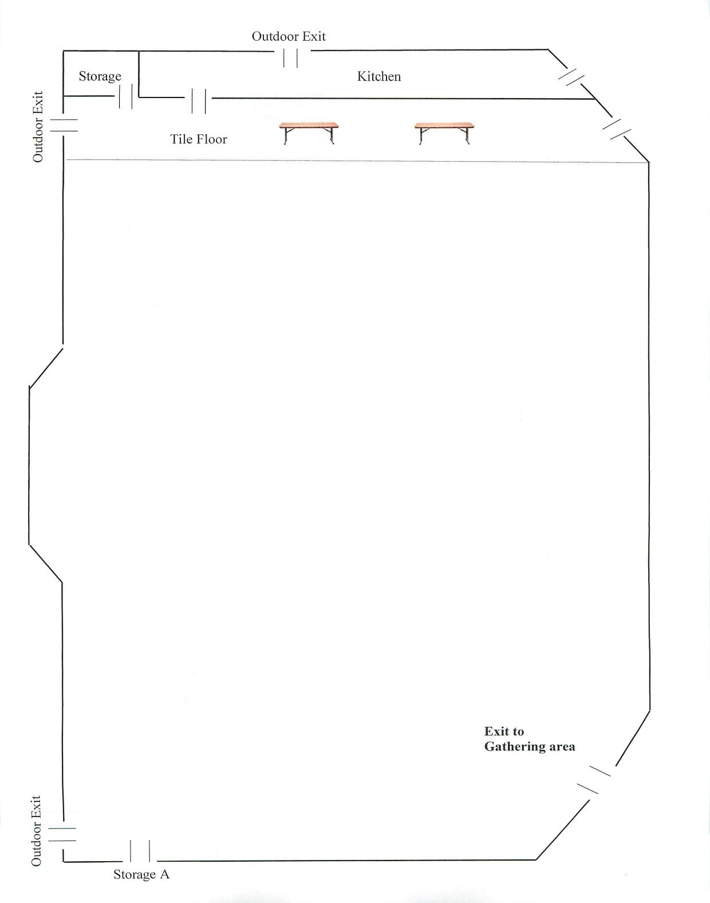

“B” (Kitchen Side)
“A” (Front)

