Religious Education
Religious Ed. for children Kindergarten through High School is offered during the school year. Call the Religious Education office at 225-654-5885 for more information.

Children’s Liturgy
Twice a month, fall through spring, children who have not made their first communion, can attend during the 11:00 am Mass. Volunteers are encouraged to contact church office at 225-654-5778.
Emmaus Road
Adult Faith Formation through Bible study held concurrently with K-5 Religious Ed. classes at 9:15 to 10:45. Contact 225-654-5778 for more information.

INFUSED
Married couples learn to “steep their marriages in Faith.” Meets monthly after Saturday Mass and a meal and free babysitting are provided. Dates are announced in The Herald, and on the Church’s FB page. An RSVP is required. Adults and/or responsible teens are needed to help with childcare for these meetings.

Bible Study
Held Mondays at 10:00 am. Thursdays at 10 am and Thursdays at 6:00 pm. Free Babysitting is provided with an RSVP. Contact Parish Office at 225-654-5778.

FORMED
FREE computer program gives access to over 33,000 video-based study programs, films, and eBooks from The Church’s foremost presenters. Sign up at sjb-ola.org by clicking on FORMED.

Parish-Wide Social Events
Everyone will be invited to these activities .The themes vary by season, but offer fun for every age. The Herald and on the Church FB page are sources of information.

The Herald
Our weekly church bulletin can be picked up after Mass from the shelves in the vestibule or viewed on our website www.sjb-ola.org/bulletin

New Member Registration
Registration forms are found in the Vestibule or can be downloaded online at sjb-ola.org
You are encouraged to become a member of this vibrant growing parish.

Mass Schedule
Saturday Vigil ~ 4:30 pm
Sunday ~ 7:00 am & 11:00 am
Wednesday ~ 7:00 am
Thursday & Friday~ 7:30 am
Holy Days and Holidays as announced

Reconciliation Times
-1 hour preceding Saturday Vigil Mass
-Weekdays by appointment
-15 minutes prior to weekday morning Masses
-Penance services several times a year

FOR FAMILIES WITH SMALL CHILDREN:

There are two “training” rooms located on the east side of the sanctuary. The one on the south side has a bathroom with a changing table.

FOR YOUR CONVENIENCE:
Water fountains and bathrooms are located off the vestibule.

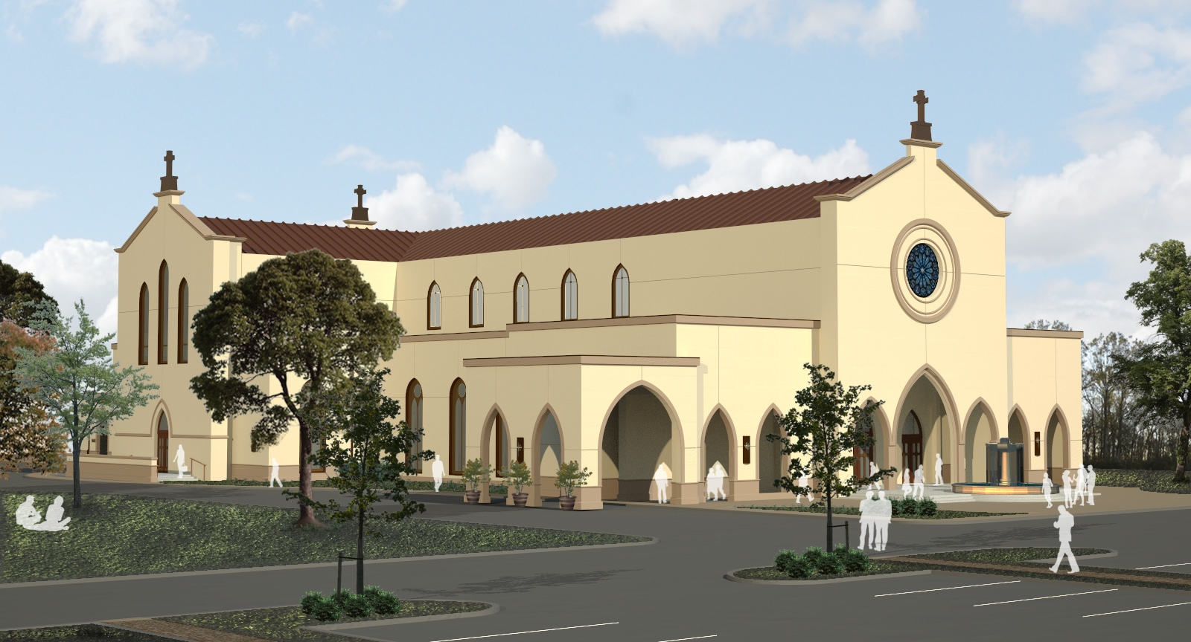

Welcome to Our Faith Community

St. John the Baptist Catholic Church
4826 Main Street
Zachary, Louisiana 70791
Phone: 225-654-5778
FAX: 225-654-5796

Pastor: Father M. Jeffery Bayhi
Parish Administrator: Nita Poole
Bookkeeper/Secretary: Melany Roberts
Religious Ed. Director: Suzanne Payne

Website:
www.sjb-ola.org

Office Hours: 8:00 am-5:00 pm M-Th
8:00 am-3 pm F

St. John the Baptist Catholic Church

Ministries Snapshot:

24 Hour Adoration: Monthly on 3rd Monday. Register for your hour with the Religious Ed. Office. 225-654-5778.

Altar Servers: Contact the Parish Office at 225-654-5778 to be considered.

Bereavement Committee: Six alternating groups prepare meals for parish family funerals. Meals are served in the Parish Hall or delivered to the family home. Contact the Parish Office at 225-654-5778.

Catechists: These share faith and knowledge of God with students in K-12th grade. Volunteers are always needed. Contact the Religious Ed. Office at 225-654-5885.

Charismatic Prayer Group: Meets Monday nights at 6:30 pm in the Adoration Chapel.

Choirs: Adults rehearse at 5 pm on Tuesdays. During the school term, Children’s & Youth Choirs rehearse at 6:00 pm on Tuesdays. Contact Parish Office at 225-654-5778 for more information.

Coffee Club: Coffee and pastries are served after 7:00 am Mass on Sundays. Members rotate the responsibility for providing the refreshments. Contact the Parish Office at 225-654-5778.

Handmaids of the Lord Prayer Group: This women’s group is dedicated to Our Lady. Meets monthly and open to all women. The group conducts study groups and sponsors an annual Women’s Morning of Reflection in October. Contact the Parish office at 225-654-5778.

Healing Rosary: Meets every 1st Monday at a parishioner’s home at 9:00 am for coffee and Rosary at 9:30 am. Contact the Parish Office at 225-654-5778.

Helping Families Heal: Provides assistance during temporary periods of infirmity. Contact the Parish Office at 225-654-5778.

Homebound, Hospital & Nursing Home Visitation: Ten teams visit Catholic residents of Grace Nursing Home, Lane Memorial Hospital, Lane Nursing Home, Zachary Manor Nursing Home, Oakwood Assisted Living and homebound parishioners. Contact the Parish Office for more information.

Knights of Columbus: Open to all men 18 years and older who are Practical, Practicing Catholics. Meetings are monthly on the 1st Sunday following the 7:00 am Mass. Contact the Parish Office at 225-654-5778 for more information.

Lectors/Commentators: Stewards are selected based on need and desire of the individual to offer this special service to Our Lord. Anyone serving on the Altar must be in a state of grace and be able to receive the Sacrament of the Eucharist. Contact the Parish Office at 225-654-5778 for an appointment with Fr. Bayhi.

Men’s Club of St. John the Baptist: All men of the Parish are invited to join. The mission is to make Christ the center of our lives by prayer and greater use of the sacraments and good works. Meetings are on the 2nd Wednesday monthly at 6:30 pm. Contact the Church Office at 225-654-5778.
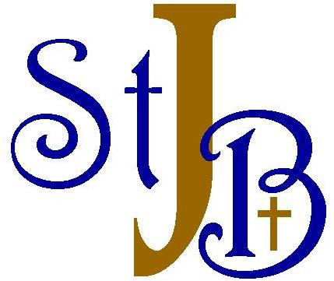

RCIA: Right of Christian Initiation for Adults
is offered for those wishing to become Catholic or Catholics wanting to learn more about our faith. Classes begin in August. Contact the Parish Office at 225-654-5778 for more information.

St. John’s Rosary Altar Society: All women are invited to join. Meets 1st Thursday (except for July & August) at 11:00 am in the Parish Hall. They serve as sacristans, sew vestments and altar linens, and assist with receptions, pray the Rosary and other activities when needed. Contact the Parish Office at 225-654-5778.

Social Media: Volunteers dedicated to communication of parish news and activities using web technologies and connecting with a growing congregation online. Contact the Church Office at 225-654-5778.

Society of St. Vincent de Paul: Volunteers assist in serving people in poverty and in crisis situations in our local community. Contact the Parish Office at 225-654-5778.

Tours: For a group tour (4+ people) of the new church, schedule online at www.sjb-ola.org/tours

Ushers: Help maintain order and efficiency at each weekend Mass by assisting with seating, collection of offerings and other duties as needed. Confirmed adult male Catholics are eligible to serve. Contact 225-654-5778.

Youth Ministry: Separate groups Middle and High School ages. Sponsors an annual trip to Washington D.C. for the March for Life. Learn more at www.sjb-ola.org/youth-ministry

Welcome Committee: “Meets and Greets” after Masses in the Vestibule. Contact 225-654-5778

