Officers 2025-2026
President: Pam Wagner
Vice President: Denise Quinn
Secretary: Kathy Kennedy
Treasurer: Janet Marra

Meetings
The CCW meets on the second Wednesday of each month beginning in September rotating meetings between Sacred Heart and Saint George churches.
Dues
Annual donation of $5 can be placed in the collection basket in an envelope labeled CCW (by October 8th) or bring it to the first meeting in September.

Interested?
Please feel free to contact an officer or any member. We hope you’ll join us!

Our Lady of Good Counsel, pray for us.
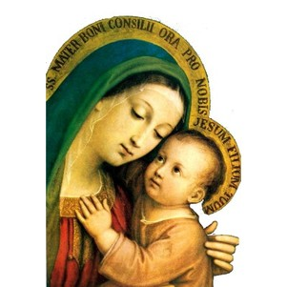

Council of Catholic Women

Sacred Heart
Saint George

Meetings and programs
2025-2026

You are invited!
Meetings and Programs
September 10, 1:00 p.m.
At Sacred Heart Church
Tureen Luncheon & Social
Meet and Greet your fellow parishioners from SH & SG!

October 8, 1:00 p.m.
At Saint George Church
General Meeting
Speaker: John Nolt
“History of Old Mill Creamery”

October 12, after 10 a.m. mass
At Saint George Church
Wedding Anniversary Mass and Celebration
Honoring milestone anniversaries plus ALL married over 50 years. Parishioners invited to celebrate with us!

November 7th 9-3, 8th 9-2
At St. George Church
Annual Rummage Sale
Drop Off 5th 11-7
6th 9am – 3pm
November12, 1:00 p.m.
At Sacred Heart Church
General Meeting (All invited)
Speakers: Lynn Fiedler M.ED
Kim Rigel RN Gerontology
“Journey to Justice”

December 10, 1:00 p.m.
At Saint George Church
General Meeting
Speaker: Nancy Haupt,
Bill Lahner, Jim Smith
“Pets Providing Comfort”

January 14, 11:30 a.m. – 1:30 p.m.
At Sacred Heart Church
Soup, Salad, and Craft
Come join the fun!

February 11, 1:00 p.m.
At Saint George Church
General Meeting
Speaker: Karen Musser
“Mifflinburg Community Park Action Project
February 17, 9:00 – 11:30 a.m.
At Sacred Heart Church
Lenten Morning of Reflection
All parishioners invited

March 11, 1:00 p.m.
At Sacred Heart Church
General Meeting
Speaker: Pat Keller
“Funeral Mass Presentation”

April 8, 1:00 p.m.
At Saint George Church
General Meeting
Speaker: Deacon Chris Darrup
“Diaconate Journey”

May 13, 1:00 p.m.
At Saint George Church
Covered Dish Social & Rosary

May 31, 8:00 a.m.
At Sacred Heart Church
Mass & Communion Breakfast
Senior Award presentation

