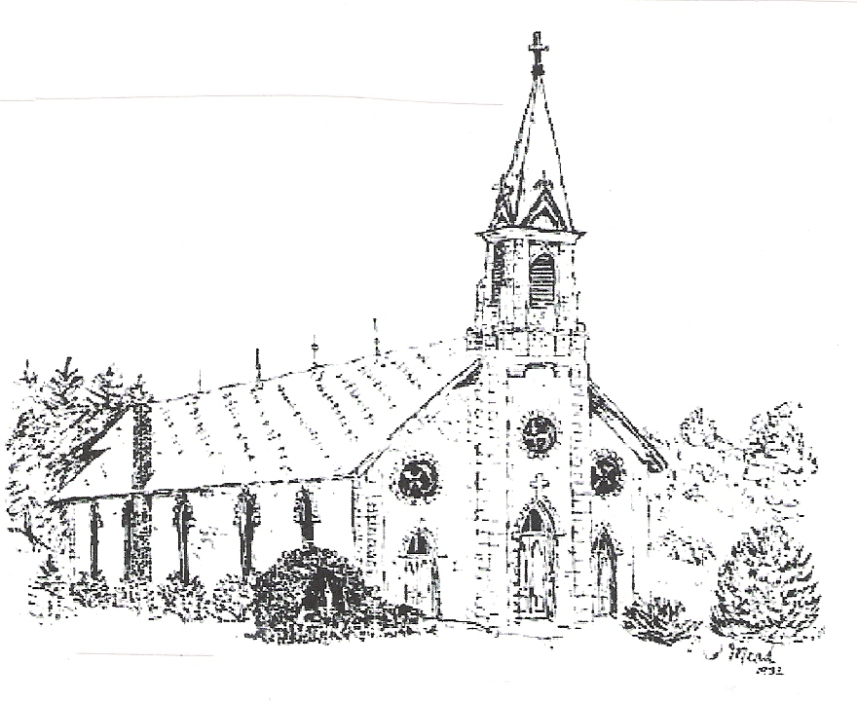 | St. Patrick/St. Clement Parish  West Albany  419 W Lyon Ave  Lake City, MN 55041  November 30, 2025 – 1st Sunday of Advent |  |  | 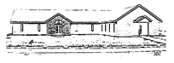
Father Thế Hoàng  Office: (651) 345-4134  Rectory: (651) 448-8541  Email: frthehoang@gmail.com | Deacon David Dose  Cell: (507) 273-1983 |  |  | Mass Schedule  St. Patrick - West Albany  Sunday - 8:00 a.m.  Confessions – 7:30 a.m.  St. Mary of the Lake - Lake City  Saturday - 5:00 p.m.  Sunday - 10:00 a.m.  Confession available before weekday Masses at St Mary’s 8:20 – 8:50 am  Website: stpatrickswestalbany.org  Facebook Page: stpatrickswestalbany
 | MISSION STATEMENT: To use our resources, wisdom, and energy to empower and encourage parish families and surrounding communities so that people see Christ in our works and commitment to make our parishes thrive and grow and to share our faith with others.
Brianna Evers: Director of Faith Formation
Hall/Office: (507) 753-2424
Cell: (507)421-5766
Email: briannaeversfaithformation@gmail.com
Bulletin Items / Mass Intentions  Contact: Becky Lukes Cell: (507)990-6657 please leave a message  Email: westalbanybulletin@gmail.com  Please contact Becky to confirm mass intention scheduling as intentions are placed weeks and months in advance. |  |  | 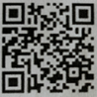  QR code to St Mary / St Patrick’s webiste.  You can visit the website and view the  calendar on your smartphone by scanning this QR code with your phone’s camera.
Pastoral Care of the Sick  Parishioners who are homebound and who wish to receive a pastoral  visit should contact Father. Persons who are seriously ill or who are anticipating surgery should make arrangements for the Sacrament of Anointing. | R.C.I.A.  Individuals who wish to learn more about the Catholic Faith are  invited to consider our Rite of Christian Initiation of Adults program.  You are welcome to contact Dave and Ann Marie Dose at (651) 345-2439.
Baptism Preparation  Parents requesting the sacrament of Baptism should call the St. Mary Parish office (651)345-4134 | Prayer Chain  To add a request to the prayer chain, please contact Becky Lukes at westalbanybulletin.com
Marriage Preparation  Couples should contact the priest at least six months prior to the  proposed wedding date to discuss the marriage preparation program. | Hall Rent  Parish members may rent St Patrick’s Community Center. For prices and to reserve the hall, contact Meg Sprick at (651)345-4804.
New Parishioner Signup  If you are interested in becoming a member or would like more information about our St Patrick's Parish Family, please see Father Hoang at church or contact him at (651)345-4134 or email frthehoang@gmail.com | Sunshine Blessings  Please contact Louann Fieck, (507)259-5824, if you know of any parish member or person in the community that would benefit from a get-well wish, some encouraging words, or even just a simple personal note from the parish.

  St Patrick’s Collection  November 23, 2025  Adult - $ 980 Plate - $ 207.15  Christmas Flowers - $ 25 |  |   Prayer Requests  If there is anyone you would like us to pray for and put in the bulletin, please contact Becky Lukes via email westalbanybulletin@gmail.com  - Please pray for healing and peace for EJ following an accident.  - Please pray for those struggling with health issues  - Please pray for all those who struggle with addiction  - Please pray for enlightenment for all those seeking answers    Welcome Nora to the St Patrick’s Faith Family!  Nora Jean McNallan  Born 10/2/25 to Kyle and Brittany McNallan  was baptized into the Catholic Faith on  Saturday November 29.  Her Godparents are Torrey & Pam McNallan  St Patrick’s Church Pies  Apple Pies 9” - $12 each Apple Crisp - $10 each  Running short on time during the Holidays?  The freezer is full of ready to bake Apple Pies & Apple Crisps.  Made with LOVE by St Patrick’s Church Members  Contains delicious apples donated by Buckridge Orchard  Pies are fresh frozen to take and bake.  Talk to, text or call Carmen Diedrich 507-951-8065,  Sandy Danckwart 651-448-3386 or Jane Timm 507-259-9505  Dear brothers and sisters in Christ,  This weekend is the first weekend of Advent! The message of this week is about careful watching and waiting for the arrival of the Messiah. How do we become more attentive to the presence of God within our lives? Do we make time for silence so that we can be quiet with God to listen to his voice?  Our world is so busy and noisy that it’s challenging to embrace the silence. This lack of noise or void is often seen as something uncomfortable. However, in the eyes of God, it is quite the opposite because He gets to have our undivided attention. Silence is about being vulnerable and honest with the ones that we love because we deeply trust them. You have seen the sign and bulletin articles along with flock notes about the book that Fr. Mike Schmitz wrote to help prepare our heart more intentionally for the coming of Christ. We are waiting at the well for Jesus to arrive and quench our thirsts. O come, O come, Emmanuel!  Just a heads up but I have been asked to be a spiritual director for the seminarians going on a silent retreat at Broom Tree in South Dakota from December 29 to January 2, 2026. There will be a priest from the seminary to celebrate the Solemnity of the Mother of God on January 1, 2026 at 10am.  Sincerely,  Fr. The
Upcoming Opportunities
Grief Support Group Dec 18 – St Patrick’s Hall
St Patrick’s Christmas Eve Mass – December 24th 6:30 pm
Christmas Giving Tree
It is that time of the year to spread Christmas cheer to all. Please take a few colored tags from the back of church to support local children in need this Christmas. There are items of needs and wants for each of the 17 different children/teens.
Please return all gifts wrapped with the colored tags lilghtly attached by December 7th. They will be delivered on the 9th.
Please add your name and phone number along with the tag number you are taking to the sheets on the table in the back of church.
Thank you for your contribution!
Come one, come all!
Please join us to sing in a small choir for Christmas Ever!
Practice will be on Tuesday in December at 6:15 pm, right after adoration. December 2 – 9 – 16 – 23
It’s a lot of fun

Bits from Brianna

Faith Formation is still searching for a teacher for the 5th and 6th grade class. Please reach out to Brianna with questions or to volunteer.

There will be a Family Advent event happening on November 30 during normal class time. Please make plans to attend with your students.
The Diocese of Winona-Rochester is excited to send, for a second time, a group of religious and laity from our diocese to experience and participate in the Walk to Mary from May 1-3, 2026!

The Walk to Mary is an annual, twent-two mile pilgrimage walk in Wisconsin. The pilgrimage begins at the National Shrine of St Joseph located in St Norbert Colledge and ends at the oly Church-approved Marian apparition site in the United States of America, the National Shrine of Our Lady of Champion. In 1859, Mary appeard to Adele Brise in Champion, Wisconsin, instructing her to teach the Catholic faith to the children of the land. On this pilgrimage, pilgrims not only remember this beautifully simple Marian apparition, but they also journey spiritually with Joseph and Mary to witness their love and fidelity to Jesus Christ. People of diverse ages, races and nationalities all come together to participate in this sacred experience.

Learn more and register at the following website:
dowr.org/event-details/3789

Verso Ministires invites you to Join them in Seous, South Korea for
World Youth Day 2027
August 1 – 10, 2027
‘Come with us to Seoul for World Youth Day 2027! Experience Spiritual awakening and Korean culture alongside other young Catholics from around the globe. This is more than just a trip. It is a life-changing encounter with your faith and with the world.’
Start planning your trip today!
Visit: versoministries.com/winona-rochester-wyd

ST. MARY'S CHRISTMAS MARKET
SATURDAY, DECEMBER 6TH 8AM-1PM
The Christmas Market Committee is busy making plans for the parish Christmas Market. Enjoy Gifts to buy, Sweet Treats to select from, the popular Cookie Walk, Used a Bit Christmas items, local Vendors, Quilted Treasures and Hot Chocolate with Fresh Caramel Rolls and Coffee Cake.

If you are interested in donating to their market or volunteering your time – there are opportunities below:
Make your own donated gift baskets or we can make them for you for the Silent Auction and Bucket Raffle. These and items for the Used a Bit Christmas area can be brought to the church office M-Th 8-4 or Fri 8-noon. Gift cards and cash are also appreciated. Try to have them to the office by Wednesday, Dec. 3rd.

It’s that time of year again to celebrate the birth of our Lord!
It is also the time for a fun-filled couple of days for the Festival of Trees and More at the
Plainview Community Center December 5 – 6
Center doors open at 8 am daily – food will be served for lunch Friday and Saturday from 11 – 2 and dinner Saturday from 4-7:30

Stop by the community center during this fun-filled weekend & see all the goodies on display during their slightly used Christmas sale and their silent auction. Silent auction ends Saturday at 7:30 pm
Quilt Group
Meets in the Hall Fridays at 6:30 pm.
No special quilting skills needed – all are welcome to join.
Contact Diane Franke 651-345-5127 or Margaret Loos 507-798-2427 for info
Quilts are made and donated to people in need, including a recent donation of 28 single bed quilts to the Veteran’s Home in Preston

Mass Schedule:
Sunday November 30 – 8:00 a.m. – Cal & Wanda Fieck +
Sunday December 7 – 8:00 a.m. - Gene, Sharon & Tim Krismer +
EUCHARISTIC ADORATION PATRIOTIC ROSARY (1st and 3rd Tuesday), CHAPLET: Tuesday 5:00 – 6:00 p.m. at St. Patrick Church
Ministry Schedule:
November 30 – Greeter/Sacristan: Meg Sprick Lector: Dawn Sexton Eucharistic Ministers: Jim Evers & Judy Kottschade
Server: Helen Sexton Ushers: Tom & Cooper Meyer Gift Bearers: Liz Riley Family
December 7 – Greeter/Sacristan: Jerry & Margie Ott Lector: Louann Fieck Eucharistic Ministers: Don Sexton & Dwaine Sexton
Server: Henry Sexton Ushers: Bill & Carmen Diedrich Gift Bearers: Dianne Johnson Family
December 14 – Greeter/Sacristan: Darlene Sommerfield Lector: Christy Shones Ushers: Dwaine Sexton & Ken Moyer
Eucharistic Ministers: Dianne Johnson & Louann Fieck Server: Bill Sexton Gift Bearers: Judy & Paul Kottschade
December 21 – Greeter/Sacristan: Bill & Carmen Diedrich Lector: Judy Kottschade Eucharistic Ministers: Julie & Dennis Makoutz
Server: Helen Sexton Ushers: Jerry Ott & Linkkon Riley Gift Bearers: Hannah & Noah Erickson Family
December 24 – Greeter/Sacristan: Ken & Vicky Moyer Lector: Carmen Diedrich Eucharistic Ministers: Rosy Krier & Meg Sprick
Server: Cooper Meyer Ushers: Leon Sexton & Jim Evers Gift Bearers: Scott & Jasmine Sexton Family

