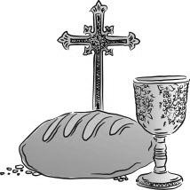Celebration of

the Eucharist

**MONDAY, SEP 04**

**8:30 AM** MARIA LE

**TUESDAY, SEP 05**

**8:30 AM** GENEVIEVE BLASKEWICZ

REGLA RIONDA

**WEDNESDAY, SEP 06**

**8:30AM** NATIVIDAD GENTOLIA

CONCHITA BICKSLER

**THURSDAY, SEP 07**

**8:30 AM**  KACHI ONWUCHEKWA

JOYCE LAYNG

**FRIDAY, SEP 08**

**8:30 AM** RICARDO QUESEA

JOYCE LAYNG

**SATURDAY,**  **SEP 09**

**5:00PM** JUAN REYES GOICOCHEA

**SUNDAY, SEP 10**

**8:00 AM** PEOPLE OF the PARISH

**10:00 AM** CHIARA & SIMONE MARIANO

12:00 PM SOULS OF PURGATORY



**Total Collected: $4434.75**

**Maintenance & Repair: $1722.00**

__________________________________________

BAPTISM DATES

OCTOBER 07TH

NOVEMBER 04TH

DECEMBER 02ND

BAPTISM CLASS FOR PARENTS

AUGUST 31ST

NOVEMBER 30TH

*LAST BAPTISM DATES FOR THE YEAR!*

[](https://www.google.com/url?sa=i&rct=j&q=&esrc=s&source=images&cd=&cad=rja&uact=8&ved=0ahUKEwiAsaqW27LPAhXJMz4KHQ_TC7UQjRwIBw&url=http://darklingstock.deviantart.com/art/Candle-01-347573422&psig=AFQjCNFlK6sDXdYF1unCj3jizE1jB9S8Mw&ust=1475174426413484)Memorials for the Week

**Altar Bread & Wine** is offered this week in memory of…

*PEOPLE OF THE PARISH*

**Altar Candles** burn this week in memory of…

*SOULS OF PURGATORY*

**Sanctuary Candle** burns this week in memory of…

*MISSED OPPORTUNITY*

**Divine Mercy Chapel Candle** burns this week in memory of…

*DONALD FOSTER*

**Memorial Opportunities are available:**

**Contact the Office at 973-777-9313**



**TWENTY-SECOND SUNDAY OF ORDINARY TIME**

**First Reading: Jeremiah 20:7-9**

In this particularly poetic passage, Jeremiah complains that while teaching the Lord’s word, he is subjected to insults and derision. He determines to remain silent, but he cannot because the desire to speak the Lord’s name is “like a fire burning in my heart.”

**Second Reading: Romans 12:1-2**

Paul tells the Christians to make sacrifices to avoid the trappings of the times, and to do God’s will.

**Gospel: Matthew 16:21-27**

Jesus tries to make his disciples realize that by following him, they will endure suffering, degradation, and death. He tells them that they must deny themselves and take up the cross in order to be his disciples.

HIS WORD TODAY

BY REV. WILLIAM J. REILLY

A FRESH PERSPECTIVE ON

THE SUNDAY READINGS

“I urge you brothers and sisters… Do not conform yourselves to this age but be transformed by the renewal of your mind that you may discern what is the will of God, what is good, pleasing and perfect… Then Jesus said to his disciples ‘Whoever wishes to come after me must deny himself, take up his cross, and follow me.’”

One of the most difficult tasks for our parents is to bring the saving message of Jesus to their children. In an age when values, customs and traditions are challenged, what is important for families and parents is often rejected or even scorned. St. Paul’s message certainly does not conform to this attitude. We are asked to be renewed and seek – 1. what is good, not just what I want to satisfy myself, 2. what is pleasing to God and to others, and 3. what is perfect, as we try to follow the way of the Lord.

The challenge never ends, but requires us to change and look for ways the gospel values become part of our daily living. Perhaps the secret for all of us is to find ourselves, praying, reflecting and asking what is the will of God for me, for us, in our particular circumstance. Unfortunately, we often forget to ask His help and go it alone. Yes, we deny self when we say ‘yes’ to the Lord, we embrace whatever comes our way, and determine once again to follow Him more closely.

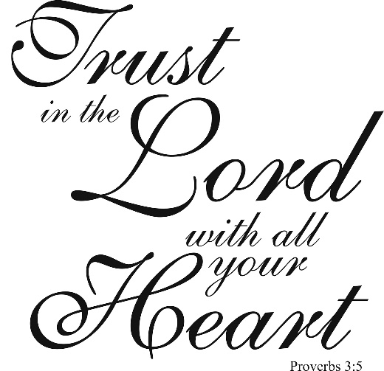

|  |  |  |  |  |
| --- | --- | --- | --- | --- |
| **SEP 09/10** | **5:00 PM** | **8:00 AM** | **10:00 AM** | **12:00 NOON** |
| **EUCHARISTIC MINISTER (H)** | NANCY FELIPE  THOMAS FELIPE | TANIA FERNANDEZ  HAROLD GENTLES | JUNE KIRBY  SONIA MARTINEZ | JESSICA LIM  MICHAEL LAROSA |
| **LECTOR** | CAROL GOMMOLL | JOSEPH REILLY | CHICHI ONWUCHEKWA | PEGGY FREDERICKSON |
| **ALTAR SERVERS** | JOHN SAGUI | GEORGE, GERARD, & KAITLYN HEMMER | MAREK RZASA; JONATHAN AVANCENA; | ROSALIN MENDEZ  LORNA & NEIL HARVEY |

LECTOR AND EUCHARISTIC MINISTER SCHEDULES WILL BE POSTED WEEKLY.

MINISTRY SCHEDULE

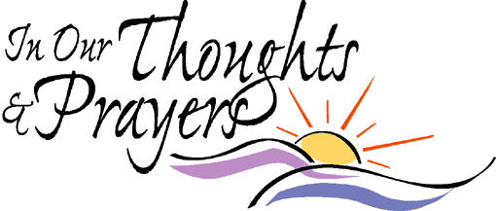

Michelle Ladlee • Liam Foley • Tina Loyacano • Caleb Brosonski • Sandy Cackowski • Cynthia Gauthe • Larry Gauthe • John Sabbak • Antonio Campanella • Sofia Perez • Angela Maldonado• Ivan Rivera • Daniel Burgers • Kenneth Franco • Ellen Buchner • Tom Matteo • Therese Matulewicz • Jayden Singer • Elizabeth Chuprevich • Edward Bajbek • Joan Fitzgerald • Daelyn Bezares • Catherine Murphy • George Blaskewicz • Michael Los • Agnes Moran • Barbara Thompson

• Allyson Hughes • Mary Anne Zisa • John M. Crosby

• Sandra Esposito • Faustino Lozano • Isabel Lozano

• Hanna Kolodziej • Walter Leszcynski • Linda Mazzola

• Asuncion Narbonita • Luis Herrera • Phyllis Phillips

***DECEASED:***

+ Josephine Bove +John R. Lacquaniti +Charles Moran

+Zofia Colucci +Leonardo Tavarone +Carol Tavarone

+Anthony Lupinacci +Mary Perry +Janet Luzzi

+Frances Madden +Peter Antonelli +Dorothy M. Marino

+Carol Lymar +Robert J. Genneken +Daniel Listmeier

+Steve Rummel +Joseph McClelland +Robert G. Walsh

+Donald Foster +Joyce D. Layng

FATIMA 2017 PILGRIMAGE

PRAYER INTENTIONS

Please, hand in your intentions for Fr. Peter to take to the Holy Sites of Fatima and Lourdes.

Drop in collection baskets or in the rectory.

***Deadline****: 10am Monday, Sept 4th*

**“Pizza Night for Women”**

***Interested in Religious Life***

***with Bishop Serratelli***

**Date:** Monday, September 25th

**Time:** 7-9pm

**Place:** Pope John XXIII High School

**For:** Open to high school and college-age women

**Contact**: Office of the Delegate for Religious 973-777-8818 ext. 2017 or [kerry@patersondiocese.org](mailto:kerry@patersondiocese.org)





Celebration of Filipino Saints

Sunday, Sep. 24th

3:00pm Holy Mass

**Cathedral of St. John the Baptist**

Celebrated by Bishop Serratelli

Fellowship Follows

More Info: Fr. Vidal Gonzales (973) 398-6377

 **CCD REGISTRATION**  

**NOW OPEN**

CCD APPLICATION AND SCHEDULES AVAILABLE IN THE RECTORY AND ONLINE AT [WWW.SAINTCLARENJ.COM](http://WWW.SAINTCLARENJ.COM).



SILVER AND GOLD WEDDING ANNIVERSARY MASS

Couples, were you married in 1967 or 1992? You are warmly invited to celebrate your 25th or 50th Wedding Anniversary with the Church of Paterson. Bishop Serratelli will be the main celebrant at Mass at The Cathedral of St. John the Baptist in Paterson.

*Sunday, November 5, 2017 at 4:00pm.*

Arrangements can be made by contacting the parish office. Registrations will be accepted through *Tuesday, October 17, 2017.* Information will be sent from the Office of Family Life once your registration has been processed.

Congratulations on this joyous occasion!

Saturday, September 16th

10am

Please call the office to register.

This session is for those who did not attend the last one.

Altar Server Training

