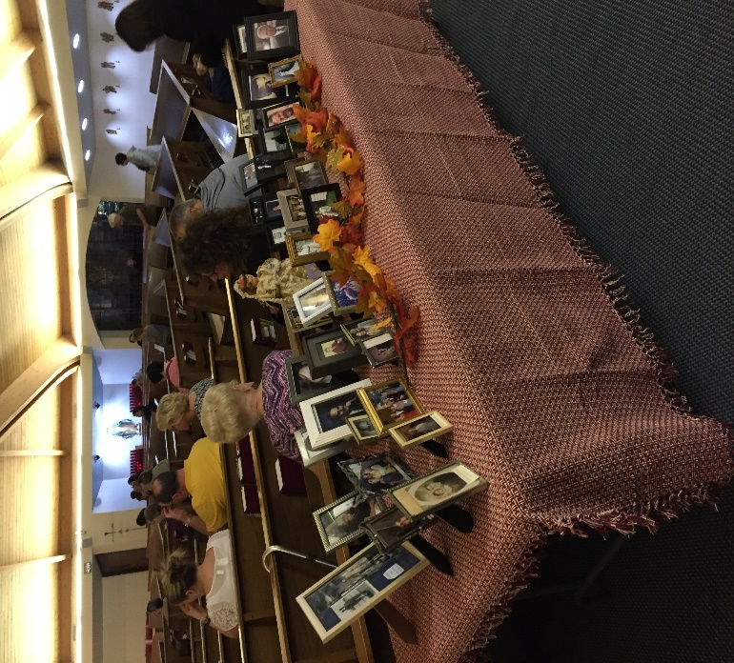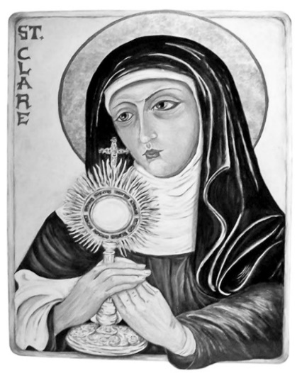[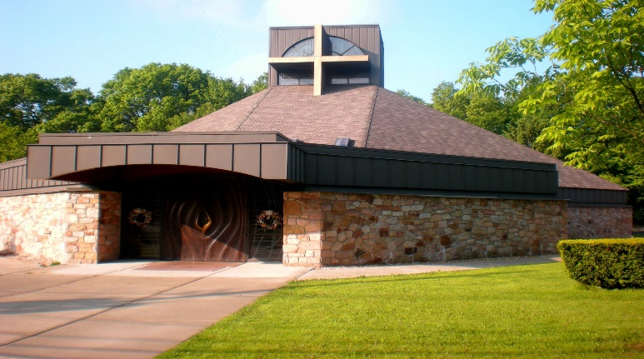](https://www.google.com/url?sa=i&rct=j&q=&esrc=s&source=images&cd=&cad=rja&uact=8&ved=2ahUKEwidsub7sqvcAhUJTN8KHWn8BBwQjRx6BAgBEAU&url=https://www.pinterest.com/pin/6192518212678668/&psig=AOvVaw3-qcKmGUSHW7USfdTsNvE-&ust=1532097706676940)

Parishioners please bring

picture frames of your

deceased loved ones for

All Souls’ Day into the

church starting next week

for the whole month of

November.

**Served By:**

**Rev. Peter Glabik** -------------------------------------------*Pastor*

**Rev. Thomas Fitzgerald** ------------------------*Parochial Vicar*

**Janet Castillo**---------------------------------------------*Secretary*

**Trustees:**

**Mrs. Josie Lagazo-Estero**

**Divine Mercy Chapel open:**

**Monday-Thursday 9-12pm**

**During Office Hours**

**Mass Hours:**

**Monday thru Fridays:** 8:30AM - Divine Mercy Chapel

**Saturday:** 5:00PM

**Sunday:** 8AM, 10AM, 12PM

**Office Hours:**

**Monday thru Thursdays**: 9AM-12PM

“We become what we love and who

we love shapes what we become”- St. Clare

Saint Clare Church

69 Allwood Road, Clifton, New Jersey 07014

**Parish Office/Rectory** 973-777-9313 **Fax** 973-777-6945  
  
**Email**  office@saintclarenj.com **Web** www.SaintClareNJ.com

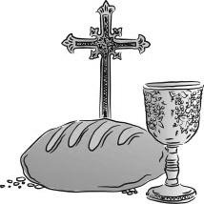

Celebration of

the Eucharist

**MONDAY, OCTOBER 21**

**8:30 AM** GERRY BARAQUIO

__________________________________________________

**TUESDAY, OCTOBER 22**

**8:30 AM** STEPHEN DENKOWICZ

__________________________________________________

**WEDNESDAY, OCTOBER 23**

**8:30 AM**  THE HOLY FAMILY

MSGR. BRENDAN MADDEN

__________________________________________________

**THURSDAY, OCTOBER 24**

**8:30 AM** ERNESTO ESGUERRA

__________________________________________________

**FRIDAY, OCTOBER 25**

**8:30 AM** JOSEPHINE MEYER

WALTER LESZCZYNSKI

__________________________________________________

**SATURDAY, OCTOBER 26**

**5:00 PM** GEORGE MERDO

KYLE MEJIA (BIRTHDAY)

__________________________________________________

**SUNDAY, OCTOBER 27**

**8:00 AM** MSGR. BRENDAN MADDEN; MICHAEL KRAUS

**10:00 AM** BRIGIDO & TRANQUILINA DAVID; DOLORES DUPLAK

**12:00 PM** GERRY BARAQUIO; NIKKIEANNE BOYLAN- WALLACE

**OCT. 12-13, 2019 COLLECTION:**

**1st Collection**

**5PM** 1,221.00

**8AM** 806.00

**10AM** 992.00

**12PM** 782.00

**TOTAL:** 3,801.00

[](https://www.google.com/url?sa=i&rct=j&q=&esrc=s&source=images&cd=&ved=2ahUKEwiN_u6w1LnjAhXGT98KHZ2wATcQjRx6BAgBEAU&url=https%3A%2F%2Fwww.istockphoto.com%2Fillustrations%2Fthank-you&psig=AOvVaw1Q_PWd-YW883axIcZIpBSb&ust=1563374064761547)

**2019 MASS BOOK/INTENTIONS OPEN:**

**DONATION: $15 PER MASS**

**PLEASE KNOW, IT’S FIRST COME,**

**FIRST SERVE.**

OFFICE HOURS

MONDAY – THURSDAY

9AM – 12PM

[](https://www.google.com/url?sa=i&rct=j&q=&esrc=s&source=images&cd=&cad=rja&uact=8&ved=0ahUKEwiAsaqW27LPAhXJMz4KHQ_TC7UQjRwIBw&url=http://darklingstock.deviantart.com/art/Candle-01-347573422&psig=AFQjCNFlK6sDXdYF1unCj3jizE1jB9S8Mw&ust=1475174426413484)Memorials for the Week

**Altar Bread & Wine** is offered this week in memory of…

*PEOPLE OF THE PARISH*

**Altar Candles** burn this week in memory of…

*THE HOLY FAMILY*

**Sanctuary Candle** burns this week in memory of…

*PEOPLE OF THE PARISH*

**Divine Mercy Chapel** Candle burns this week in memory of…

*STEPHEN DENKOWICZ*

**Memorial Opportunities are available:**

**Contact the Office at 973-777-9313**

**TWENTY-NINTH SUNDAY IN ORDINARY TIME**

**First Reading: Exodus 17:8-13**

Amalek and his people attacked the Israelites, so Moses instructed Joshua to lead some of the Israelites into battle the next day. While Moses kept his hands raised in prayer, the Israelites were winning. But when he put his hands down, they would begin to lose. So two others helped him keep his hands raised, and Joshua and the Israelites won the battle.

**Second Reading: 2 Timothy 3:14-4:2**

Paul tells Timothy that the Scriptures are inspired by God and are an excellent tool in teaching others about God's expectations of his people. Knowledge of the Scriptures, coupled with faith in Jesus, will lead many people to salvation. Paul urges Timothy to continue preaching the gospel, although this will sometimes be a difficult task.

**Gospel: Luke 18:1-8**

Jesus speaks about a corrupt judge who lacked respect for either God or man. A widow repeatedly asked him to settle a case in her favor. He finally settled the case, only because he grew weary of listening to her requests. Jesus points out that if even this corrupt judge eventually listened, then God, who is just, will certainly answer the pleas of his people.

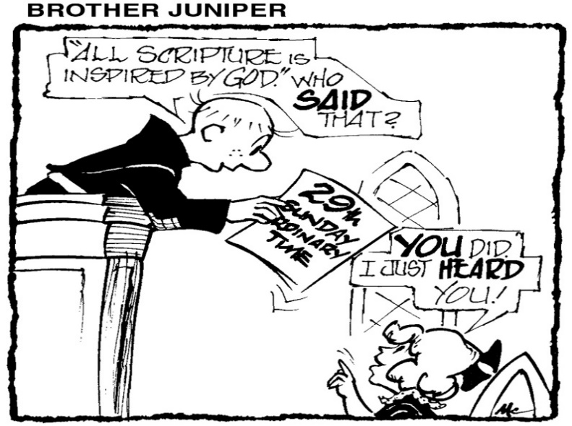

**TWENTY-NINTH SUNDAY IN ORDINARY TIME**

“Remain faithful to what you have learned and believed, because you know from whom you have learned it, and from infancy you have known the sacred scriptures, which are capable of giving you wisdom for salvation through faith in Christ Jesus. All scriptures is inspired by God and is useful for teaching, for refutation, for correction and for training in righteousness, so that those who belong to Jesus may be competent, equipped for every good work.”

When is the last time you opened your bible at home, or listened with great attention as the scriptures were proclaimed at mass? When did you reflect on God’s word, during the week after hearing it at liturgy, or heard a text which was familiar to you? When did you think it might be helpful to attend a bible study?

The words above which Paul wrote to Timothy are invitations to us, so we can grow in our faith. The teaching reminds us of growing after first communion, confirmation or our marriage. We continue to grow older, are we growing in holiness? Pope Francis’ exhortation offers us the beatitudes as the path for holiness. The bible in your living room has allergies. It is allergic to dust. Please open it read it and heed it!



HIS WORD TODAY

BY REV. WILLIAM J. REILLY

A FRESH PERSPECTIVE ON

THE SUNDAY READINGS

CCD

CCD APPLICATIONS & SCHEDULES ARE AVAILABLE IN THE RECTORY & ONLINE AT [WWW.SAINTCLARENJ.COM](http://WWW.SAINTCLARENJ.COM)

**Grades 1-4: Next Class is Oct.22nd 4-5PM**

**Grades 5-7: Next Class is Oct. 21st 4-5PM**

**Grades 8,9, & 10 Next Class: Oct. 29th 7-8 PM**

* **NO CLASS OCT. 22ND FOR GRADES 8-10**

***LAST CHANCE TO REGISTER!!!***

**BAPTISMS**

Baptisms take place after

10AM Mass on Sundays

**Requirements:**

-Baptismal Class prior to Baptism

-$100 Donation fee

-Sponsor Certificate from both Sponsors

Contact the Office for Further Information (973) 777-9313

[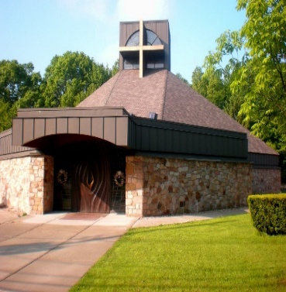](https://www.google.com/url?sa=i&source=images&cd=&cad=rja&uact=8&ved=2ahUKEwje9OGflZzbAhUJnFkKHblcCRMQjRx6BAgBEAU&url=https://www.pinterest.com/pin/6192518212678668/&psig=AOvVaw3qVZPY_qGzH5K_TNa0yXLL&ust=1527176311879995)

LIKE US ON FACEBOOK: SAINTCLARENJ

FOR MORE INFORMATION ON PARISH LIFE! WE POST PICTURES OCCASIONALLY DURING CHURCH EVENTS!

Bus Trip to Papermill Playhouse on Sunday, December 15th for the 1:30PM showing of “Cinderella”. Tickets are $75.00 and include bus transportation and orchestra seats. For reservations please call St. Andrew’s Church at 973-779-6873 X-20. All reservations need to be made by November 1st.



**OCTOBER ENVELOPE COLLECTION**

**October 20, 2019:**

Mission Sunday

Weekly Church Offering

**October 27, 2019:**

Maintenance & Repairs

Weekly Church Offering

**NOVEMBER ENVELOPE COLLECTION**

**November 1, 2019**

All Saints

**November 2,2019**

All Souls’ Remembrance

* **All Souls’ Day envelopes are due by Nov. 2nd-3rd weekend.**

SICK LIST:

**Emy Kovatch**

**Salvatore Gagliardo**

**Scotty Montague**

**James McConnell**

**Jayden Singer**

**Ms. Danko**

**Jeffrey Esubonteng**

**Kathryn Hodika**

**Nick & Joyce Boglivi**

**Florence Kaminski**

**Barbara Kheiralla**

[](https://www.google.com/url?sa=i&rct=j&q=&esrc=s&source=images&cd=&ved=2ahUKEwi3zdHX7rnkAhWFiOAKHSELDKMQjRx6BAgBEAQ&url=https%3A%2F%2Fcliparts.zone%2Foffering-envelopes-cliparts&psig=AOvVaw1g2szkbvkF8_v-WwdnGPjK&ust=1567779123139812)

[](https://www.google.com/url?sa=i&rct=j&q=&esrc=s&source=images&cd=&ved=2ahUKEwi3zdHX7rnkAhWFiOAKHSELDKMQjRx6BAgBEAQ&url=https%3A%2F%2Fcliparts.zone%2Foffering-envelopes-cliparts&psig=AOvVaw1g2szkbvkF8_v-WwdnGPjK&ust=1567779123139812)

**Sunday**

Ex 17:8-13; 2 Tm 3:14-4:2; Lk 18:1-8

**Monday**

Rom 4:20-25; Lk 12:13-21

**Tuesday**

Rom 5:12, 15b, 17-19, 20b-21; Lk 12:35-38

**Wednesday**

Rom 6:12-18; Lk 12:39-48

**Thursday**

Rom 6:19-23; Lk 12:49-53

**Friday**

Rom 7:18-25a; Lk 12:54-59

**Saturday**

Rom 8:1-11; Lk 13:1-9

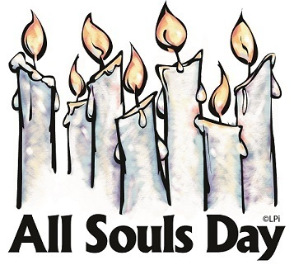

MINISTRY SCHEDULE

|  |  |  |  |  |
| --- | --- | --- | --- | --- |
| **OCT. 26/27** | **5:00 PM** | **8:00 AM** | **10:00 AM** | **12:00 NOON** |
| **EUCHARISTIC MINISTER (H)** | CAROL GOMMOLL  BARBARA WALTERS | TANIA FERNANDEZ  BARBARA SANDBERG | SONIA MARTINEZ  MARYLOU BALTAZAR-PINGOL | CHRISTINE VARGAS  RODULFO MOISES III |
| **LECTOR** | ROBERT SANTORIELLO | ELIZABETH ACEVEDO | ATHENA AQUINO | MICHAEL LAROSA |
| **ALTAR SERVERS** | N/A | ADDISON O’LEARY | JUSTIN MARTINEZ  JONATHAN MARTINEZ | ROSALIN MENDEZ  JONATHAN AVANCENA |

*Sept. – Nov. 2019 Ministry Schedules now available in the Parish Office, and online at [www.saintclarenj.com/ministry-schedules](http://www.saintclarenj.com/ministry-schedules). Questions please contact Josie Lagazo-Estero: [jlagazo395@aol.com](mailto:jlagazo395@aol.com).