2025 THANKSGIVING FOOD COLLECTION
FOR THE FATHER ENGLISH FOOD PANTRY

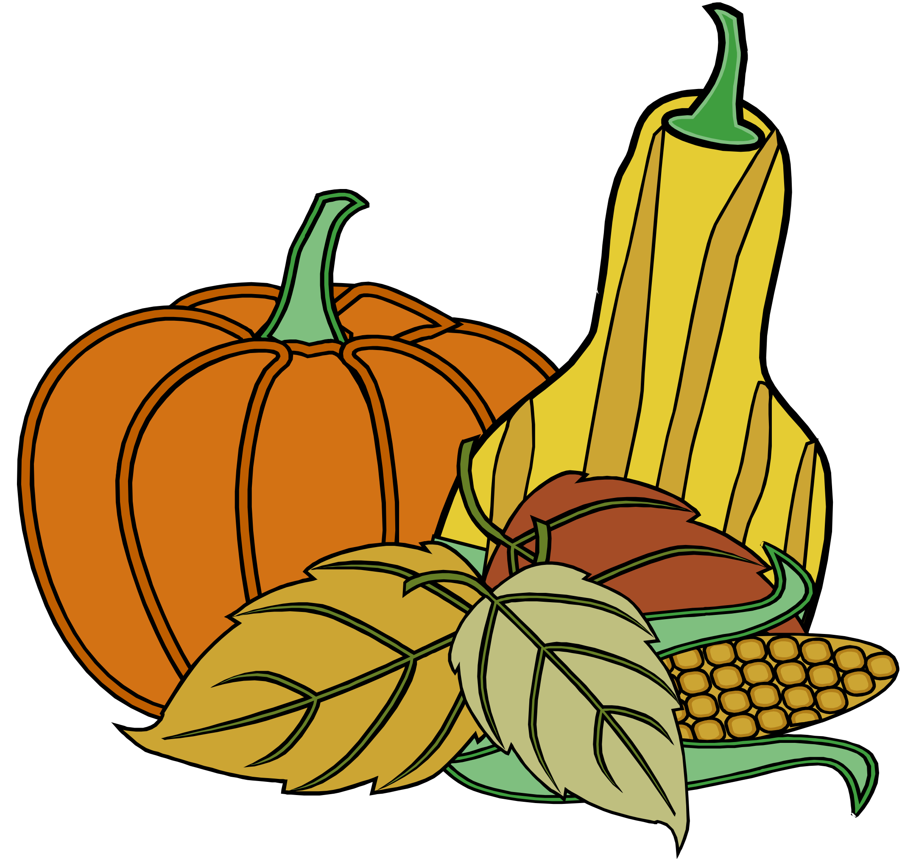
Listed below are suggested food items for donation not only for Thanksgiving dinner but also for meals throughout the year. Donations will be collected during all Masses on the weekend of November 22-23. God bless you for your kindness!

turkey (frozen only) mustard and ketchup
canned ham mayonnaise
turkey gravy cranberry juice
stuffing mix apple juice
cranberry sauce (canned) cereal
sweet potatoes (canned) noodles
white potatoes (canned) pudding
onions (jarred) Jello
pumpkin (canned) flour
pie crust mix soup
apple pie filling peanut butter
evaporated milk tuna fish
potato flakes (boxed) salmon
canned vegetables beef stew (canned)
black beans jam and jelly
red beans powdered milk
rice brownie mix
coffee spaghetti
tea pasta
sugar pasta sauce
mushrooms (canned) hash (canned)
cookies baby food
canned fruit pancake mix
salad dressing pancake syrup

Lord, when did we see you hungry and feed you,

or thirsty and give you drink?’

And the king will say to them in reply,

‘Amen, I say to you, whatever you did for one of

these least brothers of mine, you did for me.’

Matthew 25: 37,40

