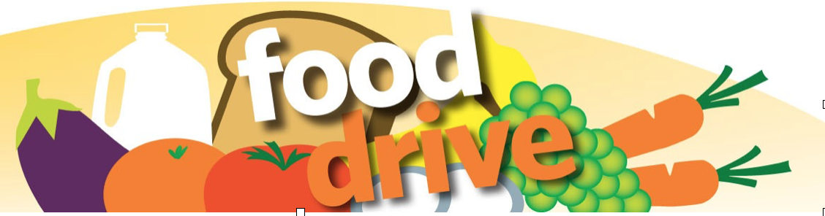

## The **Fr. English Food Pantry in Paterson**

## needs your help to feed thousands of families a month!

## 

## Help **St. Joseph Church’s 8th grade Confirmation class feed our North Jersey neighbors in need!**

## **Contactless collection!**

## **Leave your donations on your front steps on:**

## *(insert date/time)*

All unexpired non-perishable food accepted. Most needed items:

**Rice • Coffee • Tea • Beans • Pasta Sauce**

**mustard** • **ketchup** • **mayonnaise** • **apple juice** • **cereal** • **noodles** • **white potatoes (canned)** • **pudding** • **Jello** • **flour** • **soup** • **peanut butter** • **evaporated or powdered milk** • **tuna** • **potato flakes** • **salmon (canned)** • **canned vegetables** • **black beans** • **jelly** • **red beans** • **sugar** • **baby food** • **canned fruit** • **pancake mix** • **salad dressing**

**Contact your neighborhood collection organizer for more information:**

***(Insert your contact information)***

***Thank you for your generosity!***