The First Eucharist
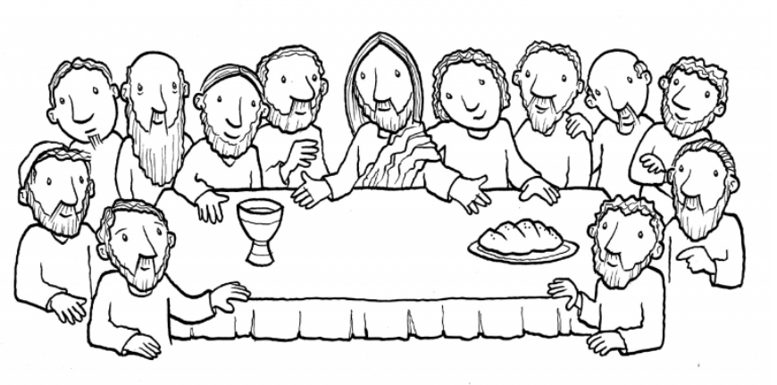
Mathew 26:26-30
¹⁷ On the first day of the Festival of Unleavened Bread, the disciples came to Jesus and asked, “Where do you want us to make preparations for you to eat the Passover?” ¹⁸ He replied, “Go into the city to a certain man and tell him, ‘The Teacher says: My appointed time is near. I am going to celebrate the Passover with my disciples at your house.’” ¹⁹ So the disciples did as Jesus had directed them and prepared the Passover.
²⁰ When evening came, Jesus reclined at the table with the Twelve.
²⁶ While they were eating, Jesus took bread, said the blessing, broke it, and giving it to his disciples said, “Take and eat; this is my body.” ²⁷ Then he took the cup, gave thanks, and gave it to them, saying, “Drink from it, all of you ²⁸ for this is my blood of the covenant, which will be shed on behalf of many for the forgiveness of sins.
³⁰ When they had sung a hymn, they went out to the Mount of Olives.

At Mass Today
We hear those same words when Father holds up the host and the cup. This is called the Consecration. It is a very holy time of the Mass. Everyone is quiet and focused on this because Jesus gave us the gift of his life and gave us the Eucharist.
