What is on the altar?
Match the picture with the letter of the name of the item.

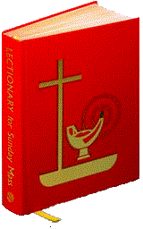 | A. The altar candles. They are lit before Mass begins by altar servers.  B. Altar: The sacred table where the priest prays the consecration of the Mass.  C. The chalice: The vessel which holds the wine that becomes the Sacred Blood of Christ.  D. The cruets hold the wine and the water that are used at Mass.  E. The Crucifix: The cross that hangs above the altar reminding us that Jesus died for us.  F. A new Paschal Candle is lit every Easter. During the Easter Season it is on the altar. The rest of the year it is by the Baptismal Font.  G. The Ambo: the lectern or stand where the readings are read.  H. The Lectionary: The book containing the biblical readings arranged for the celebration of Mass.  I. The patten: The golden plate that holds the bread that becomes the Sacred Body of Christ.
