Why Do We Sing at Mass?
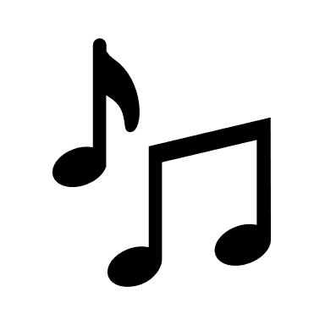
St. Augustine once proclaimed that “Singing is for the one who loves.” (Sermo 336, 1). People sing to express how they are feeling. God has given us music as a gift of expression. In giving us music, God gives us a sign of His love for us.
With music, we can express our love for God. We can do this by ourselves or with others. When we pray through song, we often have a greater sense of the Holy Spirit within us.
Singing involves more thought on our part so we often pay closer attention when we sing.
“The one who sings prays twice.” Attributed to St. Augustine

The songs at Mass today celebrate the Epiphany when the three Kings or the Magi, found the baby Jesus with Mary and Joseph and brought gifts.
Look at these songs and find them in the Today’s Missal Music Issue in the pews. Which ones do you already know? Which ones are new to you?

• We Three Kings #105
• The First Noel #110
• What Child Is This/Child of the Poor #95 and 96
• Good Christian Friends, Rejoice #83
• I Saw Three Ships (Back side of this paper)

I Saw Three Ships
I saw three ships come sailing in
On Christmas Day, on Christmas Day
I saw three ships come sailing in
On Christmas Day in the morning
On Christmas Day in the morning

And what was in those ships all three
On Christmas Day, on Christmas Day?
And what was in those ships all three
On Christmas Day in the morning?
On Christmas Day in the morning

The Virgin Mary and Christ were there
On Christmas Day, on Christmas Day
The Virgin Mary and Christ were there
On Christmas Day in the morning

And all the Angels in Heaven shall sing
On Christmas Day, on Christmas Day
And all the Angels in Heaven shall sing
On Christmas Day in the morning

Then let us all rejoice again
On Christmas Day, on Christmas Day
Then let us all rejoice again
On Christmas Day in the morning
On Christmas Day in the morning
Songwriters: Edith Bergdahl, Nat King Cole. For non-commercial use only.

