# t

**Those that did not have your family photo taken with Dakota Lifestyle Photography and would like to submit a photo to be included in the directory,** please email the office the picture in a .jpeg form or bring a photo to the office. **All submitted photos dropped off at the office will be returned.**

You are invited to partake in the second annual **North Dakota March for Life**, taking place at the North Dakota State Capitol on January 21st, 2022. On January 22nd, 1973, the United States Supreme Court handed down the Roe v. Wade decision that made abortion legal, allowing many to choose to have an abortion without government intervention. Since then, well over 62 million lives have been lost due to abortion. To begin the event on January 21st, Bishop Kagan will celebrate Mass at 10:30 am at Cathedral of the Holy Spirit. Following Mass, groups are welcome to march (or drive) to the Capitol grounds for a program beginning at 12:30 pm to include a keynote speaker and a period of silence for the 62+ million lives who have been silenced by abortion in the United States since 1973. For more information on how you can participate, check for frequent updates at the Diocese of Bismarck website.

**Footsteps of St. Paul pilgrimage 2022:** Pilgrims are invited to follow the footsteps of St. Paul as he traveled and explored the world he knew including the places where the “Apostle to the Gentiles” preached and taught. This pilgrimage into the life and times of St. Paul will be from Sept. 19-30, 2022, leaving from Bismarck. The all-inclusive price is $4,550 (except lunches). Monsignor Chad Gion will serve as the spiritual director of this trip sponsored by L.P. Pilgrimages. For more information, contact LeAnn Brand at 833-910-1545 or [GaSales@lpjp.org](mailto:GaSales@lpjp.org) . You can register and pay directly at the website [www.lpjp.org](http://www.lpjp.org) . A deposit of $400 is payable on booking with the second payment of 50% due April 20, 2022 and full balance due on June 20, 2022.

**Cursillo weekends in March:** The Cursillo of the Bismarck Diocese will be holding their 2022 Cursillo weekends at Trinity High School in Dickinson in March. Cursillo is a short course in Christianity for adults that takes place over a four-day retreat. The men’s weekend will be March 3rd – 6th and the women’s weekend will be March 17th -20th. For more information or to register, please visit [www.bismarckcursillo.com](http://www.bismarckcursillo.com) or call/text Dennis Meyer at 701-290-7091 (for the men’s weekend) or Kim Kostelecky at 701-590-4726 (for the women’s weekend).

**Father Bruce Krebs** will be assisting our parishes for weekend Masses and any funerals thru January 16th, 2022.

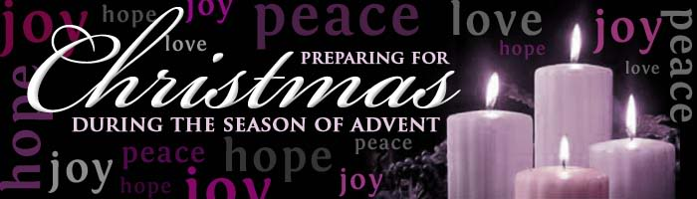In i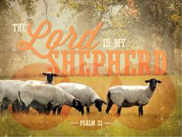1 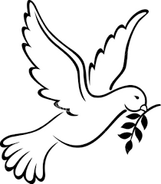

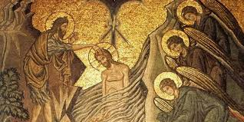

**Mass Schedule & Intentions for Jan 11th – Jan 16th**

**Tues, Jan 11th…. 5:00pm Communion Services** at **St. Martin**

**Wed, Jan 12th….. 7:30 am Communion Service** at **St. Joseph:**

**Thurs, Jan 13th …. No 12:00pm Communion Service** at **St. Martin**

**Fri, Jan 14th ....8:30 am Communion Service at St. Joseph**

**Sat, Jan 15th…..** **5:00pm Mass** at **St. Joseph:**  Audrey Phillips by Rosie Schumacher

**Sun, Jan 16th ….8:00am Mass** at **St. Joseph:**  Alan Abbey by Jalane Mann

**10:00 am Mass** at **St. Martin:**  Ralph Schultz by John and Tena Weinand

**Father Grafsgaard will be gone thru the month of January, all scheduled**

**weekday Mass intentions will be said privately.**

January 9th, 2022

Baptism of the lord

Pastor: Father Thomas Grafsgaard

Rectory: 701-873-2586 [tgrafsgaard@bismarckdiocese.com](mailto:tgrafsgaard@bismarckdiocese.com)

Deacon Dan Wallach

701-880-0204





#### **St. Martin Catholic Church**

101 3rd Ave SW, PO Box 387

Hazen, ND 58545

Office: (701) 748-2121, Rel. Ed. 748-6184

[stmhazen@westriv.com](mailto:stmhazen@westriv.com)

www.saints2b.org

St. Martins Catholic Church, Hazen, ND

#### **St. Joseph Catholic Church**

#### 115 3rd St. NE, PO Box 146

Beulah, ND 58523

Office: (701) 873-5397, Rel. Ed. 873-5006

[stjbeulah@westriv.com](mailto:stjbeulah@westriv.com)

www.saints2b.org

St. Joseph Catholic Church, Beulah, ND

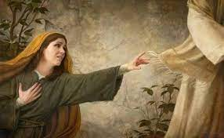us pm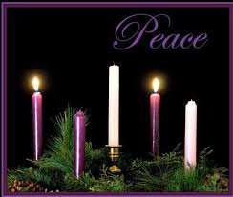 (5pm)

**St. MARTIN CATHOLIC CHURCH**

**Confessions**- 4:15-4:50pm before Saturday Vigil Mass; 7:15-7:50am before Sunday Mass; 9:30–9:50am before 10am Sunday Mass; 20 minutes before Daily Mass.

**Office Hours: Tuesday: 8:30am-2:30pm, Wednesday: closed, Thursday: 8:30am–2:30 pm**

**New to the Parish** – Please call the church office to register- 748-2121: **Baptism-** Contact the Church Office –

**Prayer Chain**- For special prayer needs- LuAnn Woeste at 748-2300; **Homebound:** Dorry Peterson (870-2030)

**                              **

**                           ** ** **

**Upcoming Parish Events:**

**Mon, Jan 10th:** Adoration and Prayer, StJ, 8:30-9:30 am

**WWP Connect Coffee**

**Tues, Jan 11th:** Adoration @ StM 4:00 – 6:30 pm

StM Altar Society meeting @5:30 pm Library

**Wed, Jan 12th: RE Classes**

**Confirmation to attend One Dei Adoration @ StJ**

**One Dei Eucharistic Adoration 7:00- 8:00pm**

**                           ** ** **

**Sun, Jan 16th: 10:00am Mass: Lector:** Mandy Grossman**; Precious Body Distribution:** Mary Robson**; Altar Servers:** Logan Garrett, Ethan Schantz and Anna Roth**; Communion to Homebound:** Sylvia Lorenzano (701-226-2030)

**                             **

**RELIGIOUS EDUCATION- Michelle Reinhardt - 748-6184; Email:**[**stmreled@westriv.com**](mailto:stmreled@westriv.com)

**                             **

**St. Martin Altar Society** will meet on Tuesday, January 11th at 5:30pm in the Library. All Ladies of the parish are invited to attend.

**Volunteers are needed** following the 10:00 am Mass on Sunday, January 16th to undecorate our parish and reset the hall. Any help is greatly appreciated.

**St. JOSEPH CATHOLIC CHURCH**

**Confessions**- 4:15-4:50pm before Saturday Vigil Mass; 7:15-7:50am before Sunday Mass; 9:30–9:50am before 10am Sunday Mass; 20 minutes before weekday Mass.

**Office Hours: Monday: 8:30am-2:30pm, Wednesday: Closed; Friday: 8:30-1:00pm**

**New to the Parish** – Please call the church office to register- 873-5397; **Homebound:** Jessie Palaniuk 873-5820

**Baptism-** Contact the Church Office - **Prayer Chain**- For special prayer needs- Audrey Krebs-873-5949

**                             **

**                            **

**Upcoming Parish Events:**

**Mon, Jan 10th:** Adoration and Prayer, StJ, 8:30-9:30 am

**WWP Connect Coffee**

**Tues, Jan 11th:** Adoration @ StM 4:00 – 6:30 pm

**Wed, Jan 12th: RE Classes**

**Confirmation to attend One Dei Adoration**

**One Dei Eucharistic Adoration 7:00- 8:00pm**

**                           **

**Sat, Jan 15th: 5:00 pm Mass: Lector:** Joe Bren; **Precious Body Distributer**: Dennis Candrian; **Altar Servers:** Dylan Knight, Jonas and Isaac Braun; **Ushers:** Dennis and Kim Candrian; **Communion to Homebound:** Carrie Koch (870-1264)

**Sun, Jan 16th: 8:00am Mass: Lector:** Rosie Schumacher; **Precious Body Distributer**: Carmy Bren; **Altar Servers:** Braylen and Bensyn Schirado and Emma Olson**; Ushers:** Brandon and Jenny Schirado; **Communion to Homebound:** Carrie Koch (870-1264)

**                            **

**RELIGIOUS EDUCATION – Darlene Mellmer- 873-5006; Email:** [**stjk-12@westriv.com**](mailto:stjk-12@westriv.com)

**                            **

**Volunteers are needed** at 4:00 pm on Monday, January 10th to undecorate our church. Any help is greatly appreciated. Poinsettias will be available for pick up after Monday.

Everyone is invited to attend **Eucharistic Adoration with live Praise and Worship music led by One Dei.**  Please join us in offering prayers for Father Grafsgaard and any personal intentions.  This event will be held at St. Joseph on January 12th, 2022, 7:00 pm to 8:00 pm.  Father Bruce Krebs will be offering the Sacrament of Reconciliation during that time.

|  |  |  |  |  |
| --- | --- | --- | --- | --- |
| **Jan 2021** | Last Week | Monthly | YTD Collection | YTD Budgeted |
|  | (Jan 1 - 7) | (Jan 1-7) | (July 1 – Jan 7) | (July 1 – Jan 7) |
| Adult Collection | $ 1,728 | $ 1,728 | $ 50,732 | $ 48,437 |
| EFT Collection | $ 905 | $ 905 | $ 19,595 | $ 21,354 |
| Loose Collection | $ 263 | $ 263 | $ 5,290 | $ 3,385 |
| **Total Income:** | **$ 2,896** | **$ 2,896** | **$ 75,617** | **$ 73,176** |
| Youth Collection | **$ 61** | **$ 61** | **$ 5,541** |  |
| **Jan. Exp:** | **$ 1,853** | **$ 1,853** |  |  |

|  |  |  |  |  |
| --- | --- | --- | --- | --- |
| **Jan 2021** | Last Week | Monthly | YTD Collection | YTD Budgeted |
|  | (Jan 1 - 7) | (Jan 1-7) | (July 1 – Jan 7) | (July 1 – Jan 7) |
| Adult Collection | $ 2,040 | $ 2,040 | $ 58,454 | $ 52,583 |
| EFT Collection | $ 3,070 | $ 3,070 | $ 42,118 | $ 41,145 |
| Loose Collection | $ 106 | $ 106 | $ 4,872 | $ 3,104 |
| **Total Income:** | **$ 5,216** | **$ 5,216** | **$105,444** | **$ 96,832** |
| Youth Collection | **$ 0** | **$ 0** | **$ 9,197** |  |
| **Jan. Exp:** | **$ 2,688** | **$ 2,688** |  |  |