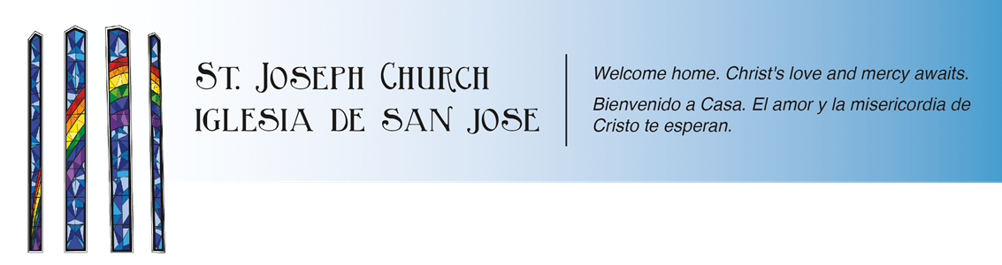

High School Youth Ministry
2022-2023 Schedule

Youth Ministry sessions are nights where our trained youth minister and Core team lead the teens to develop a deeper sense of community and faith in a social setting. Each Youth Ministry Night, the teens are introduced to topics that will range from fun social nights, issue-oriented nights, and teaching nights. Our hope is that every Youth Night is not just fun, but also challenges teens to go deeper in their relationship with God and to know about our Catholic faith.

St. Joseph High School Youth Ministry will meet every other Tuesday night at 7pm-8:30pm inside the Youth Center. Confirmation candidates need to attend at least 6 of these Youth Ministry nights.

Dates from October- December Dates from January-May

10/30/22 11/1/22 11/15/22 1/17/23 2/7/23 2/21/23 3/7/23

11/29/22 12/6/22 3/21/23 4/4/23 4/18/23 5/2/23

Sunday- 12/18/22 5/16/23 5/30/23

Please keep in mind, these nights are separate from the Confirmation nights. For any questions concerning these nights, please contact the front office 805-684-2181 or
contact the Youth Minister, Dan Niel
dan@stjosephchurch.org



