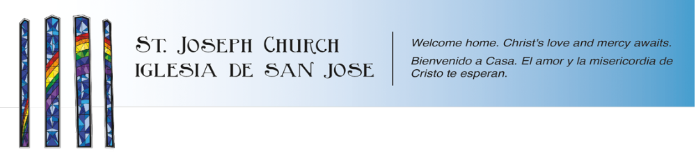

Confirmation Sponsor Form

Confirmation candidate :

What is your relationship to this Confirmation candidate?
(Please Note: Parents or guardians of candidates may not serve as their Confirmation sponsor.)

How long have you known this Confirmation candidate?

Your name (sponsor) Date of Birth
Spouse’s name (if married)

Mailing Address
Email Address
Home Phone

Mobile Phone

What parish are you a member of?

Sponsors must be fully initiated¹ and practicing Catholics. Sponsors should be at least 18 years old when their candidate is confirmed. Sponsors may not be a parent or guardian of the candidate. If married, Sponsors should be married in the Catholic Church.


Have you received the sacrament of Confirmation in the Catholic Church? Yes No
Do you regularly attend Mass on Sundays and days of Holy Obligation? Yes No
Will you be 18 or older by about the time this candidate is confirmed²? Yes No
If you are currently married, are you married in the Catholic Church? Yes No

Statement of Confirmation Sponsor:
I recognize that in accepting the office of sponsor I am responsible to be a model and example of faith as a committed and active Catholic in good standing. I hereby certify that my responses to the questions on this form are true and that I am living out my Catholic faith in good conscience.

Signature of Confirmation sponsor:
_______________________

¹ Have received the Sacraments of Baptism, First Communion, and Confirmation in the Catholic Church

² April of their second year in the Confirmation Preparation Process

