For December –near Christmas.
(This is a lesson prepared for our Catechism students to present to parents in Church—this took the place of Fr.’s sermon. We used a screen and the PowerPoint included in the lesson-we try to have a presentation once a month-if possible. Sometimes it is one class-and sometimes-it is a group presentation. We also have a Christmas Pageant and a play for honoring St. Nicholas-many things in December.)
1. Younger groups-1st-2nd -come down side aisle with bells. They will come to the center and sing
2. Grades 3rd- 4th will come down the other side aisle with student hitting ‘Talando’* will come to center and sing Silent Night.
3. 5th -8th will come down the center aisle.
4. Some will carry a picture of the icons and the relics with them.
5. Students will explain each of the icons and share information about the Gifts that the Magi brought to the Christ child.
6. After the students complete this – Christmas words will be read…
(See below-parts are separated to give to selected students)
*Talando is the stick that the Monks use to sound the time for prayer, etc to the monks on Mt. Athos.

Precious Gifts of the Magi
Many years ago, our Christ was born to Mary, our Theotokos. Many came forth to greet Him. Shepherds were visited by the angels who told them, Do not be afraid for we bring you good tidings that in the city of David, the Savior had been born. Christ the Lord. They would find Him lying in a manger and wrapped in swaddling clothes. The shepherds did as the angels said and they came to the manger and praised the Christ Child. They then went about telling all what they had seen.
In a far way land, Magi saw the light shining in the East and went in search of Him who was born King of the Jews and they came to greet Him and to worship Him. When the Magi came, they brought Him gifts of gold, frankincense and myrrh.
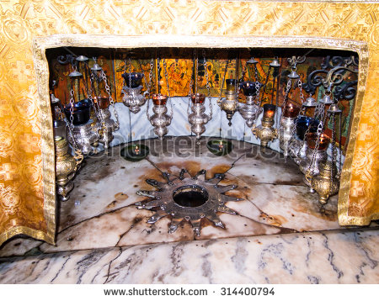

We have learned of all these wonderful things about the birth of our Lord. However, what became of the swaddling clothes that Christ had been wrapped in and what became of the gifts of the Magi?
In the Gospel of Luke 2:19, we are told while all went about telling what they had seen, “Mary kept all these things and pondered them in her heart.” She kept all the ‘words’ in her heart and she revealed them to the Holy Apostle Luke and he included them in his gospel. In theological studies, we find that the ‘words’ that the Theotokos kept were all events and happenings in the life of our Lord. She kept everything that belong in the earthly life of our Lord, including the Precious Gifts of the Magi.


Before the Dormition of our Theotokos, she gave the Gifts of the Magi, along with the ‘Swaddling Clothes of Christ, her Precious Robe and Holy Belt to the Church of Jerusalem—They remained there until 400 AD. They were then brought to Constantinople for the blessing of the people. The gifts remained in this place until 1204, when they were taken to Nicea for the safety of the Holy Relics. They remained there for 60 years until all was safe and the Holy Relics were returned to Constantinople until 1453 AD when the Turks overtook the land.

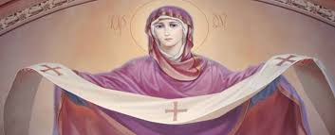

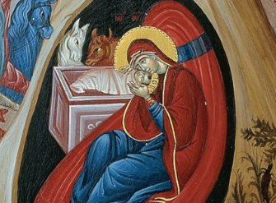

When this terrible time was over, Queen Maro, the Christian wife of the Sultan, chose to bring the Holy Relics to the Holy Monastery of St. Paul of the Holy Mountain, Mount Athos. It is told that as she came to the port of the Monastery. She tried to come on to the Holy Mountain. No woman but the Theotokos had ever been allowed to enter Mount Athos.

At this point, our Theotokos, spiritually prevented her from entering Mount Athos. Queen Maro obeyed and gave over the Holy Relics to the monks. They brought the Holy Relics to the place where our Holy Theotokos revealed herself. A Cross revealed itself at this place and is there even today. There is even a document from the sultan that tells of all that occurred.

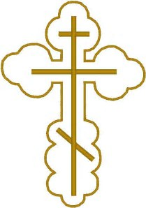

The place where the Theotokos was seen is called “Cross of the Queen”. This place is at the Monastery of St. Paul on Mount Athos.

The Monastery of St. Paul was built in 939 AD. In this Monastery can be found the portable icon of the Virgin of Mirovlitissa which has myrrh flowing from it, a fragment of the True Cross and part of the gifts brought to the Christ Child by the Magi.

Skete of St. Paul
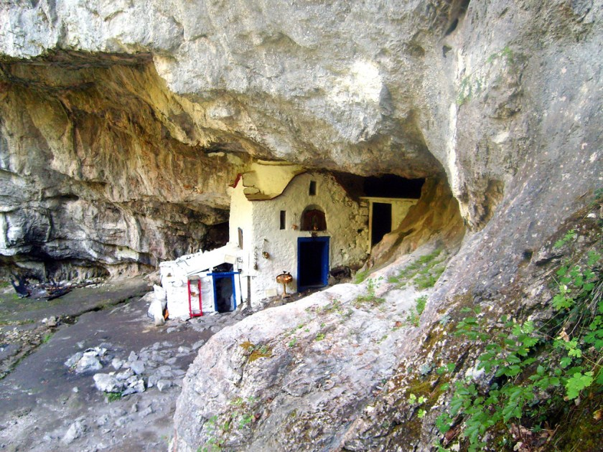

The gift of Gold is in the form of 28 pieces of gold coins, in many shapes and different designs. Each coin is about 5 centimeters by 7 centimeters large.

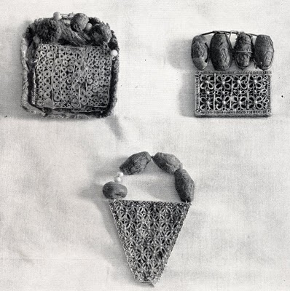
Precious Gifts of the Magi

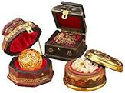

Myrrh /Frankincense

The frankincense and myrrh have been formed into 62 round beads, which are the size of a small olive. Because of the importance of these Holy Relics, they are protected with extreme care. In order to protect these Holy Relics, they are only presented for veneration in the Holy Monastery of St. Paul and are carefully guarded when they are taken out of the Holy Mountain as a blessing for many Metropolises.

We know that these are the Precious Gifts brought by the Magi. The truth comes to us from what has been told in oral tradition and history. Most importantly, we are told that what strongly proves that these are the Precious Gifts is the strong aroma coming from them, as well as the miracles and miraculous grace of the gifts even up to now.

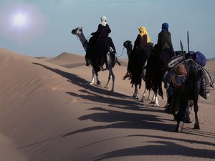

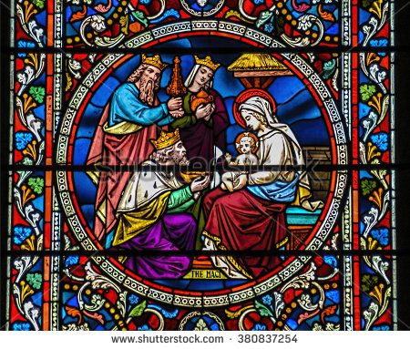

We are fortunate to know that this is what became of the Precious Gifts brought by the Magi in that Blessed time when our Lord was born and found wrapped in swaddling clothes, lying in a manger.

