Special Agents of Christ

**STEP ONE: Recruiting Special Agents**

Special Mailings:

1. Week of August 25th: Students are sent “secret code” and red “spyglass decoder”

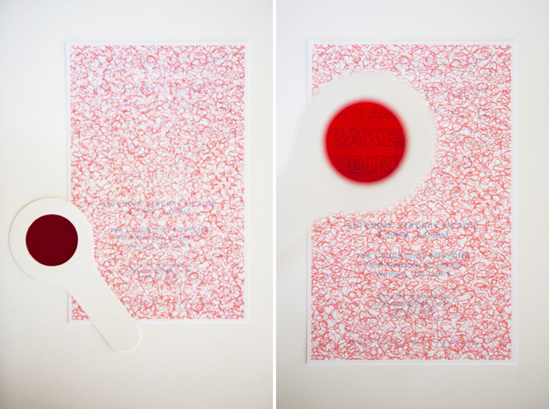

Message reads:

You have been selected to serve as a

SPECIAL AGENT OF CHRIST

Should you choose to accept this mission, please report to

St. Sophia Greek Orthodox Church

Sunday, September 7th at 10AM

for Liturgy and Sunday School

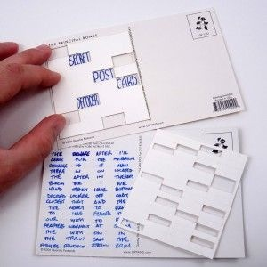

2) Week of September 1st: Secret “Cardan Grille” Code

Students are mailed a postcard with a series of words that appear to read as gibberish. Message across postcard reads “To Crack the Code, Come to Sunday School September 7th, St. Sophia Greek Orthodox Cathedral”

Students will receive code breaking “grille” in Sunday School to reveal the secret message. (Code: You can talk to God about everything. Pray Always.)

**Agent Induction**

September 7th, First Day of Sunday School

1. “Background Checks”, iPad app called “Fingerscan”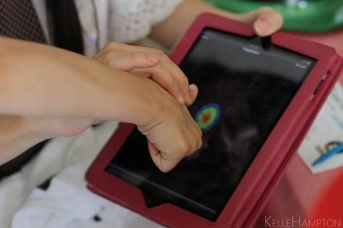

2) “Laser” Obstacle Course through hallway, red streamers taped to wall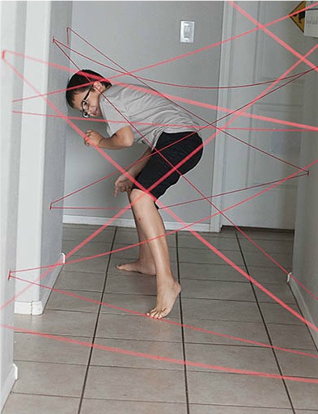

3) Special Agent Badge- Take student’s picture in disguise for ID to be given next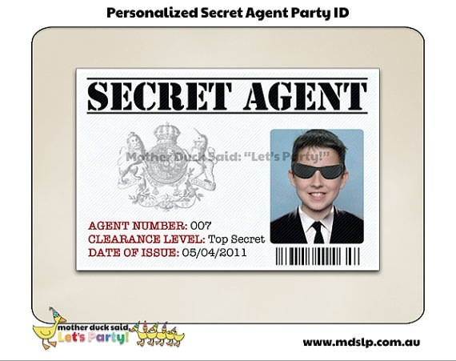 week

**Delivering the Secret Mission**

Sunday School Lessons

Follow Fr Spiro’s suggested curriculum, “flesh out” curriculum with spy themed activities.

**Example: Lesson One, Prayer, “Checking in with the Chief Commander”**

**Introductory Activity:**

Older students: Students get decoder wheel and lines of code to break. (Do first code, save last code for extra class time filler) 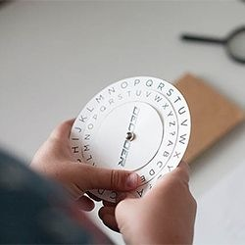

How do we communicate with God? Code: PRAYER

(Save for end of class time filler)

Code: LORD JESUS CHRIST SON OF GOD HAVE MERCY ON ME A SINNER

Younger students: Play a game of “telephone” with phrases such as “Jesus Loves You” and “Lord Have Mercy”

**Lesson:** Teacher discusses what prayer is, etc. according to lesson outline.

**Activity:**

Older students: Special Mission prayer reminder band with names of people to pray for

Preschool: “I can pray when I…” Special Mission wheel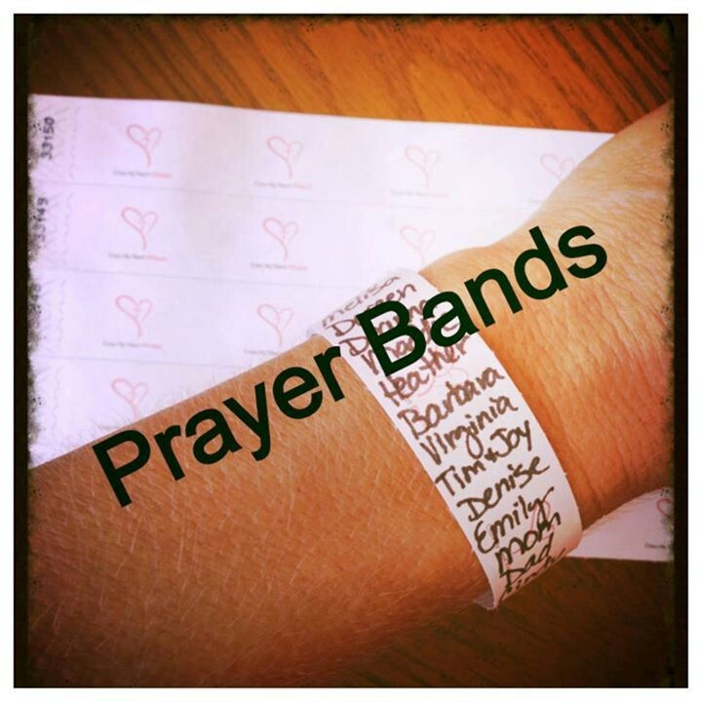

**Closing activity:** Decode Jesus Prayer, Handout “Candon Grille” decoder for mailed postcard for students to take home. Demonstrate how to use.

**Upper Elementary/Middle School Curriculum Option:**

Special Agents of Christ, A Prayer Book for Young Orthodox Saints

$8.21 each from Ancient [faith.com](http://faith.com) (<http://store.ancientfaith.com/special-agents-of-christ/>)

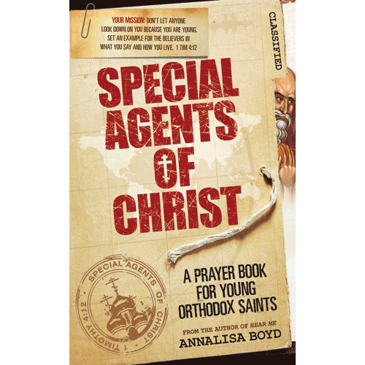

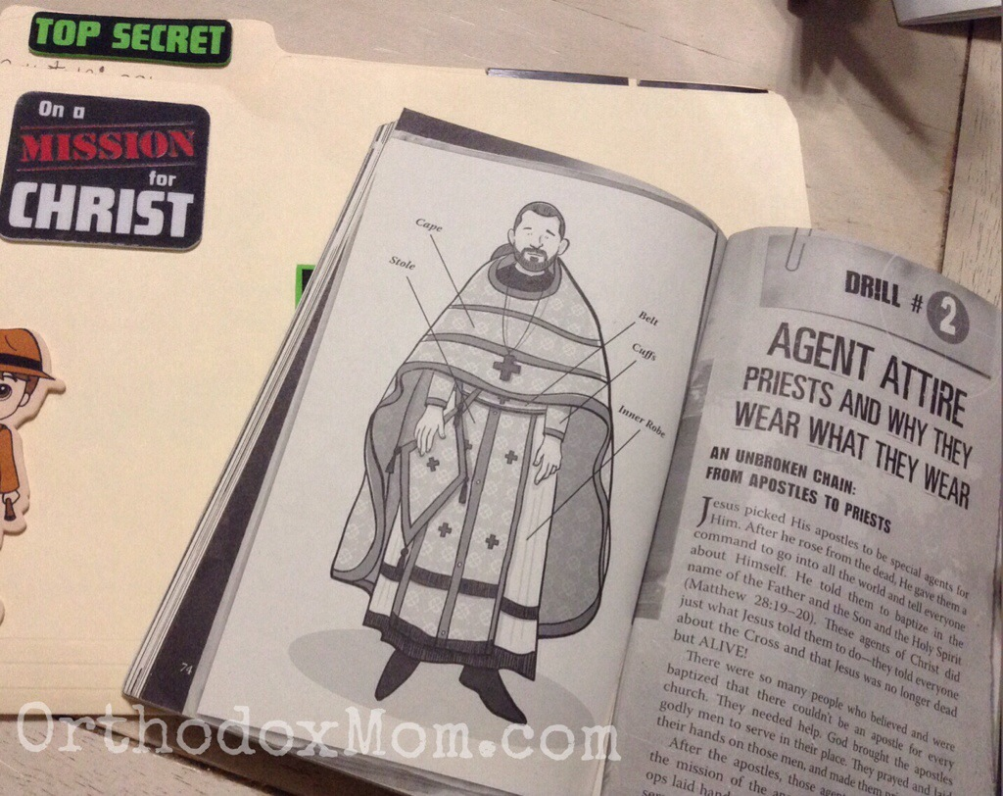

**Additional Activity Examples:**

**Prizes/Snacks for students:**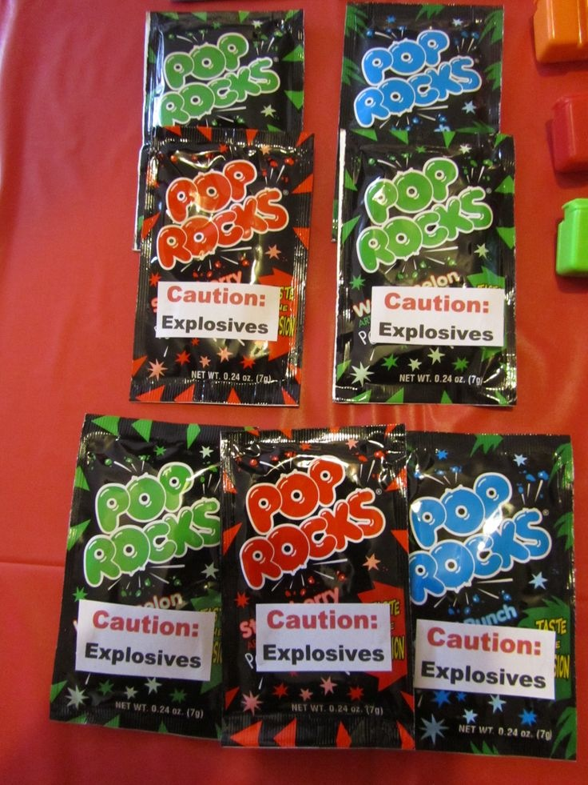

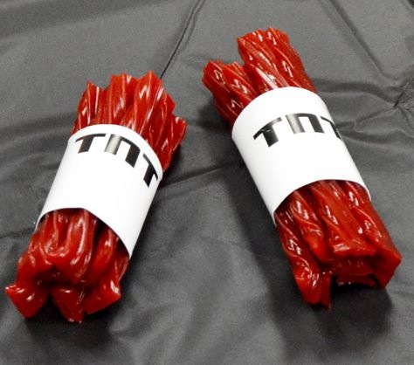

Pop Rocks “Explosives” Twizzler “Dynamite”

**Themed games** (tie in with curriculum)

Scratch off mystery tickets Pop “bomb” balloons, (contain paper with   
 code inside related to lesson as intro)