2026 spiritual retreat registration form info
This is the link to the registration form:
https://pci.jotform.com/atlmetphilop/spiritual-retreat-registration-form
This is the QR code to link the registration form:
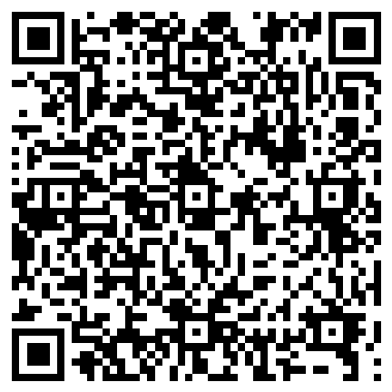
This is the imbed code for the website for the QR code:
<a href="https://pci.jotform.com/atlmetphilop/spiritual-retreat-registration-form" rel="no-follow"><img src="https://www.jotform.com/uploads/atlmetphilop/form_files/260046142428147_1767642877_qrcode_muse.png" width="100%" style="max-width: 200px" alt="QR Code for Jotform form"/></a>
This is the App to access the registration form:
Link to App with forms
https://www.jotform.com/app/Atlanta_Metropolis_Philoptochos/spiritual_retreat

