The Poor Clare Colettines of Roswell share their Joy
in Eucharistic Celebrations…

Sister Mary Paul of the Good Shepherd celebrated her fiftieth anniversary of profession on January 25, 2018. Bishop Oscar Cantu celebrated the public Mass of Jubilee for our golden jubilarian on Thursday, February 1, 2018. The photo shows Bishop Cantu with Sister Mary Paul at the Communion doors after the Mass.

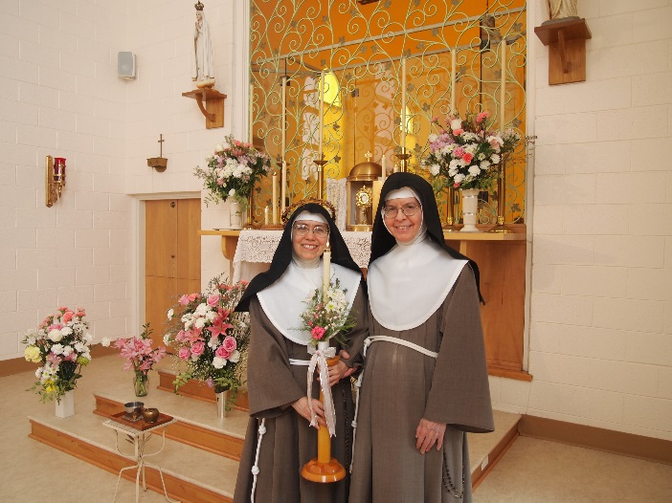
Mother Vicaress Mary Therese of the Queen of Heaven celebrated her silver jubilee on July 16, 2018, the memorial of Our Lady of Mount Carmel and the day traditionally given as the birthday of Mother St. Clare. Sister Mary Therese wore the crown of thorns that she received at her solemn profession of vows. The photo shows Sister Mary Therese and the Mother Abbess, Mother Mary Angela, in choir before the Blessed Sacrament.

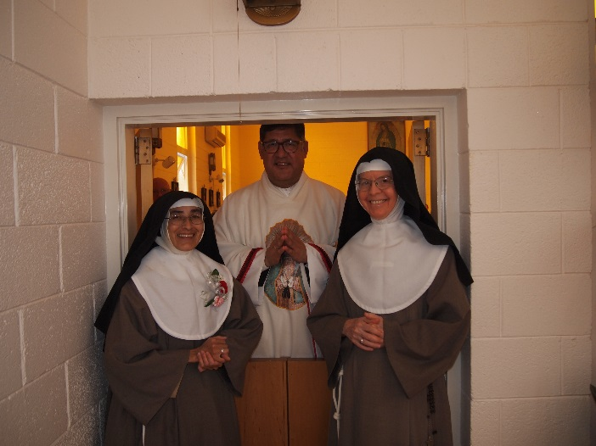
On October 8, 2018 Sister Rose Marie celebrated her silver jubilee with Father Enrique Lopez-Escalera, Chancellor of the Diocese of Las Cruces, as principal celebrant. The photo shows Sister Rose Marie with Father Enrique and Mother Angela at the Communion doors after the Mass.

