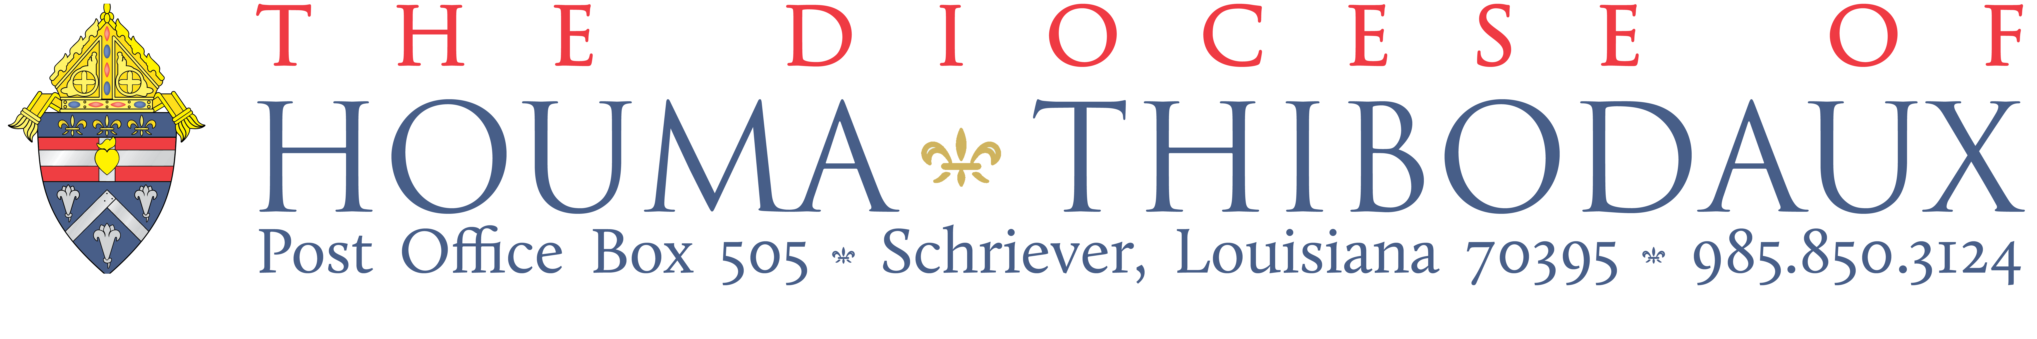

ADULT FORMATION TEAM CHARTER – DRAFT

Charter Element | Element Description
1. Rationale (Why) | The Adult Formation Team has been formed primarily as a means to assist the pastor with implementation of small groups. Establishing small groups is an essential aspect within reaching the parish’s strategic planning goal for Adult Formation at <Name of Parish>.  See attachment A: Adult Formation Action Plan
2. Purpose and Key Responsibilities (What) | The purpose of the Adult Formation Team is to be the primary means of implementation of parish-based Small Group Adult Faith Formation at <Name of Parish>, as outlined in the parish’s strategic plan.  The Adult Formation Team will include the following key responsibilities:  - Meeting as an Adult Formation Team for the purpose of on-going formation to grow in understanding of: the Formation Life Cycle (a “discipleship model” for the parish, as well as to learn more about small group dynamics and facilitation, etc.)  - Assist the pastor and Implementation Team with on-going recruitment of small group leaders, small group hosts and new small group members  - Provide orientation meetings and training for new small group leaders and small group hosts  - Assist in forming small groups, as well as monitor their “health”, providing ongoing support  - Provide ongoing monitoring of small groups and work to add no less than {#} new small groups per year, as outlined in the parish strategic plan  - Provide on-going assessment and discernment of the small group process to the assigned member of the Implementation Team so to assist the pastor in recognizing “what’s working?” or “what do we see God doing?"

3. Operational Guidelines and Norms (How) | Decision Making Guidelines: Decisions by the Adult Formation Team will be made by working toward consensus with the final decision to be made by the Pastor. Major concerns will be aired during the meetings by members. After the decision is made, it will be fully supported by each member.  Meeting Structure: The Adult Formation Team will meet at least once a month to:  - Receive initial and ongoing formation regarding communal discernment, the Formation Life Cycle, and best practices as related to parish adult faith formation  - Pray and discern together  - Plan for all steps needed for implementation and oversight of small groups  Norms:  - Assume positive intentions  - Be candid and respectful  - If you have concerns or hear about concerns of someone on the team, bring it to the person or team as appropriate.
4. Committee Sponsors, Leaders and Members (Who) | Sponsors, Leaders and Members:  - Sponsors: {Name of Pastor}, Pastor  - Adult Formation Team Leader: {Name of lay leader}  - Person to lead the meetings: {Name of person}  - Timekeeper: Rotated  - Team Members: [list members below]
5. Initial Focus and Outcomes | Vision: Adult Formation Teams will have a firm understanding of the unified Diocesan vision: “The purpose of the parish is to make disciples of Jesus Christ.” Adult Formation Teams will understand the Formation Life Cycle (“The 5”), the flow therein and how it serves the architectural framework for parish-based evangelization.  Discernment: Adult Formation Teams will learn the practice of communal discernment. They will have a basic comfort with communal discernment and understand how it is to serve as the normative method of decision making.  Establishing Small Groups: Adult Formation Teams will feel confident in all necessary steps for setting up small group as well as providing initial training, monitoring and ongoing support them.

