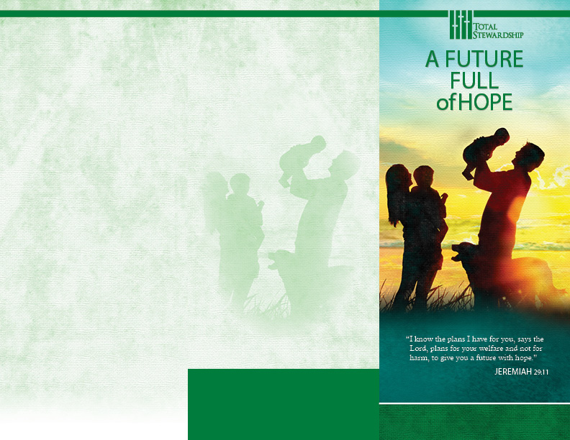
A Message from Mark’s Gospel,
On the Nature of Sacrificial Giving:

NOTE THE EXAMPLE OF A POOR WIDOW

Jesus sat down opposite the treasury and observed how the crowd
put money into the treasury.
Many rich people put in large sums. A poor widow also came
and put in two small coins worth a few cents.

Calling his disciples to himself, he said to them,

“Amen, I say to you,
this poor widow put in more than all the other contributors to the treasury.

For they have all contributed from their surplus wealth, but she, from her poverty, has contributed all she had, her whole livelihood.”

MARK 12: 41-44
“Each must do

as already determined, without sadness
or compulsion, for God loves
a cheerful giver.”

2 CORINTHIANS 9:7

PARISH NAME
ADDRESS
CONTACT

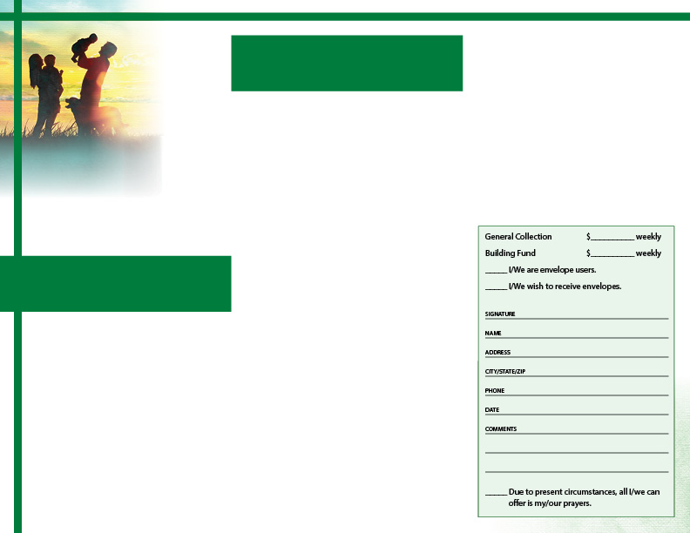
“I have never
We Invest in a Hopeful Future.
From the Blessings God Grants,
We Give to Bless Others

wanted
anyone’s

silver or gold
or clothing. You know well that these very
hands have served my needs and my
companions. In every way I have shown you that by hard work of that sort we must help the weak, and keep in mind the words of the Lord Jesus who himself said, ‘It is more blessed to give than to receive.’ ”

ACTS 20:33-35
Focused on Others’ Needs, We Give. Jesus Taught It. St. Paul Taught It. Investing in Others, We Honor God.

Per Income | 3% | 5% | 6% | 8% | 10% | ADDRESS CITY/STATE/ZIP
100.00 | 3.00 | 5.00 | 6.00 | 8.00 | 10.00
200.00 | 6.00 | 10.00 | 12.00 | 16.00 | 20.00 |  | PHONE
300.00 | 9.00 | 15.00 | 18.00 | 24.00 | 30.00
400.00 | 12.00 | 20.00 | 24.00 | 32.00 | 40.00 | DATE  COMMENTS  Due to present circumst is my/our prayers.
500.00 | 15.00 | 25.00 | 30.00 | 40.00 | 50.00
600.00 | 18.00 | 30.00 | 36.00 | 48.00 | 60.00
700.00 | 21.00 | 35.00 | 42.00 | 56.00 | 70.00
800.00 | 24.00 | 40.00 | 48.00 | 64.00 | 80.00
900.00 | 27.00 | 45.00 | 54.00 | 72.00 | 90.00
1000.00 | 30.00 | 50.00 | 60.00 | 80.00 | 100.00

FIVE ASPECTS OF FINANCIAL STEWARDSHIP
Please keep in mind five aspects of sound financial
stewardship. Giving is planned, the product of thoughtful reflection. Whether modest or generous, giving is proportional too, a dedicated amount of your regular income. From the very best we have to offer, giving is also sacrificial. And, giving is free— neither coerced, nor conditional. Most importantly, giving is an act of prayer.

A PERCENTAGE OF GOD’S BLESSING
To help determine your level of planned giving, you
may find the following chart helpful. Please make a prayerful commitment and one that reflects God’s blessing in your life.
Please complete your commitment card, detach it from this form, and then return it during Mass next week. Or, if you prefer, simply mail your completed card directly to the church office.

In prayerful gratitude for the many blessings God has given, and in wise stewardship of those gifts, I/we offer my/our intent to contribute to the support of our parish, trusting God for the health and the ability to do so.

“It is more blessed to give than to receive.” We know the words, their sentiment, and expect it was likely Jesus who first said them. It is a bit surprising, then, to discover St. Paul quoting them, recorded for us in the Acts of the Apostles, and not in one of the Gospel narratives.

Our spiritual mentors remind us that Jesus spoke on the subject of finances more often than on almost any other subject. We quote the Lord; clearly Paul did as well. Jesus devoted himself to serving others, and the blessedness of giving follows that example. When we give of our resources, we honor Christ.

