Key words to remember about the Mass:
Mass: Another name for the celebration of the Eucharist
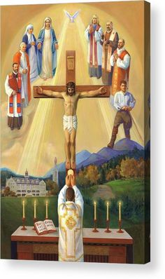
Eucharist: the Sacrament of the Body and Blood of Jesus
Church: All the people who believe in Jesus
These are some things we see in the Church
Tabernacle: The special place in the church in which the Blessed Sacrament is kept
Altar: the table in the church where the bread and the wine are consecrated by the priest
Chalice: the large Cup that holds the wine during Mass
Holy Communion: when we receive the Body and Blood of Jesus
Sanctuary Lamp: The Candle that is lit when the Blessed Sacrament (Jesus) is in the Tabernacle
Ambo: the pulpit in the Sanctuary where the Lector stands to read Scripture
Crucifix: the Cross that has Jesus’ body on it
See how many of these you can find in the picture below

