Dear Reps,

Welcome to the ninth edition of our Y+FE bi-monthly newsletter! The previous eight editions of the Y+FE newsletter can be accessed on the Y+FE Newsletter webpage.

Through June 2025, (on the 2nd & 4th Thursdays of the month) we will be featuring both research-based and action-oriented tools to assist your team in its effort to effectively engage the youth and families in your faith communities. Each edition will also feature someone from one of our diocesan parishes or schools who will share a Y+FE experience, along with their contact information should you wish to get in touch with them. Please let me know if you have an experience to share with your fellow reps.



RESEARCH: register to attend “Jubilee: Biblical Roots and Implications for the Family” - Sunday of the Word of God – January 26, 2025 from 1-3:30 pm

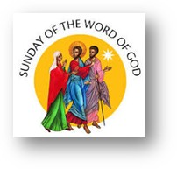
The Church observes the 3rd Sunday in Ordinary Time as the Sunday of the Word of God. Since its inception, our diocese has kept this celebration by offering an afternoon of reflection on the scriptures. This year, we will explore the theme of Jubilee and how it intersects with our diocesan synodal focus: youth and family engagement. The title of our afternoon of reflection is: “Jubilee: Biblical Roots and Implications for the Family.” Our presenters will be Rev. Dr. Matthew Coomber and Dr. Ella Johnson, both from the St. Ambrose theology faculty. Join us in-person at the chancery (780 W. Central Park, Davenport) or via zoom from 1 to 3:30 in the afternoon. For more information, or to register for our session, please visit: https://www.davenportdiocese.org/sunday-of-the-word-of-god.

ACTION: Questions of the Week – Share this link or its content with households in your parish or school.

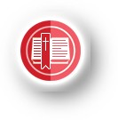
Lifelong Catechesis
Forming Catholic identity across generations

Questions of the Week from Our Sunday Visitor offers step by step instruction and faith conversation building questions for children, youth and adults based on the Sunday readings. You may also want to check out OSV’s Activity of the Week and Saint of the Week for use in your parish or school communities. All of these resources are free and available in both English and Spanish.



Hannah Campbell, Director of Religious Education, St. Joseph Church, West Liberty, shares her experience:
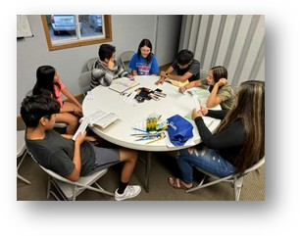
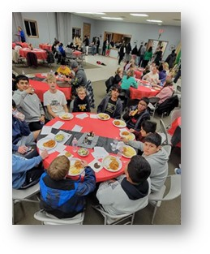
St. Joseph’s in West Liberty has been busy growing their Faith Formation program with a big emphasis on family-centered activities. Thanks to a grant from Catholic Extension, St. Joseph’s has launched a new program called Family Faith Nights. Family Faith Nights are for families of all ages and sizes and includes a 20-30 minute lesson followed by a free dinner. Lessons are taught in both English and Spanish and have covered topics like God’s Never-ending Promises and the Nativity. This program has served over 100 families and will continue through December 2025. St. Joseph’s is excited to bring families together in communion and fellowship!
Contact Hannah at 319-541-0838 or
stjoesreligiouseddirector@gmail.com .

Click here to unsubscribe from the Y+FE newsletter

Blessings,

Marianne

Marianne Agnoli, MPH, MPTh
Marriage & Family Life Coordinator
Diocese of Davenport
780 West Central Park Ave.
Davenport, IA 52804
Office: 563-888-4242
Cell: 563-676-9745

