C:\Users\AgnoliM\Dropbox\Camera Uploads\2011-10-25 10.38.58.tif

**DIOCESE OF DAVENPORT**

**Natural Family Planning Resources**

**Billings Ovulation Method Online Instruction (English & Spanish)**

Live online classes with a certified instructor are available. A listing of online instructors are available at <https://boma-usa.org/learn-remotely/> Costs may vary.

[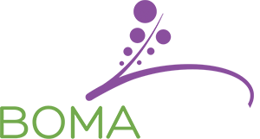](http://boma-usa.com/index.php)

**Billings Ovulation Method Instructors**

**Marianne Agnoli, MPH, MPTh**

780 West Central Park, Davenport, IA 52804

563-888-4242

[agnolim@davenportdiocese.org](mailto:agnolim@davenportdiocese.org)

**Yolanda Bello Bogdanyi (English & Spanish**)

Council Bluffs, IA

712-322-5378

[ybnfp@live.com](mailto:ybnfp@live.com)

**Brenda DeLathouwer, CFC**

Cycle Solutions LLC – Moline, IL

309‐269‐0797

[bdelath@yahoo.com](mailto:bdelath@yahoo.com)

**Betty McGehe, MSN, ARNP, FNP‐C**

Norwalk, IA

515‐961‐8098 or 515‐240‐2751 (cell)

[bmcgehe@aol.com](mailto:bmcgehe@aol.com)

**Couple to Couple League (Sympto-thermal) Method – Online Instruction (English & Spanish)**

Couple to Couple League (CCL) offers two on-line options for those couples who do not have a local CCL Teaching Couple, or for those whose schedule prevents them from attending local instruction. Couples will receive the same materials as those attending on site classes, plus access to professional chart reviews until confident in their method skills.

* Self-Paced Online - $135
* Live Class Online (check website below for dates and times) - $135 <https://ccli.org/>

**Couple to Couple League Instructors**

**[](https://ccli.org/)**

**Al and Beth Budelier**

Davenport, IA

563-324-7040

[elizabethimel@yahoo.com](mailto:elizabethimel@yahoo.com)

**Nick and Jessica Ragsdale**

2950 Pleasant Ridge Ct.

Bettendorf, IA 52722

(563) 343-6809

[jessicamartin84@gmail.com](mailto:jessicamartin84@gmail.com)

**Elizabeth and Thomas Riester**

Cedar Rapids, IA

563-571-0027

[riesterte@gmail.com](mailto:riesterte@gmail.com)

**Laura and Carlos Moreno (Spanish)**

St. Mary Catholic Church - Moline, IL

309- 764-1562

[Lauramoreno28@yahoo.com](mailto:Lauramoreno28@yahoo.com)

**Additional CCL instructors and class schedules at** [www.ccli.org](http://www.ccli.org)

**Creighton Model (In Person or Remote Skype Instruction)**

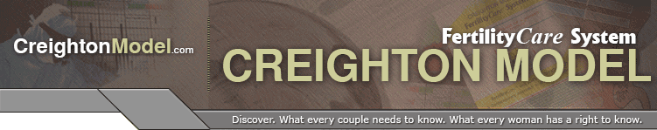

**Tommi Hutchins, FCP**

Whole Life Fertility Awareness

Cedar Rapids, IA

319-440-8277

[wholelifefa@gmail.com](mailto:wholelifefa@gmail.com)

**Linda Jacobs, FCP**

FertilityCare Services of Central Iowa - Marshalltown Satellite Center

Marshalltown, IA 50158

641-753-5965

[ljacobs_2@mchsi.com](mailto:ljacobs_2@mchsi.com)

**Cassidy Kuhn, CFCP**

**Via Veritas Fertility**

Iowa City, IA

319-929-2224

[Viaveritasfertilitycare.com](https://linkprotect.cudasvc.com/url?a=https%3a%2f%2fViaveritasfertilitycare.com&c=E,1,xQo8DhchDTcw91SpTNzWgdvPBFEVch1nh1iBWzOxeFskL4l7FSERClmrF9hjIKgHH7PpEh5m9tdRhrhZPq7FY0wuXd8sJ_pvagvk35Olhcpe7-_CXg,,&typo=1&ancr_add=1)

[viaveritasfertility@protonmail.com](mailto:viaveritasfertility@protonmail.com)

**Rebecca Luoma, FCP**

3665 Ketstone Dr.

Dubuque, IA

563-580-9277

[rebeccaluoma@hotmail.com](mailto:rebeccaluoma@hotmail.com)

**Michelle McKernan, MA, FCP**

Vitae Family Care Clinic

1355 50th St., Suite 100

West Des Moines, IA 50266

515-225-3261

**Jamie Rathjen, FCP**

Fiat FertilityCare Center

220 Southbrooke Dr.

Waterloo, IA 50613

319-464-6072

[cvfiatfertility@gmail.com](mailto:cvfiatfertility@gmail.com)

**Creighton Model - (In Person or Remote Skype Instruction) continued**

**Dr. Marie Ripslinger-Atwater, D.C., M.S., FCP**

**Ripslinger Family Chiropractic**

4217 N. Ripley St.

Davenport, IA 52806

563-505-8578

[drmariedc@gmail.com](mailto:drmariedc@gmail.com)

**Sheryl Schwager, FCP**

Agápe FertilityCare

Iowa City, IA

319-855-8475

[agapefertility@gmail.com](mailto:agapefertility@gmail.com)

[agapefertilitycare.com](https://linkprotect.cudasvc.com/url?a=http%3a%2f%2fagapefertilitycare.com&c=E,1,tomK9oRui-rp1o_O8Zjb4Z60znyvRFr3I1JJVtLv3Tw_S9hcxqfVLK_sO3dwxac3Kp8tlKU2nuk48fqaHMyZvsN3l9GZB9H76GUo7lNO7zc4Jw,,&typo=1)

**Meredith Simon, FCP**

Fiat FertilityCare Center

5073 15th Avenue Drive

LaPorte City, IA 50651

319-830-1470

[merkoz_85@hotmail.com](mailto:merkoz_85@hotmail.com)

**Cassandra White, BS, FCP**

Vitae Family Care Clinic

1355 50th St., Suite 100

West Des Moines, IA 50266

515-225-3261

[Cassandrawhite1212@gmail.com](mailto:Cassandrawhite1212@gmail.com)

**Family of the Americas – (In Person Spanish & English)**

**Anna & Gerardo De La Torre**

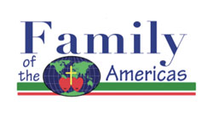439 Appanoose St.

Ottumwa, IA 52501

641-208-2146 (Anna) 641-455-6576 (Gerardo)

[AnaR8127.ar@gmail.com](mailto:AnaR8127.ar@gmail.com) [Delatorre_1163@yahoo.com](mailto:Delatorre_1163@yahoo.com)

**Nely & Juan De La Torre**

439 Appanoose St.

Ottumwa, IA 52501

641-208-4306 (Nely) 641-455-6004 (Juan)

[rodrigueznelly237.87@gmail.com](mailto:rodrigueznelly237.87@gmail.com)

**Marquette Method Online Instruction (English & Spanish)**

**Marquette Registration Process for Couples**

The Marquette Method offers a variety of class options and services. Online classes are conducted through a secure video meeting platform. All class options include individual follow-up for a minimum of 1 full year, and course documents are included. Fertility testing supplies are not included: you do not need to have a fertility monitor before taking a class. <https://www.mmnfp.com/learn>

[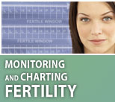](http://nfp.marquette.edu/charting_monitoring_intro.php)**Marquette Method Instructors**

**Julie Cutler RN, MSN, IBCLC**

Davenport, IA

563‐505‐9857

[lcqueen@mchsi.com](mailto:lcqueen@mchsi.com)

**Bethany Smith, MSN, RN, MMCP**

Online / Distance Learning

918-932-6005

[bethany.smith@vitaefertility.com](mailto:bethany.smith@vitaefertility.com)

(Also teaches FEMM)

**Kelsey Vukov, MS, RN**

Online / Distance Learning

515-689-6280

[kelseyvukov@gmail.com](mailto:kelseyvukov@gmail.com)

**Online Self Paced or Live Online Sessions - $15 fee**

**[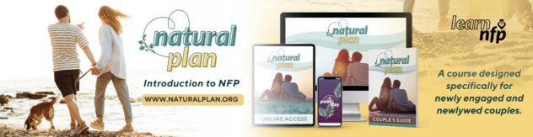](https://ccli.thinkific.com/courses/natural-plan-review)**

An introduction to Natural Family Planning, different methods and benefits of NFP. Couples to learn at their own pace online. Introductory pricing that is subject to change.

Course includes:

* Online Access to 10 Video Modules
* 5 Bonus Modules
* Natural Plan Couple’s Guide Mailed to You
* Natural Plan Downloadables
* 60 Days Free of PeakDay App
* Free Fertility Coaching Consult

**Preview this product**[**here**](https://ccli.thinkific.com/courses/natural-plan-online)**.  
Purchase**[**here**](https://learnnfp.org/product/natural-plan-online/)**.**

**Natural Plan Online - Live**

An introduction to Natural Family Planning, different methods and benefits of NFP. Couples to learn online via Zoom with a live teaching instructor. Introductory pricing that is subject to change.

Course includes:

* Online Access to Video Modules
* 5 Bonus Modules
* Natural Plan Couple’s Guide Mailed to You!
* Natural Plan Downloadables
* 60 Days Free of PeakDay App
* Free Fertility Coaching Consult
* Live Instructor

There will be some modules that need to be completed on your own before and after your Live Online session.

**Preview this product**[**here**](https://ccli.thinkific.com/courses/natural-plan-live)**.  
Purchase this product**[**here.**](https://learnnfp.org/product/natural-plan-live-online/)

**Introductory Videos**

***Plan Your Family Naturally – Introduction to Natural Family Planning***

DVD & Study Guide (English & Spanish)

Available for purchase through Diocese of Rockville Centre – Office of Faith Formation: English <http://drvc-faith.mybigcommerce.com/faith-formation-videos/>

Spanish <http://drvc-faith.mybigcommerce.com/espa-ol/>

**Additional NFP Distance Learning Resources**

<http://www.usccb.org/issues-and-action/marriage-and-family/natural-family-planning/nfp-distance-learning.cfm>

**Questions? Contact:**

**Marianne Agnoli, MPH, MPTh**

**563-888-4242**

[**agnolim@davenportdiocese.org**](mailto:agnolim@davenportdiocese.org)