DIOCESE OF DAVENPORT
Natural Family Planning Resources

Billings Ovulation Method Online Instruction (English & Spanish)

Live online classes with a certified instructor are available. A listing of online instructors are available at https://boma-usa.org/learn-remotely/ Costs may vary.

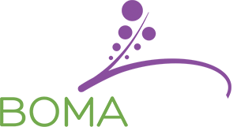

Billings Ovulation Method Instructors

Marianne Agnoli, MPH, MPTh
780 West Central Park, Davenport, IA 52804
563-888-4242
agnolim@davenportdiocese.org

Yolanda Bello Bogdanyi (English & Spanish)
Council Bluffs, IA
712-322-5378
ybnfp@live.com

Brenda DeLathouwer, CFC
Cycle Solutions LLC – Moline, IL
309‐269‐0797
bdelath@yahoo.com

Betty McGehe, MSN, ARNP, FNP‐C
Norwalk, IA
515‐961‐8098 or 515‐240‐2751 (cell)
bmcgehe@aol.com

Couple to Couple League (Sympto-thermal) Method – Online Instruction (English & Spanish)

Couple to Couple League (CCL) offers two on-line options for those couples who do not have a local CCL Teaching Couple, or for those whose schedule prevents them from attending local instruction. Couples will receive the same materials as those attending on site classes, plus access to professional chart reviews until confident in their method skills.
- Self-Paced Online - $135
- Live Class Online (check website below for dates and times) - $135 https://ccli.org/

Couple to Couple League Instructors

Al and Beth Budelier
Davenport, IA
563-324-7040
elizabethimel@yahoo.com

Nick and Jessica Ragsdale
2950 Pleasant Ridge Ct.
Bettendorf, IA 52722
(563) 343-6809
jessicamartin84@gmail.com

Elizabeth and Thomas Riester
Cedar Rapids, IA
563-571-0027
riesterte@gmail.com

Laura and Carlos Moreno (Spanish)
St. Mary Catholic Church - Moline, IL
309- 764-1562
Lauramoreno28@yahoo.com

Additional CCL instructors and class schedules at www.ccli.org

Creighton Model (In Person or Remote Skype Instruction)

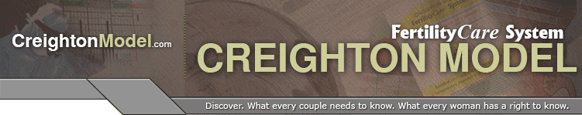
Tommi Hutchins, FCP
Whole Life Fertility Awareness
Cedar Rapids, IA
319-440-8277
wholelifefa@gmail.com

Linda Jacobs, FCP
FertilityCare Services of Central Iowa - Marshalltown Satellite Center
Marshalltown, IA 50158
641-753-5965
ljacobs_2@mchsi.com

Cassidy Kuhn, CFCP
Via Veritas Fertility
Iowa City, IA
319-929-2224
Viaveritasfertilitycare.com
viaveritasfertility@protonmail.com

Rebecca Luoma, FCP
3665 Ketstone Dr.
Dubuque, IA
563-580-9277
rebeccaluoma@hotmail.com

Maria Mendizabal (English & Spanish)
Guadalupe NFP LLC
319-382-5878
nfpguadalupe@gmail.com

Michelle McKernan, MA, FCP
Vitae Family Care Clinic
1355 50th St., Suite 100
West Des Moines, IA 50266
515-225-3261

Jamie Rathjen, FCP
Fiat FertilityCare Center
220 Southbrooke Dr.
Waterloo, IA 50613
319-464-6072
cvfiatfertility@gmail.com
Creighton Model - (In Person or Remote Skype Instruction) continued

Dr. Marie Ripslinger-Atwater, D.C., M.S., FCP
Ripslinger Family Chiropractic
4217 N. Ripley St.
Davenport, IA 52806
563-505-8578
drmariedc@gmail.com

Sheryl Schwager, FCP
Iowa City, IA
(319) 855-8475
sschw1@gmail.com

Meredith Simon, FCP
Fiat FertilityCare Center
5073 15th Avenue Drive
LaPorte City, IA 50651
319-830-1470
merkoz_85@hotmail.com

Cassandra White, BS, FCP
Vitae Family Care Clinic
1355 50th St., Suite 100
West Des Moines, IA 50266
515-225-3261
Cassandrawhite1212@gmail.com

Family of the Americas – (In Person Spanish & English)

Anna & Gerardo De La Torre
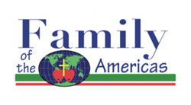
439 Appanoose St.
Ottumwa, IA 52501
641-208-2146 (Anna) 641-455-6576 (Gerardo)
AnaR8127.ar@gmail.com Delatorre_1163@yahoo.com

Nely & Juan De La Torre
439 Appanoose St.
Ottumwa, IA 52501
641-208-4306 (Nely) 641-455-6004 (Juan)
rodrigueznelly237.87@gmail.com

Marquette Method Online Instruction (English & Spanish)

Marquette Registration Process for Couples
The Marquette Method offers a variety of class options and services. Online classes are conducted through a secure video meeting platform. All class options include individual follow-up for a minimum of 1 full year, and course documents are included. Fertility testing supplies are not included: you do not need to have a fertility monitor before taking a class. https://www.mmnfp.com/learn

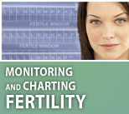
Marquette Method Instructors

Julie Cutler RN, MSN, IBCLC
Davenport, IA
563‐505‐9857
lcqueen@mchsi.com

Bethany Smith, MSN, RN, MMCP
Online / Distance Learning
918-932-6005
bethany.smith@vitaefertility.com
(Also teaches FEMM)

Kelsey Vukov, MS, RN
Online / Distance Learning
515-689-6280
kelseyvukov@gmail.com

Online Self Paced or Live Online Sessions - $15 fee
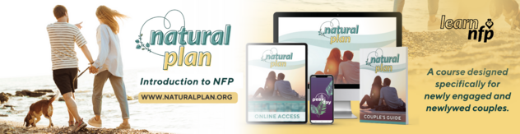
An introduction to Natural Family Planning, different methods and benefits of NFP. Couples to learn at their own pace online. Introductory pricing that is subject to change.
Course includes:
- Online Access to 10 Video Modules
- 5 Bonus Modules
- Natural Plan Couple’s Guide Mailed to You
- Natural Plan Downloadables
- 60 Days Free of PeakDay App
- Free Fertility Coaching Consult

Preview this product here.
Purchase here.

Natural Plan Online - Live
An introduction to Natural Family Planning, different methods and benefits of NFP. Couples to learn online via Zoom with a live teaching instructor. Introductory pricing that is subject to change.
Course includes:
- Online Access to Video Modules
- 5 Bonus Modules
- Natural Plan Couple’s Guide Mailed to You!
- Natural Plan Downloadables
- 60 Days Free of PeakDay App
- Free Fertility Coaching Consult
- Live Instructor
There will be some modules that need to be completed on your own before and after your Live Online session.

Preview this product here.
Purchase this product here.


Introductory Videos

Plan Your Family Naturally – Introduction to Natural Family Planning
DVD & Study Guide (English & Spanish)
Available for check out from the diocesan Faith Formation Media Library and select local parishes.

Additional NFP Distance Learning Resources

http://www.usccb.org/issues-and-action/marriage-and-family/natural-family-planning/nfp-distance-learning.cfm

Questions? Contact:

Marianne Agnoli, MPH, MPTh
563-888-4242
agnolim@davenportdiocese.org

