Deacon Convocation with Renewal of Diaconal Promises

October 17-18, 2026

Sacred Heart Cathedral - 422 E 10th St., Davenport, IA

Featuring Dr. Ken Novak

St. Ambrose University
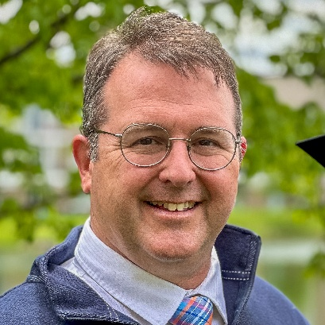

Ken attended the University of Notre Dame, where he found the love of his life, Amy. Upon graduation from ND, Amy and Ken got married, and Ken received a commission as an Air Force officer. Ken was medically retired from the US Air Force in 2003. Since then, he has been an adjunct college professor, a lay hospice chaplain, a high school varsity boys soccer head coach, and a stay-at-home dad to his and Amy’s eight children. Ken is an adjunct professor of philosophy for St. Ambrose, works as a staff member of Mercy One-Genesis hospice/bereavement support, and is the boys' assistant soccer coach at Pleasant Valley High School. Amy and Ken are members of St. Joan of Arc Parish (St. John Vianney Campus) in Bettendorf. Ken has spoken about faith for over thirty years in a variety of venues, including college athletics, retreats for religious orders, puppet shows with elementary school children, adults exploring Catholicism through OCIA, and sophomores preparing for Confirmation. Saturday morning coffee with Amy is one of his most cherished moments.
Our Theme:
"Shema: Holy Listening and Pastoral Response."
Sunday, October 18, 2026
8:00 Arrive, Continental Breakfast
8:30 Morning Prayer in Hall
9:00 Presentation
Noon Lunch

Departure after lunch

Saturday, October 17, 2026
12:30 Arrival (Lunch on your own)
1:00 Presentation
4:00 Mass with Bishop Walsh
with renewal of vows
5:00 Presentation
6:00 Dinner
6:45 Evening Prayer in Church
7:00 Social hour

Registration – Due by Sunday, September 15, 2026
Register on-line HERE:
https://www.davenportdiocese.org/deacon-convocation

If you cannot register on-line you may complete the registration below and send along with your check.

A block of rooms has been reserved at Hilton Garden Inn
959 Middle Road in Bettendorf, IA

Registration form: https://www.davenportdiocese.org/deacon-convocation

Hotel room cost is included in the registration categories below:

Deacon couple at hotel $300.00 □  Single at hotel $250.00 □ 

1 King Bed □ OR 2 Queen Beds □
--------------------------------------------------------------------------------------------------------------------------------
Deacon couple at home $200.00 □  Single at home $150.00 □ 
--------------------------------------------------------------------------------------------------------------------------------

Attendee Names: _____________________________________________________________________

Any special needs / dietary requirements? _______________________________________________________

Please REGISTER ON-LINE and have your parish send a check made payable to the Diocese of Davenport to:
Jeff Schuetzle
Diocese of Davenport For more information contact:
780 W Central Park Ave. Deacon Jeff Schuetzle; schuetzle@davenportdiocese.org
Davenport, IA 52804-1901 or : (563) 219-3402

NOTE: Diaconate Director will handle the hotel reservations, do NOT call the hotel.

