
accreditation visitation Summary Report


2025-2026
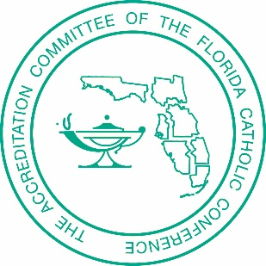
School

Date

Team Members

Mission, Vision, and Philosophy

- Key Phrases: What did the team witness, read, hear, see, experience at this school? In the work on Accreditrac? Through observations and conversations?

- One Word: Include all the words collected throughout the review and visitation

- MVP Validation/Recommendations: based on the full review and site visit, what validations and/or recommendations or comments does the team have?

Classroom Observations (brief summary and feedback)

Benchmarks with a Different Rating (list the benchmarks and explain why the rating is different)

Action Plan (any validations, recommendations, and comments)

Validated Strengths (what has the school done that deserves note)

Recommendations
Immediate Attention: any safety or scholarship compliance areas that must be addressed this school year

Recommendations: practice or procedural recommendations based on accreditation standards and Catholic educational best practices that the school should definitely review/implement in the coming three years

Opportunities for Growth: practice or procedural suggestions based on standards and Catholic educational best practices that the school should consider, but is a lower priority

-----------------------------------------
These responses are for FCCAP use only and will not be included in the final report given to the school.

Did the school follow the Continuous Improvement Process for Accreditation?
Were all of the staff involved in the process in some way?
Do you recommend the school for continued full accreditation? If not, why not?

