Assistant
Before Mass, set out as follows:
Hosts in the ciboria (gold host dish); place on table at back.
Wine (amounts posted in the cupboard) in pitcher; place at back.
Credence table:
Priest’s chalice with purificator draped over the top, paten with large host, pall on top with 2 corporals.
Pitcher with water, bowl, towel
4 purificators
4 chalices
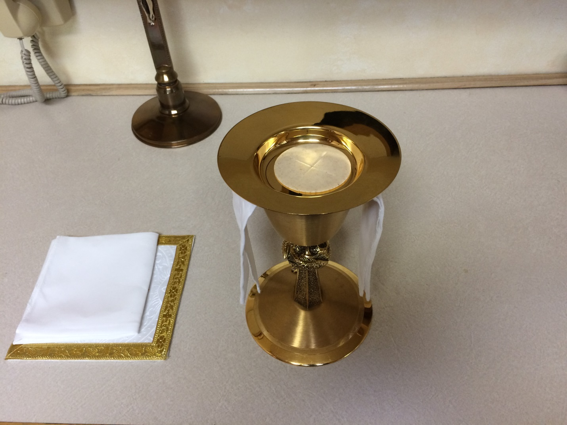
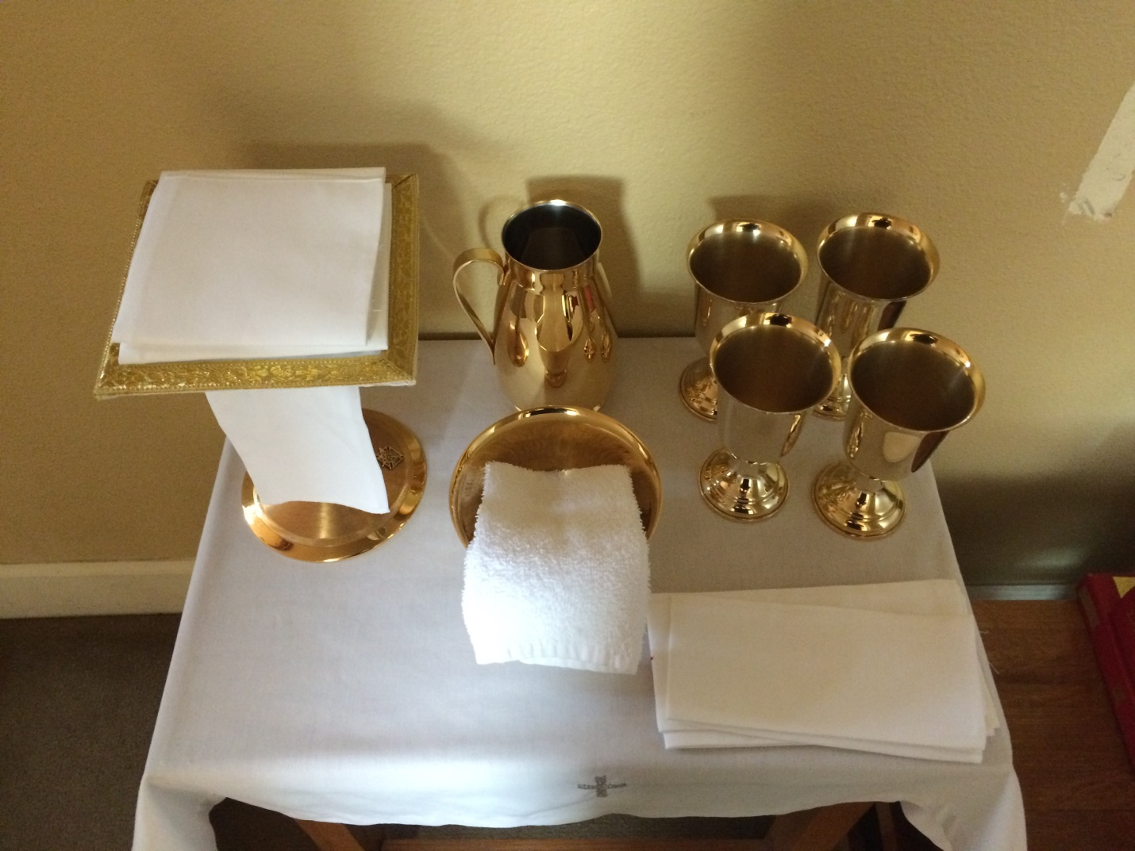
At the Sign of Peace, come up, bow to the altar, come into the sanctuary, stand behind the priest.
Priest will give you Communion under both species. Wait for him to bring your ciboria to you. Please do not take it off the altar.
When giving Communion, say, “The Body of Christ.” If someone approaches you for a blessing, here is an option, said with a cross or touch on their forehead or shoulder, “Until the day you receive our Lord in Holy Communion, may He bless and keep you.”
When done, bring ciboria to Father. He will combine it with his; place ciboria in Tabernacle, shut the door, dip your fingers in the little finger dish, go to the sacristy, rinse your hands, leave with the other ministers.
After Mass, put vessels away as shown on the pictures. If you are at Sunday morning Masses, they can be left out for the next Mass. Used linens go in the cupboard under the sacrarium.

