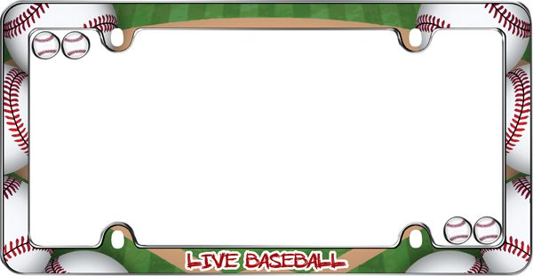

**Name** ___________________________________________________________________________

**Email**___________________________________________________________________________

**Phone number** _________________________________

**Number of Tickets**________________

**Payment:** ____**Cash** __________**Check** ________**Givebutter:**

[**https://givebutter.com/TrentonThunder**](https://givebutter.com/TrentonThunder)

____**Send tickets home with my child** _____**Pick up tickets**

**Contact Lisa Honnig** [**saintpaulburlington@gmail.com**](mailto:saintpaulburlington@gmail.com) **with questions**

**\*\*Please make checks out to St. Paul PTA**

***Join the Knights of Columbus #589 and***

***St. Paul School, Burlington***

For a night of fun, baseball and FIREWORKS!

Bring the whole family and friends too- EVERYONE’S WELCOME!

***Trenton Thunder vs. Williamsport Crosscutters When:*** Saturday, July 30th at 6:30pm

***Where:*** Trenton Thunder Ball Park, 1 Thunder Rd.,

Trenton, NJ

***Cost:*** $10 a ticket-please place order by July 24h