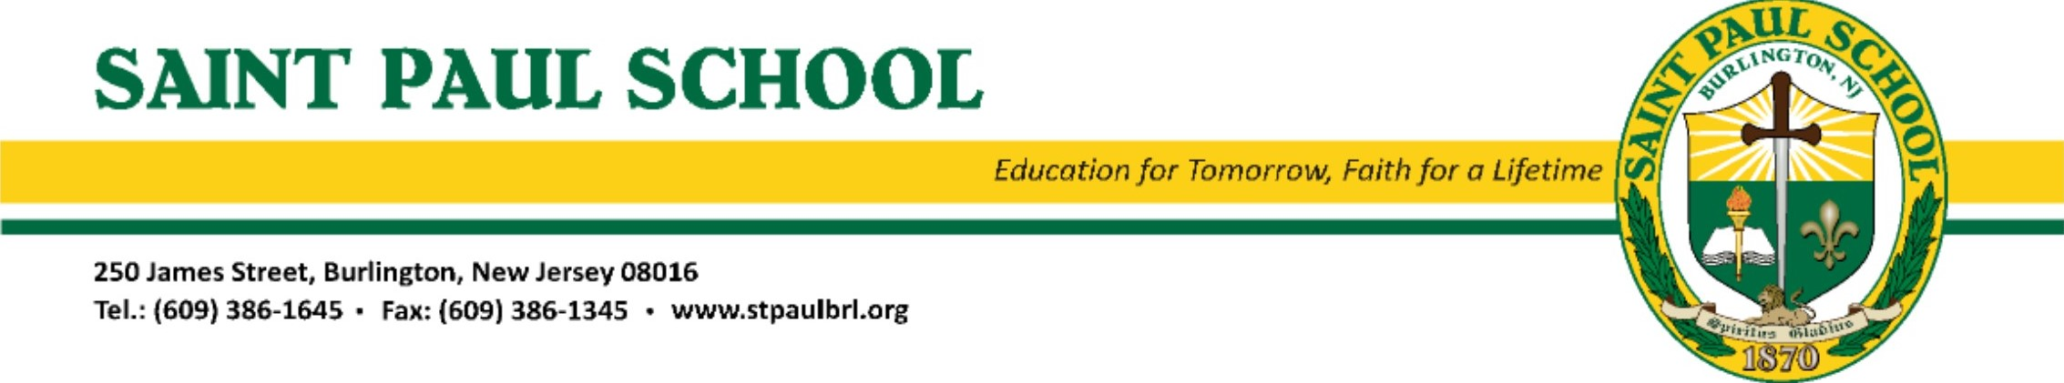
euc
Crafters, Direct Sellers, and Small Business Owners:
Reserve your spot now for St. Paul School's Indoor Marketplace, which is scheduled for Sunday, November 20, 2022. The school gym will host Crafters, Direct Sellers and Small Business Owners from 9:00am to 1:00pm. Set-up time will begin at 7:00am.
The cost to rent a space and bring your own table(s) is $35.00 per spot. The cost to rent a space and have a table provided is $50.00 per table/spot. Rental fees shall be submitted in advance along with your reservation request. At this time, we can accept cash or check (payable to St. Paul PTA) mailed to the school, as noted below. If you wish to pay online, please visit https://givebutter.com/SPSIndoorMarketplace. Please be sure to indicate if you are renting a table. If you do not request and pay for a table, one will not be provided for you. This is a fundraising event to support education, no refunds will be issued if the event is cancelled.

Reservation deadline is Monday, November 6th, 2022.
Masks/face coverings are optional.
If you have any questions, please email Barbie Nicolai at pta@stpaulbrl.org.

-------------------------------------------------------------------------------------------------------------------------------------------------------------
Saint Paul School Indoor Marketplace 2022 Table/Spot Reservation Request
Name:__________________________________________ Craft/Business:__________________________________
Address________________________________________________________________________________________
Phone:_________________________________________ Email:__________________________________________
___Spot(s) to be reserved– No Table Provided $35 per spot $________ Total Amt. ___Check ___Cash ___ Givebutter
___Spot(s) to be reserved – Table to be Provided $50 per spot $________ Total Amt. ___Check ___Cash ___ Givebutter

CHECKS PAYABLE TO ST. PAUL PTA
Please mail reservations to: Attn: Indoor Marketplace Chairpersons
250 James Street
Burlington, NJ 08016
Reservations will be on a first come, first served basis. Variation in vendors will be considered to avoid duplicate crafters or home consultants. Spaces are only guaranteed once completed reservation form AND deposit is received. I understand that this is a fundraising event & no refunds will be issued if the event is cancelled. Please retain the above portion of this form for your records.
By signing this reservation request I acknowledge my reservation is on a first come first served basis with a fully paid deposit for spaces reserved and I will repay incurred costs from returned check fees for insufficient funds for my reservation.
Crafter/Consultant Signature: ______________________________________________

