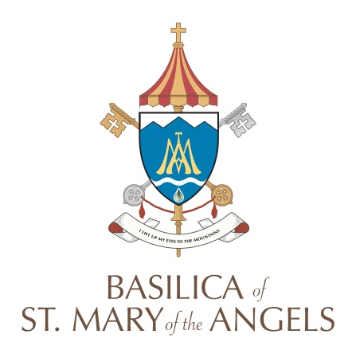
Parish Council Minutes
Tuesday, November 15, 2022

Mission Statement
To lead to the Kingdom of God by
Living and Nurturing the Good News of Jesus Christ

In Attendance:
Fr. John Adams Justin Smith, VP Frank Aloi
Sr. Regina Aman Joe McLarney Carol Autieri
Fr. Peter Bassey Andrew Caya Mary Cygan, Recording Secretary

Absent/Excused:
Jim Tkacik, Philippe Yates, Michael Matz, Deacon Matt Wenke, Naomi Butler, Lee Filbert, Tom Enright,
Buz Wenke, Mike Tominez, Varma Childs, Paula Snyder, Jim Brown, Ronni Gronemeier

I. Call to Order & Opening Prayer: The meeting was called to order by Justin Smith at 6:59 p.m.
Prayer was offered by Sr. Regina.

II. Roll Call: Secretary

III. Approval of Minutes from last Parish Council Meeting: The minutes of the October meeting were presented. Motion to approve the minutes was made by Frank Aloi and seconded by Fr. Peter Bassey. Motion carried.

IV. President’s Report: Justin Smith presided at the meeting.

V. Pastor’s Report: Fr. John Adams, Pastor/Rector
- Road to Renewal Update—There has been a slow down in the process and the activation date to know who the pastor of the families will be has been moved to January 15, 2023. The implementation of our Road to Renewal family will take place six months from January 15th.
- Social Christmas Gathering for the tri-Parish Councils is being planned for December. Fr. John will touch base with Fr. Michael Reyes from St. Bonaventure Parish.
- Future plans include a tri-parish Town Hall Meeting, socials and a needs assessment.
- Low parish attendance is being evaluated. There is a great need for volunteers. We want to encourage the growth of a vibrant parish. Announcements are being made at all parishes to dispel any rumors about the renewal process and personnel.
- We are looking for a Community Christmas Dinner Coordinator.

VI. Old Business:
1. Finance Committee: Joe McLarney
- October presented a positive cash flow
- Attendance is coming back slowly to pre-COVID records.
- The Catholic Campaign plaque in the back of the church is completed. The installation is to be decided.
- Spaghetti Dinner Fundraiser for the Oratory of the Sacred Heart: We lost $1,000 in raffle sales due to NYS raffle regulations this year but we made a profit of about $6,000 because sponsors and donations made a difference.
- Switching the conference room and Business Manager’s office is in progress.

BSMA Parish Council Minutes 2022
Page 2 of 3

2. Joint Operations Manager: Philippe Yates via E-mail
- The engineers met by Zoom last week (Hank Balling and Mike Sullivan plus structural engineers). A short report from Hank was forwarded to Fr. John. From a phone conversation with Hank, there are no immediate concerns about the stability of the steeples. There is no need for emergency netting. They recommend doing a 3-D drone survey this fall to identify any bulging stones. Probably next spring take some samples. The engineers will come up with a fee proposal within the next week or so. In short, no need to panic but a measured way forward being pursued. (Reasons why this has taken so long are due to backlog of tasks and that engineers were ill with COVID after their visit.)

3. Communications: Mary Cygan
- Basilica Tours are offered Fridays 1-2 p.m.
- 175th Anniversary DOB Guidebook: Treasures of Our Diocese was published online and shared on DOB Facebook and Western New York Catholic. Our Basilica is featured in this publication.
- Children of Fatima Chapel: List of items obtained regionally is now placed in the chapel.
- Copies of the Parish Pastoral Council Constitution will be shared with Parish Council via e-mail.
- Mary Cygan attended the “Life in the Eucharist” Workshop on October 29th in Buffalo. The program binder was shared with Fr. John.
- Eucharistic Exhibit will be traveling to St. Gabriel’s in Port Allegany for two weeks.

VII. Committee Reports:
Liturgy & Worship: Fr. John
- Dawn Both and Mary Lou Plesac are planning an ensemble and a children’s choir.
- We are looking for a Spiritual Life Committee Coordinator.
- Both parishes will have the Thanksgiving Mass at 9:00 a.m.
- Christmas Schedule is being worked on this week.

Faith Formation: Sr. Regina
- Faith Formation is going well.
- Jay and Ann Sorokes are leading Confirmation Class and they are planning Confirmation possibly in June.

Youth Ministry: Fr. Peter Bassey
- Fr. John met with youth teams: Young Adults/Youth Group--Fr. Peter & Mary Fofanah, Children’s Liturgy--Wendy Filbert, Confirmation--Jay Sorokes and Catechesis of the Good Shepherd & CVBC--Mary Cygan to brainstorm ideas and activities for the youth.
- Children’s Liturgy will be coordinating St. Nick’s Pizza Party on December 4th.

Stephen Ministry: Jim Freitag via E-Mail
- Stephen Ministry continues to meet twice a month with supervision groups. It also continues to instruct the new recruits via zoom. One parishioner is a Snowbird and the other is local. Zooming is working well for them and we are optimistic to complete their training by February. Our Stephens leader Bridge training continues and we hope to see two new leaders by the end of November. The bridges training is also via zoom from St. Louis. We currently have care receivers and continue supporting them. As always if any ministry has people who might need a Stephen Minster, please keep us in mind and have them contact us via the Parish Office at extension 44.

BSMA Parish Council Minutes 2022
Page 3 of 3

Dynamic Catholic: Ronni Gronemeier via E-Mail
- Dynamic Catholic will offer their Best Advent Ever daily email series again this year. Ronni Gronemeier will work with Dynamic Catholic to take advantage of promotional materials they offer for this program, including coordinating with Mary Cygan regarding bulletin ads.

VIII. Closing Prayer: Prayer was offered by Fr. John

IX. Adjournment: Meeting was adjourned at 7:40 p.m. Motion to adjourn by Frank Aloi and seconded by Andrew Caya. Motion carried. Next meeting is scheduled as a tri-Parish Council gathering for Tuesday, December 13, 2022. This will include St. Bonaventure Parish, St. John’s and the Basilica of St. Mary of the Angels.

Respectfully submitted,
Mary Cygan
Recording Secretary

