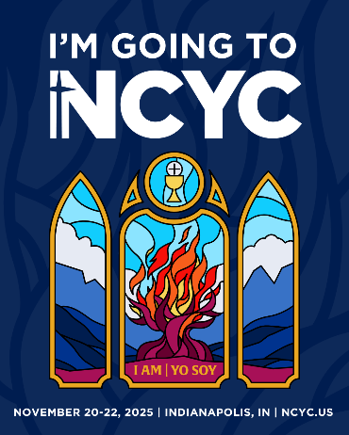 **Diocese of Trenton NCYC Information Packet**

***What is NCYC?***

The National Catholic Youth Conference (NCYC) is a powerful, biennial, three-day experience that brings together the young Catholic Church of the United States to build community, pray and empower young Catholics (high-school age) and their adult chaperones in our faith.

***\*\* Attending NCYC is more than just a trip***; it can be a life-changing, pilgrimage experience! In a distinctly Catholic setting, participants are invited to encounter Christ, experience Church, and be empowered for discipleship. ***For more info check out*** <http://www.ncyc.info/>

**Important NCYC Dates:**

|  |  |
| --- | --- |
| **June 26th** | *\*Registration, non-refundable Deposit ($335 per person) and Rooming List Due to Diocese via email* |
| **TBA** | *\*\*Final Payment due*  *This will be Announced once travel is confirmed – expect early Fall* |
| **August 28th** | *Deadline for Late additions and changes IF hotel and travel accommodations have capacity*  *(additional NCYC fees may apply after this date)* |
| **November/TBA** | *Last date NCYC will accept registrations/changes (this will include additional fees)* |
| **November 19th** | *Bus departs in the late evening from location in the Diocese (TBA)* |
| **November 20-22rd** | *NCYC 2025!* |
| **November 23rd** | *Return home in the evening.* |

**Conference Schedule**

The schedule includes keynote presentations, prayer, workshops, liturgy, and opportunities to participate in reconciliation and adoration of the Blessed Sacrament, as well as recreational activities, concerts, and exhibits. A key component of NCYC is the thematic park which is a blend of traditional exhibit booths with interactive areas featuring service projects, games, recreation, live musical performances, arts and sports. NCYC is sponsored by the National Federation for Catholic Youth Ministry, Inc. (NFCYM). Please check[**http://www.ncyc.info/schedule/**](http://www.ncyc.info/schedule/) for the complete NCYC 2017 Schedule.

**Cost and Fees** ***APPROXIMATELY* $900 per registrant plus meals/spending money**Cost includes: registration for NCYC; bus transportation hotel for 3 nights, breakfast at the hotel, DoT T-shirt and a Region III T-shirt. *(this is only an estimate - final cost to be determined based on the total number of participants, number of teens in your room, and mode of Travel)*

**\*Registration and Payment**  
***Groups Leaders:*** Please fill out the ***NCYC Interest form FOUND ON THE WEB SITE by July 26th.***  
***\*\**NCYC payment schedule:**

* We have spaced out the full amount as much as possible into 2 payments.  Please make every effort to meet the deadlines.  Thank you!
* Reminder that Breakfast in the hotel is included in the cost below but all other meals are not… see “*Meals*” below

**First Payment**: $335 (Conference Fee) due to the Diocese by ***June 26, 2025.***

Please send 1 check per parish group (if possible) made out to “Diocese of Trenton”

**Final Payment**: Approximately $600

Total will be will be determined based on the total number of participants, how many teens in your hotel room and the cost of the bus per rider.  Final cost will be calculated and published shortly after July 26th registration deadline.  ***Final Payment is due Early Fall after Travel costs are determined***

***Hotel, Transportation, Meals and additional costs***

**Hotel Name:** Staybridge Suites Indianapolis Downtown. 535 S West St. Indianapolis, IN 46225

*The hotel is within walking distance to the Convention Center and Lucas Oil Stadium

**Bus/Travel Information:**

We are planning to leave NJ on **Wednesday, November 19th** at approximately **9/10 pm** from a location within the Diocese. We will leave Indianapolis on **Sunday, November 23 at approximately 6 am**, with a return to NJ later that evening. It is about 11 hours each way plus stops.

**Meals** :

For those traveling on the DOT Bus, there will be a stop for breakfast on Thursday November 20. Breakfast cost will be on your own. Upon arrival at the Hotel parish groups will eat Lunch on their own.

Throughout our time at NCYC, ***Breakfast will be provided in the hotel each morning***.   
Please be aware that this is the only meal provided. All other meals will be on your own. **Please bring enough cash for all of other meals/snacks for either in transit or in Indy** (*approx. 6 meals in Indy plus 1-2 meals in transit each way*).

**Additional Costs:**Spending money to purchase T-shirts and other apparel, snacks, or items from the exhibit Hall.

**Prep meeting:**There will be a mandatory meeting for all NCYC participants and parents **on most likely in October.**

**Required Forms** will be available online soon after the official registration goes live.