Dear Pastor,

This letter is seeking your endorsement of the person listed below to participate in “Youth Ministry Bootcamp”. YM Bootcamp is a training series on the vision and practical components of comprehensive youth ministry offered by the Diocese of Trenton. All participants are expected to attend 5 virtual sessions, develop a yearlong Youth Ministry plan, and then meet individually with me for feedback on their plan. A “letter of completion” will be given to those who meet all requirements. For more details please visit https://dioceseoftrenton.org/ym-formation.
If you endorse this candidate, please sign the bottom of this page and return it to them. Thank you for all you do to support youth ministry in your parish.

God bless you,

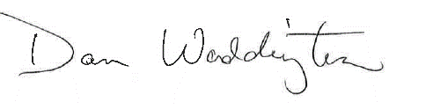
Dan Waddington, Director
Youth and Young Adult Ministries
Diocese of Trenton

Candidate’s Name (Print):______________________________________________________

Current Role in the Parish: _____________________________________________________

Pastor Endorsement:
I hereby endorse the above-named person to participate in Youth Ministry Bootcamp in support of their ministry with the young people of my parish.

Pastor’s Signature: _______________________________________ Date: ________________

