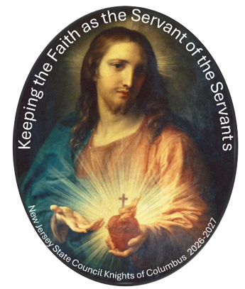
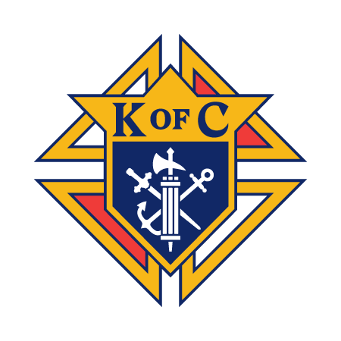
THE TORCH IS COMING
OUR LADY OF GUADALUPE
A WEEK OF PRAYER • FAMILY • FAITH • FELLOWSHIP

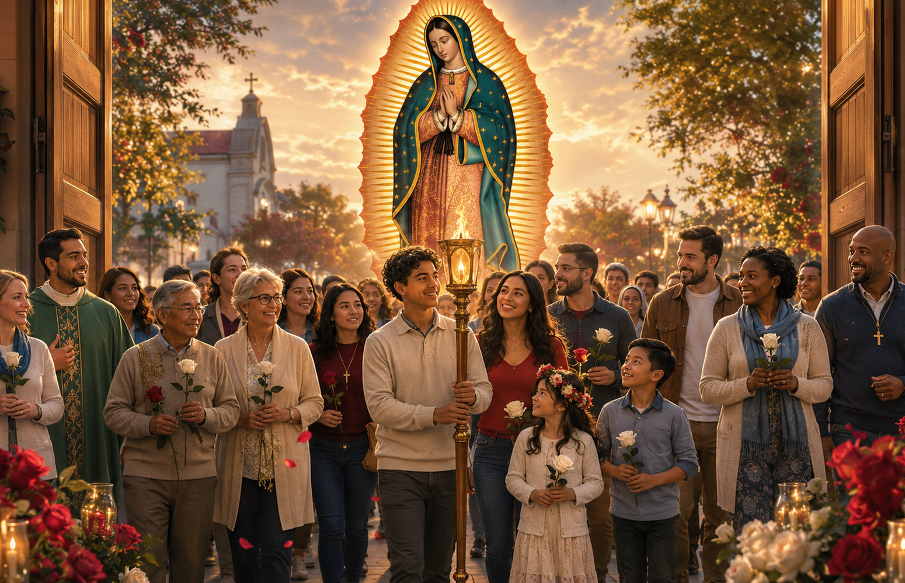
Welcome the traveling Torch of Our Lady of Guadalupe to our parish and join the Knights of Columbus for a special week of devotion and community.
FAITH IN ACTION: IMITATING SAINT JUAN DIEGO
DATE  [DATE] |  | TIME  [TIME]
LOCATION  [PARISH / ADDRESS] |  | HOST  KofC Council [# / NAME]
ROSARY | HOLY HOUR | FAMILY EVENT | CULTURAL NIGHT
OUR TORCH WEEK SCHEDULE
[EDIT THIS TEXT]
[EDIT THIS TEXT]
[EDIT THIS TEXT]
ALL ARE WELCOME • BRING YOUR FAMILY & FRIENDS
COUNCIL CONTACT / REGISTRATION  [NAME • EMAIL • PHONE]  [WEBSITE OR RSVP LINK] | INSERT QR CODE  OR COUNCIL LOGO HERE
