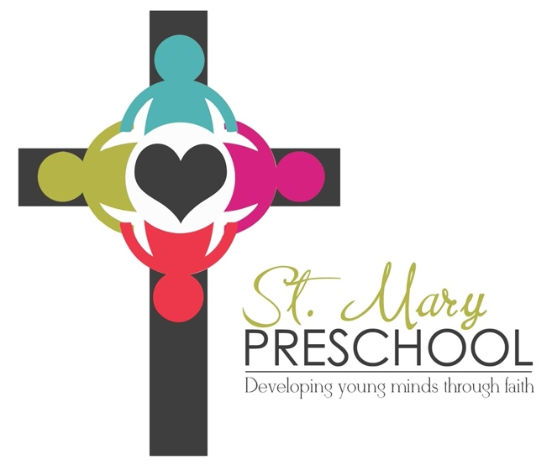

February 3, 2023

Dear Parents,

Thank you for your interest in St. Mary Preschool. It is time to begin forming the class list for the next school year. The following are the tuition costs and class times for the 2023/2024 school year:

3 year old class (must be 3 by September 15) $80/month
Classes meet Tuesday and Thursday mornings 9:00 - 11:30 am

4 year old class (must be 4 by September 15) $95/month
Classes meet Monday, Wednesday, and Friday mornings 9:00-11:30 am

If you will have two children in St. Mary Preschool at the same time, please speak to Ms. Dorothy, Tracy Diehl or myself about the tuition rate.

In order to secure a place for your child for the 2023/2024 school year I need to have received both the enclosed enrollment form as well as the first month’s tuition (this is a non-refundable deposit). Please make the check to St. Mary Preschool. Mail both the completed enrollment form and check to:

Molly Mosinski
2600 180th Street
Fairfield, IA 52556

Your child’s name will be added to the class list as soon as I have received both the enrollment form and the deposit. I will not hold a place for a child on the class list without first receiving both an enrollment form and deposit. The three year old class can have a maximum of 16 students and the four year old class a maximum of 20 students.

Thank you for your interest in St. Mary Preschool. Please feel free to contact me if you have any questions.

Sincerely,

Molly Mosinski
Enrollment Coordinator
641-472-4335 or 641-233-8480

