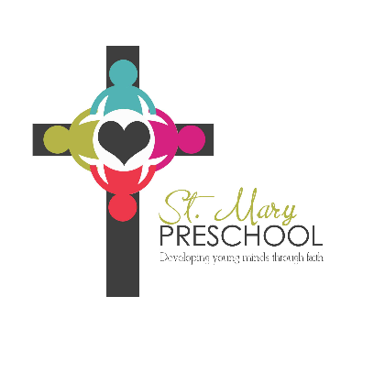 | St. Mary Preschool  3100 W Madison Ave  Fairfield IA 52556  641-472-5996
Snack Requirements

Each child will take a turn at supplying snacks for preschool on a rotating basis. You will receive a monthly calendar which will list your snack day and the amount needed. Because we are a licensed preschool, we follow the CACFP nutrition mandates.

We accept all fruits, vegetables, whole grains, protein, and dairy. Beverages need to be 100% juice, milk 1% or skim.

If you send sugary snacks we will have to substitute something healthy and send that snack home with the children. We are not allowed to serve it.

Due to allergies NO peanuts or peanut butter.

Birthday snacks – you may send a sugary treat.

Snack Suggestions

Dairy: Cheese, cheese sticks, yogurt, milk (skim/1%), hardboiled eggs, cottage cheese

Grains: Must be whole grain – Crackers, bread, Triscuit, multigrain wraps, rice cakes, popcorn, sun chips, nutria-grain bars, pretzels, granola bars.

Fruit: Fresh or frozen

Meat: beef sticks, meat roll ups, turkey, ham, pepperoni

Vegetables: Fresh, you may send a dip

Beverages: Juice must be 100% juice, milk – skim or 1%

Birthday: Snacks may be your choice

