**Completing Safe Environment Requirements for Diocesan Parishes and Schools**

Please allow for an hour and a half to complete, and complete within one sitting. Due to security on some smart phones/tablets, please complete on a standard computer and not a smart phone. When completing the background check, do not exit until you hit submit or you will be locked out and you will need to let us know to reset the background check for you.

1. Please click on: [www.madisondiocese.org](http://www.madisondiocese.org)/safe-enviornment (Or search for Diocese of Madison, click on the homepage, then at the top select: **Offices & Apostolates,** then **Safe Environment**). The screen shot should be similar to below. Click the bottom links to register as a first time user. *Please Note: if logging back in, after exiting for any reason, you will click on the top links, or go to the main Virtus website:* [*www.virtusonline.org*](http://www.virtusonline.org)

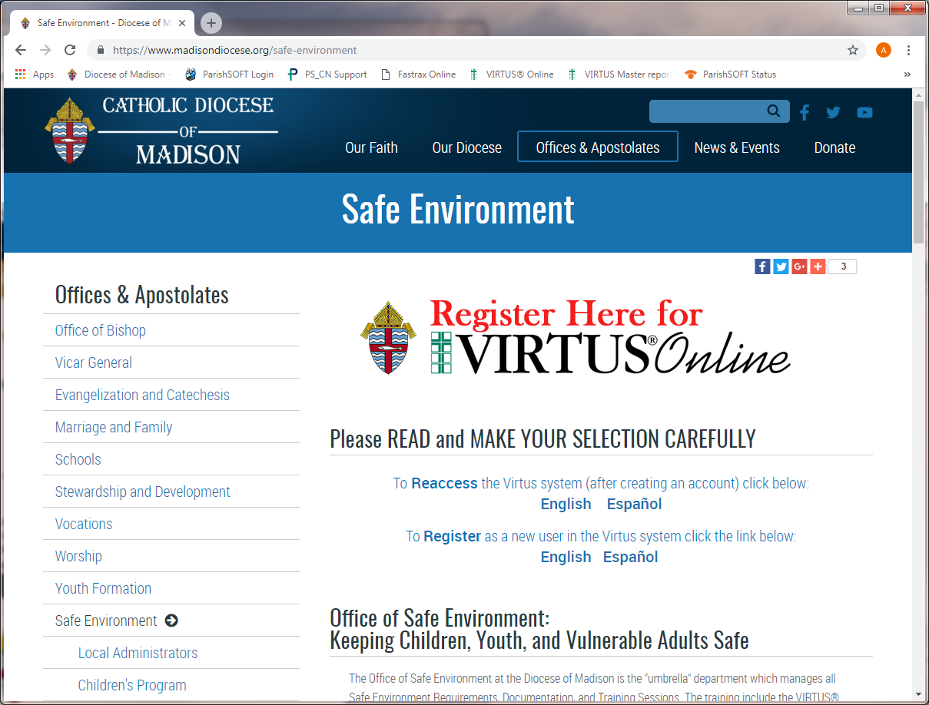

1. New Users will create an account and select a location for your record.

Please select the **Primary Location: __________________________________**

Your role to select within the diocese is: Employee, Educator or Volunteer

You will complete the following requirements, in this order:

* 1. Read and Sign off on the Diocese of Madison Policy Regarding Sexual Abuse of Minors, Sexual Misconduct and Sexual Harassment
  2. Complete Virtus’: Protecting God’s Children Online Awareness Session online training class and
  3. Provide information for a Background check through the Fastrax website.

My parish/school please contact: ___________________

Diocese of Madison Office of Safe Environment, please call: 608-821-3133

Virtus Online help desk (M-F 8-5pm): 1-888-847-8870

Fastrax (Selection.com) helpdesk: 800-325-3609