**Compliance Report – Review compliance status of accounts**

Ability to filter by name, location, role, profile, compliance, active or items:

Run Report to show details with the ability to drill into a user’s account to address the ‘Needs Attention” items. This includes an expiring notification when an item is close to the expiration date:

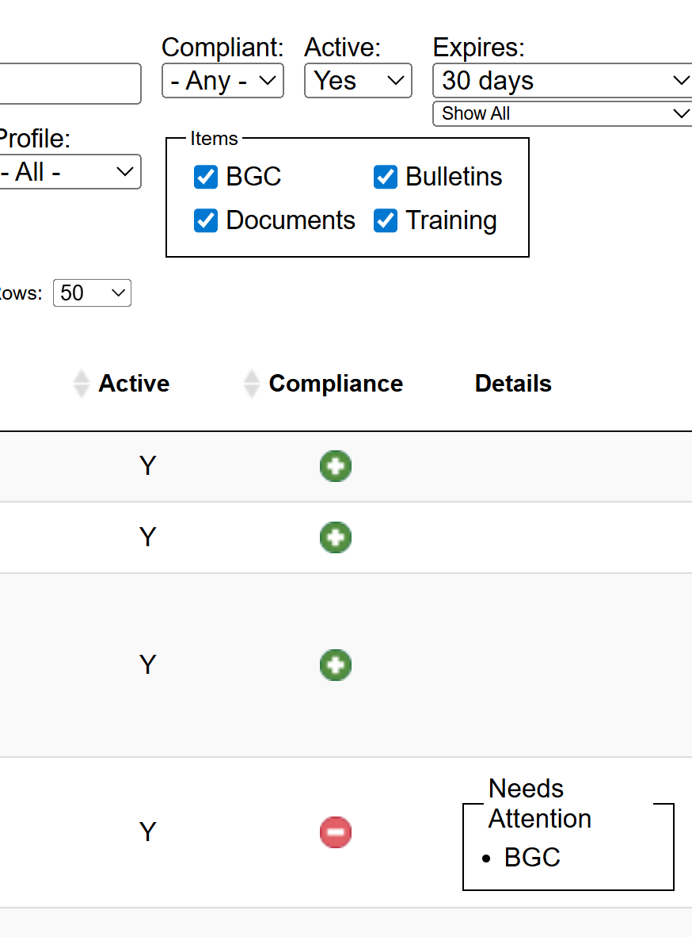

When drilling into an account, you can review the Compliant or Non-compliant within the tabs.