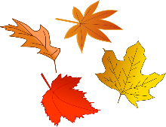
Home School Connection
November Suggested Activities

Themes: Us, Our School Environment, Our Community, Thanksgiving

Language & Literacy:
- Thanksgiving is a time to be thankful and for family traditions. Discuss with your child about holiday traditions and what it means to be thankful. Have your child draw a picture of your family’s special tradition. Ask them about it and record their response.

Writing Skills:
- Have your child practice tracing his/her first letter of their name on the paper provided, using the appropriate grasp. (Or for a challenge writing their first name.)

Cutting Skills: ***Remember THUMBS UP***
- Create the scarecrow craft, using scissors to fringe the hay for the scarecrow. (See additional page for instructions). Practice holding the scissors the correct way (thumbs up).
- Thanksgiving Meal: Have your child cut out their favorite foods they eat on Thanksgiving and glue them on a paper plate. Grocery store sale papers from the newspaper can be used for pictures (or print out clipart).

Fine/Gross Motor Skills:
- Have your child practice putting on his/her jacket independently.
- Have your child practice putting on his/her mask. (Behind one ear, behind the other.)
- Have your child complete the Turkey Trot exercises. See attached sheet.

Math Skills:
- Let’s practice sorting. Harvesting is a time when things grow. Using foods found in your home, make two piles. Have your child make a fruit pile and a vegetable pile. How many vegetables do you have? How many fruits do you have? Practice counting. Additional practice sheet on sorting also located in packet.
- Count the pumpkins and circle the correct number.

Free Drawing:
- Have your child draw a picture of someone or something they are thankful for on the attached page. Ask your child why and record their response.

***Remember to break up these activities throughout the month. Enjoy!**
Thanksgiving is a time to be thankful and for family traditions. Discuss with your child about holiday traditions and what it means to be thankful. Have your child draw a picture of your family’s special tradition. Ask them about it and record their response.

Have your child practice tracing his/her first letter of their name on the paper provided, using the appropriate grasp. (Or for a challenge writing their first name.)

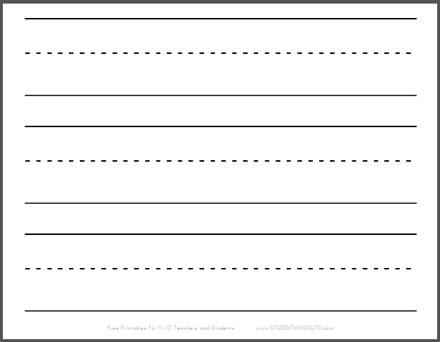

Scarecrow Craft
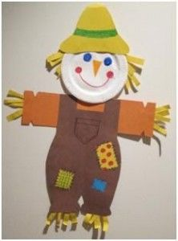
- Use a paper plate for the face. Have your child create a face using crayons/markers/paint.
- Draw the body on construction paper and help your child cut it out using the appropriate scissor grasp. Also, make the hat.
- Use yellow construction paper, to make strips/fringe the “hay.”
- Then paste all parts of the scarecrow together. Help your child with their gluing skills.
- Great job! The picture is a sample. Be creative.

Thanksgiving Meal: Have your child cut out their favorite foods they eat on Thanksgiving and glue them on a paper plate. Grocery store sale papers from the newspaper can be used for pictures (or print out clipart).

