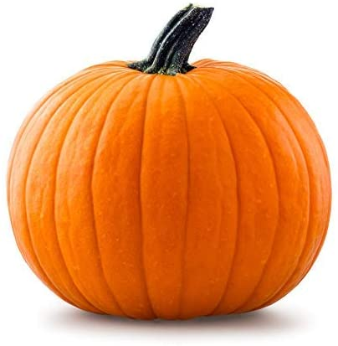
Home School Connection
October Suggested Activities

Themes: Families, Things We Like, Our Feelings, Our Bodies

Language & Literacy:
- Talk with your child about family. Discuss that every family is special and unique in their own way. Have your child illustrate their family portrait. Have your child tell you about their picture.
- Discuss feelings with your child. Ask your child, “How are you feeling today? Why?” Record their answer on the paper provided.

Writing Skills:
- Have your child practice tracing his/her first name on the paper provided, using the appropriate grasp.

Cutting Skills: ***Remember THUMBS UP***
- Practice holding the scissors the correct way (thumbs up) and making snips on a piece of paper.

Fine/Gross Motor Skills:
- Have your child practice putting on his/her jacket independently.
- Play hopscotch. Practice jumping!
- Play Head, Shoulders, Knees, & Toes!

Math Skills:
- Use the sheet provided and practice counting the number of our body parts. (Example: two eyes)

Free Drawing:
- Have your child illustrate something they like a lot. For example, it can be a favorite food or toy. Ask, “Why do you like it?”

***Remember to break up these activities throughout the month. Enjoy!***

Talk with your child about family. Discuss that every family is special and unique in their own way. Have your child illustrate their family portrait below. Have your child tell you about their picture and write their response below.

Discuss feelings with your child. Ask your child, “How are you feeling today? Why?” Record their answer below.

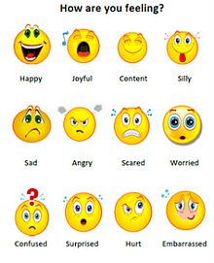

Have your child practice tracing his/her first name on the paper provided, using the appropriate grasp.

Practice holding the scissors the correct way (thumbs up) and making snips on a piece of paper.
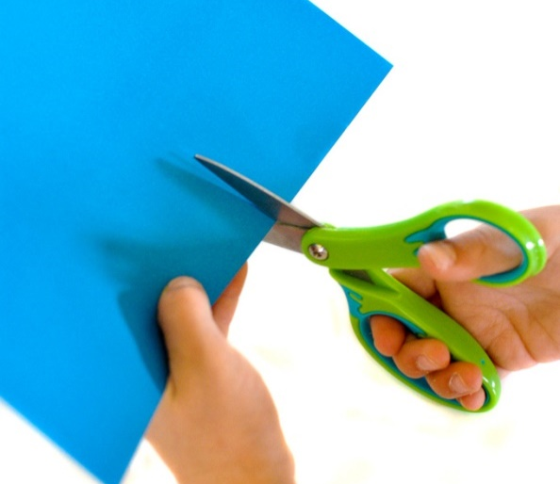

- Play hopscotch. Practice jumping!
- Play Head, Shoulders, Knees, & Toes!

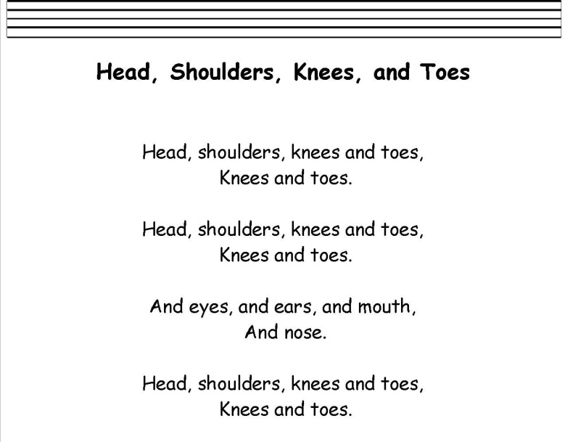
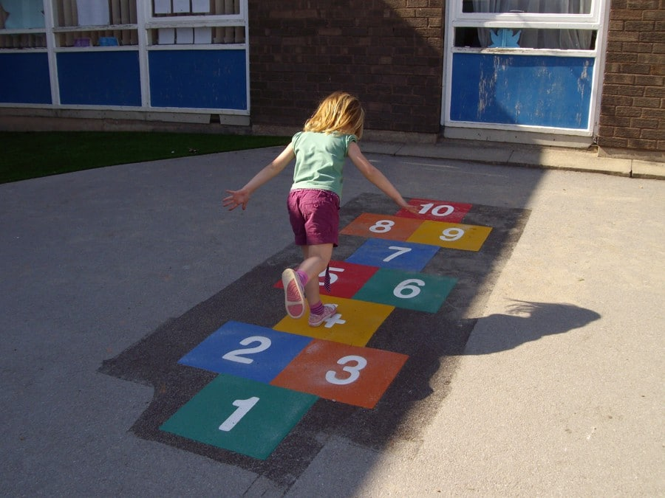
Practice hopping on one foot!

Practice touching the correct body parts, while singing the
song!

Practice counting the number of our body parts. (Example: eyes? 2)

How many do you have?

Eyes? ________
Nose?________
Arms?________
Legs?________
Fingers?_______
Hands?________
Toes?_________
Elbows?________
Feet?_________
Mouth?________

Have your child illustrate something they like a lot. For example, it can be a favorite food or toy. Ask, “Why do you like it?”

