

Monday | Tuesday  Menu is subject to change, and a variety of low fat OR skim milk is offered daily, condiments offered daily, fruit & vegetable juices are 100% juice, grains are whole grain. All Items are pork free. | Wednesday | Thursday | Friday
3  370 Cinnamon Toast  Mini French Toast  752 Fruit Punch Juice  658 Cherry Craisins | 4  325 Cinnamon Chex  Cup  749 Apple Cherry    Juice  670 Fresh Fruit | 5  368 Wheat Bagel  748 Grape Juice  684 Strawberry Banana  Applesauce | 6  329 Honey Cheerios Cup  670 Fresh Fruit  750 Apple Juice | 7  321 Banana Muffin  752 Fruit Punch Juice  659 Watermelon Craisins
10  312 Fruit Loops Pouch  748 Grape Juice  670 Fresh Fruit | 11  328 Chocolate Chip  Muffin  749 Apple Cherry Juice  697 Sliced Apples | 12  307 Cherry Frudel  750 Apple Juice  688 Orange Mango  Applesauce | 13  317 Confetti Mini  Pancakes  753 Orange Juice  659 Watermelon  Craisins | 14  364 Mini Cinni Pull-A-  Part  National Pickle Day  752 Fruit Punch Juice  670 Fresh Fruit
17  334 Cinnamon Toast  Crunch Cup  752 Fruit Punch Juice  National Homemade Bread Day  670 Fresh Fruit | 18  316 Maple Mini  Pancakes  657 Strawberry Craisins  670 Fresh Fruit | 19  327 Maple Mini Waffles  670 Fresh Fruit  748 Grape Juice | 20  Assorted Cereal  Assorted Juice  Fresh Fruit | 21  NO SCHOOL
24  NO SCHOOL BREAKFAST | 25  NO SCHOOL  BREAKFAST | 26  NO SCHOOL | 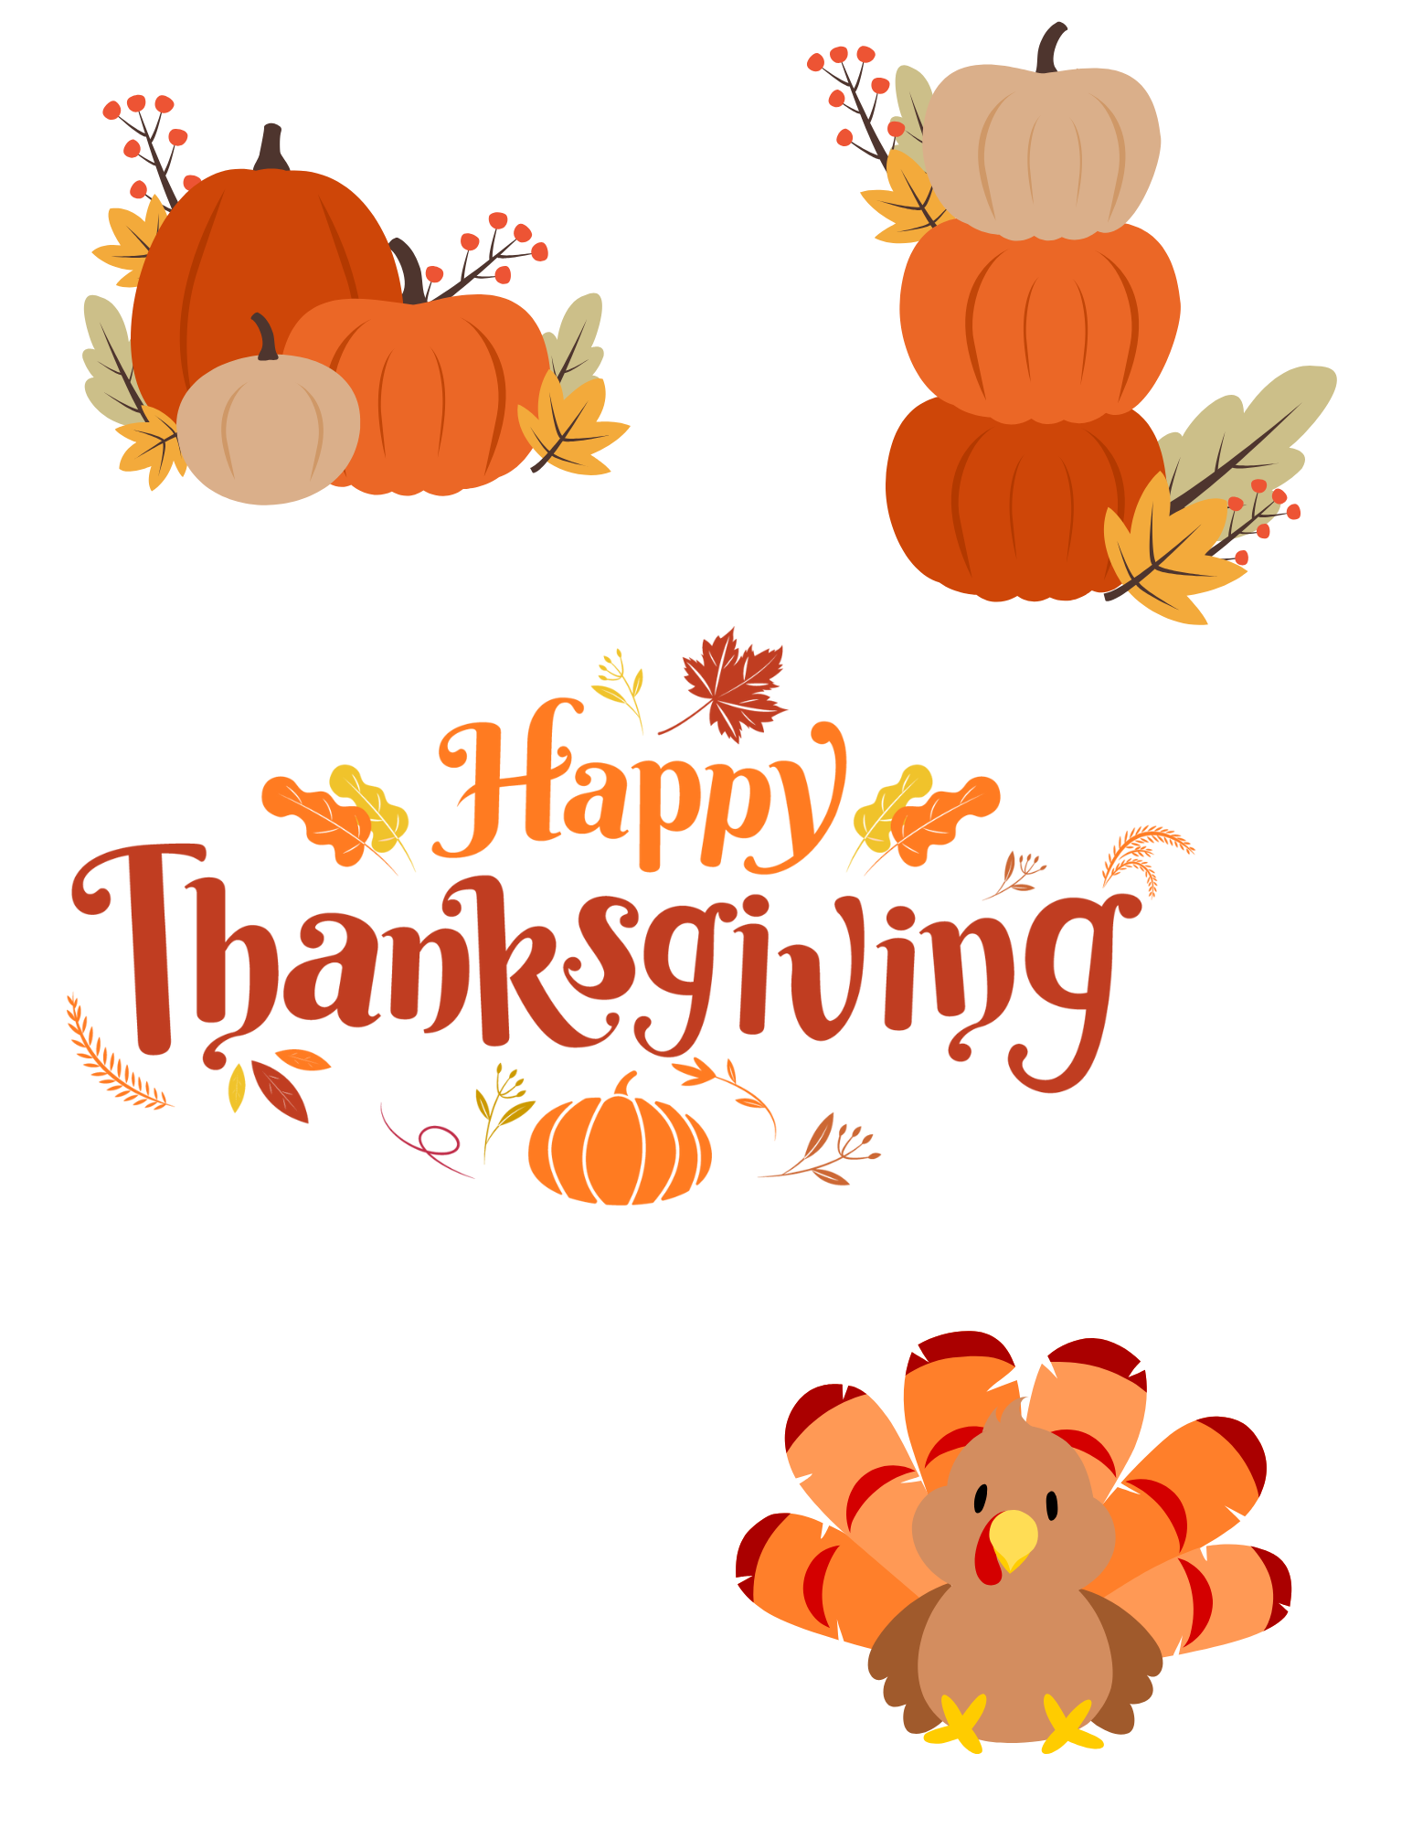 | 27-28
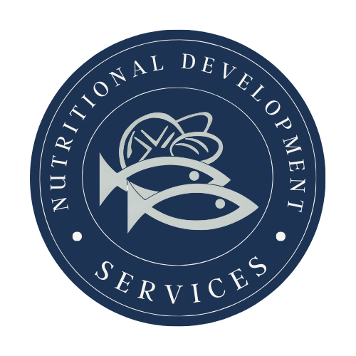
PLEASE READ CAREFULLY - Parents are strongly advised to review the menu completely to ensure that each of the food items is suitable for their children and will not trigger an allergic reaction OR related illness. The Archdiocese of Philadelphia, Nutritional Development Services, Inc. and your children’s school shall not be responsible for any allergic reaction OR related illness caused by any food item. Upon request and without charge, Nutritional Development Services will provide parents with information on any food item which has been provided by the supplier of the food item. To request product information please call (215) 895-3470 during normal business hours.
Nutritional Development Services
Archdiocese of Philadelphia
222 N 17th St, Philadelphia, PA 19103
215-895-3470, option 1

