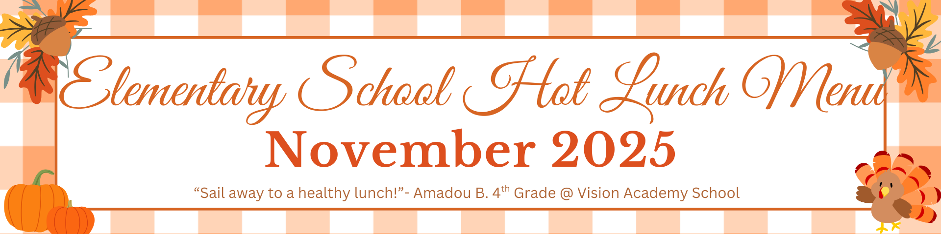

Monday | Tuesday | Wednesday | Thursday | Friday  Menu is subject to change, and a variety of low fat OR skim milk is offered daily, condiments offered daily, fruit & vegetable juices are 100% juice, grains are whole grain. All Items are pork free.
3  208 Mini Corn Dogs  630 Dragon Punch Veggie  Juice  543 Red Pepper Hummus  670 Fresh Fruit  937 Apple Cinnamon Bear  Grahams | 4  200 Hamburger  611 Bagged Baby Carrots  541 Chocolate Hummus    750 Apple Juice | 5  206 French Toast w/  Sausage  702 Potato Smiles  697 Bagged Sliced Apples | 6  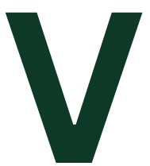  255 Pizzaboli  706 Spinach Salad w.  Tomatoes  670 Fresh Fruit | 7  257 Mozzarella Sticks  632 Wango Mango Veggie  Juice  622 Marinara Sauce  670 Fresh Fruit
10  273 Swedish Meatballs,  Noodles and Broccoli  634 Ruby Rusher Veggie  Juice  670 Fresh Fruit  909 Dinner Rolls | 11  280 Beef Burger w/  Green Beans  & 915 Hamburger Buns  631 Cherry Star Veggie Juice  752 Fruit Punch  Juice | 12  205 Popcorn Chicken  611 Bagged Baby Carrots  543 Red Pepper Hummus  659 Watermelon Craisins  928 Pretzel Goldfish | 13  264 4x6 Cheese Pizza  708 Spinach Salad  w. Chickpeas  648 Strawberry  Gel Cup | 14  222 Sloppy Joes & 915  Wheat Hamburger Buns  623 Tater Tots  630 Dragon Punch  National Pickle Day  Veggie Juice  670 Fresh Fruit
17  256 Cheese Stuffed  Breadsticks  622 Marinara Sauce  National Homemade Bread Day  630 Dragon Punch  Veggie Juice  684 Strawberry Banana  Applesauce | 18  208 Mini Corn Dogs  611 Bagged Baby Carrots  541 Chocolate Hummus  749 Apple Cherry Juice | 19  215 Beef & Cheese  Taco Stick  620 Salsa  631 Cherry Star Veggie Juice  670 Fresh Fruit | 20  NOON DISMISSAL | 21  NO SCHOOL
24  NO SCHOOL  LUNCH | 25  NO SCHOOL  LUNCH | 26  NO SCHOOL | 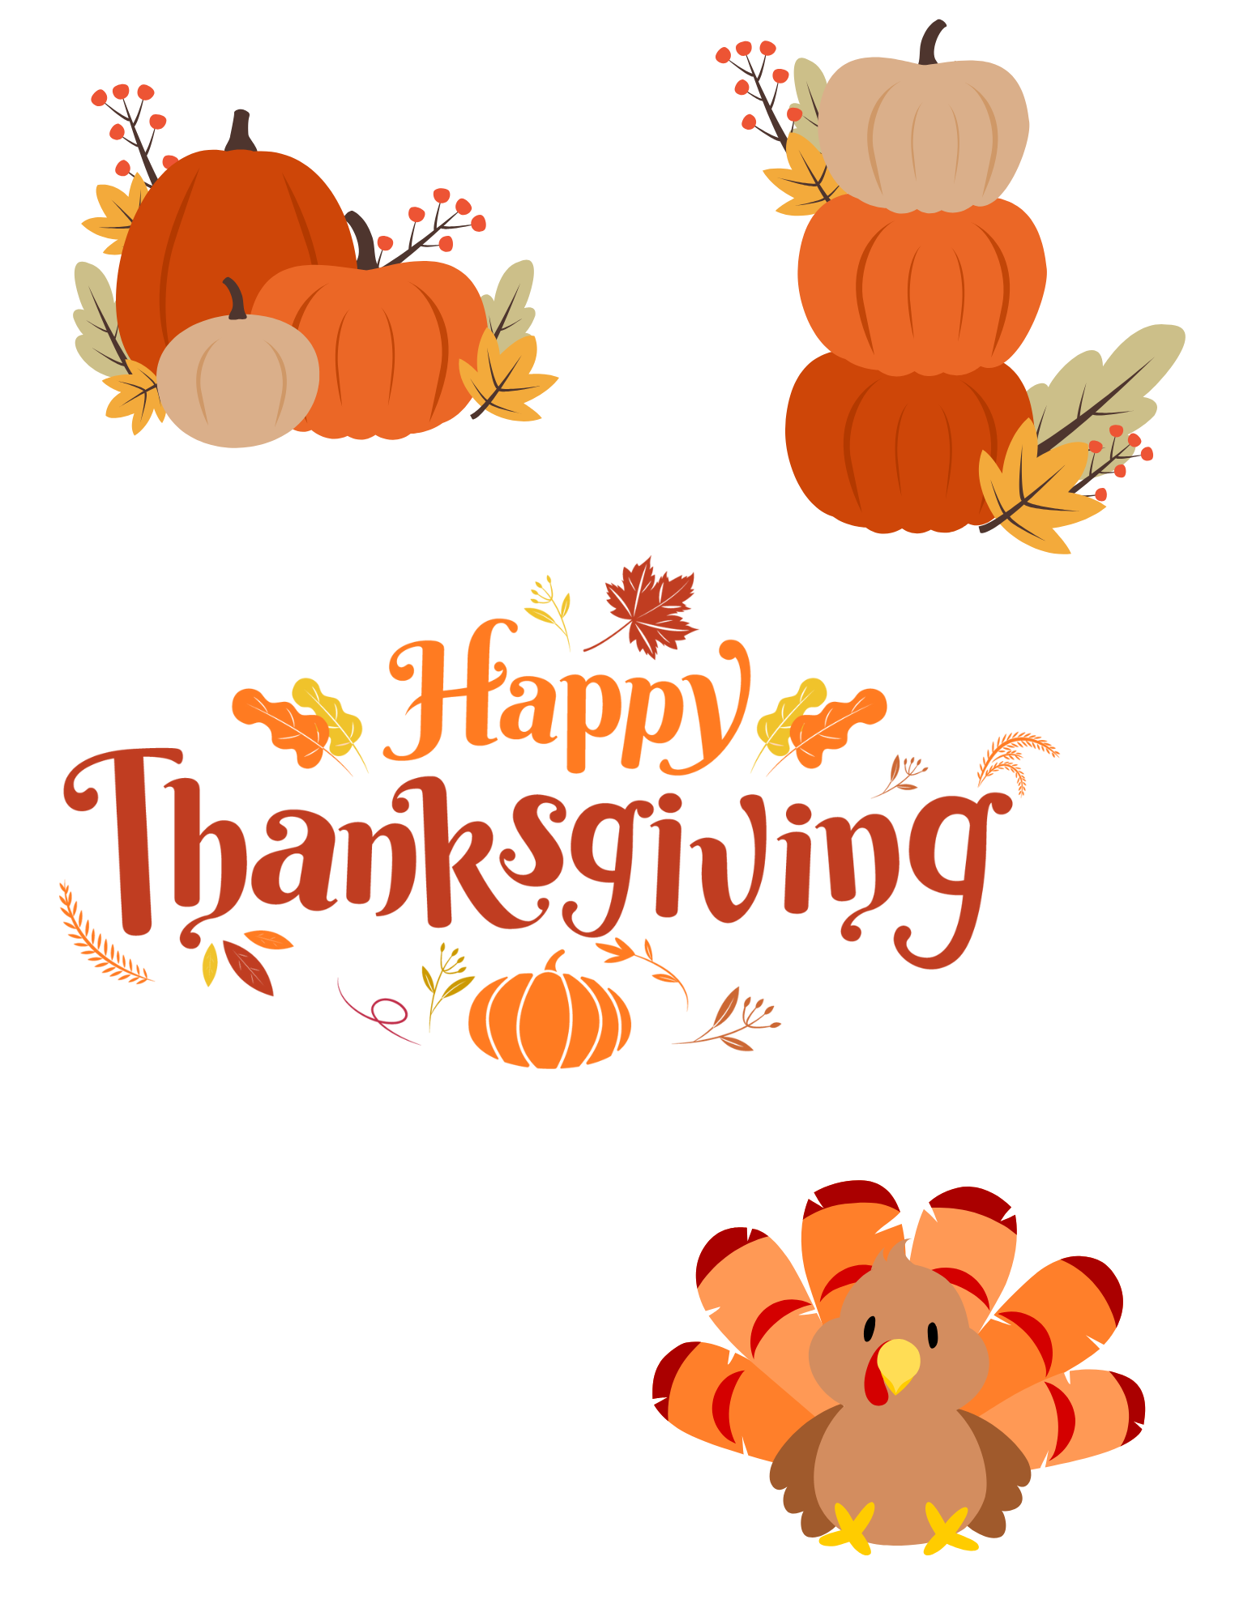 | 27-28
V= Vegetarian Options
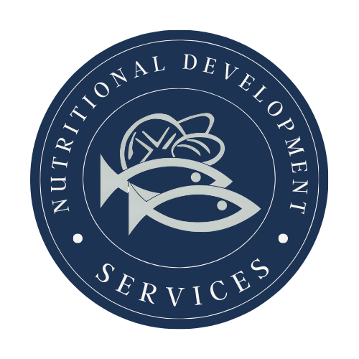
PLEASE READ CAREFULLY - Parents are strongly advised to review the menu completely to ensure that each of the food items is suitable for their children and will not trigger an allergic reaction OR related illness. The Archdiocese of Philadelphia, Nutritional Development Services, Inc. and your children’s school shall not be responsible for any allergic reaction OR related illness caused by any food item. Upon request and without charge, Nutritional Development Services will provide parents with information on any food item which has been provided by the supplier of the food item. To request product information please call (215) 895-3470 during normal business hours.
Nutritional Development Services
Archdiocese of Philadelphia
222 N 17th St, Philadelphia, PA 19103
215-895-3470, option 1

