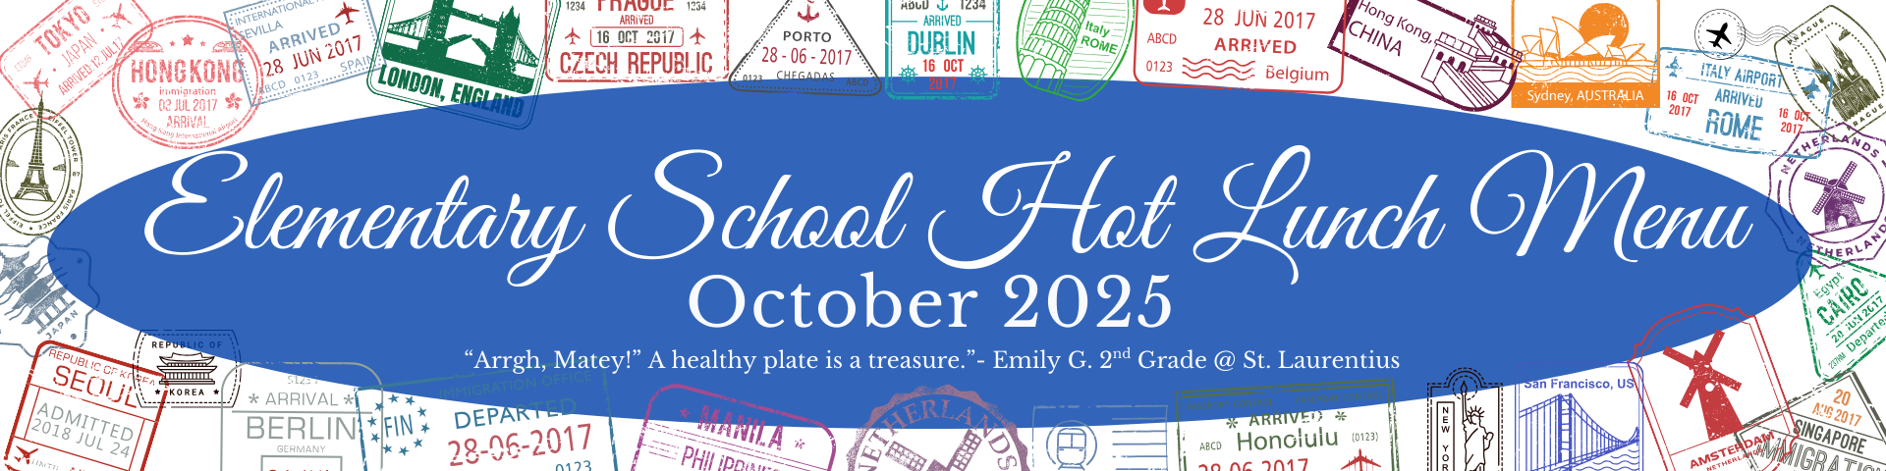

Monday | Tuesday | Wednesday | Thursday | Friday  Menu is subject to change, and a variety of low fat OR skim milk is offered daily, condiments offered daily, fruit & vegetable juices are 100% juice, grains are whole grain. All Items are pork free.
29  284 Chicken Alfredo,  Penne and Broccoli  634 Ruby Rusher Veggie Juice  752 Fruit Punch Juice  909 Dinner Rolls | 30  286 Penne w/ Meat Sauce  & Italian Veggies & 909  Dinner Rolls  631 Cherry Star Veggie Juice  670 Fresh Fruit | 1  205 Popcorn Chicken  611 Bagged Baby Carrots  543 Red Pepper Hummus  659 Watermelon Craisins  928 Pretzel Goldfish | 2  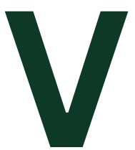  264 4x6 Cheese Pizza  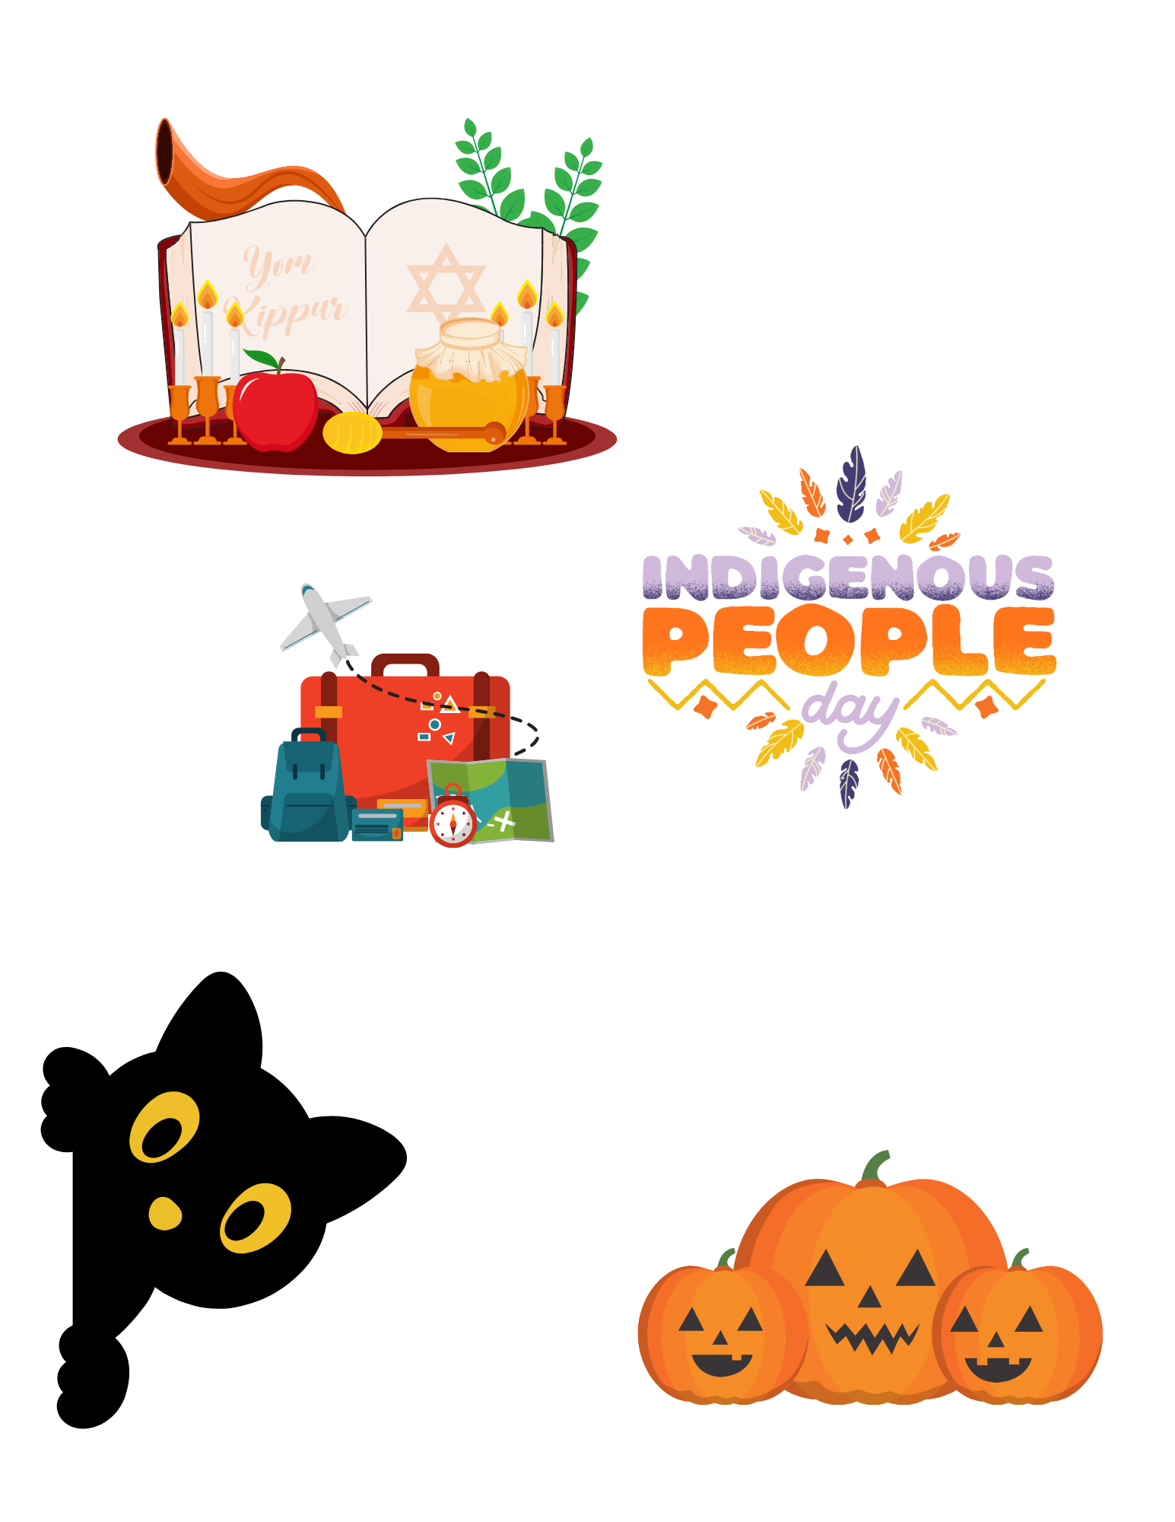  708 Spinach Salad  Yom Kippur  w. Chickpeas  648 Strawberry Gel Cup | 3  204 Chicken Nuggets  & 932 Cinnamon Scooby  Snacks  623 Tater Tots  630 Dragon Punch Veggie  Juice  670 Fresh Fruit
6  256 Cheese Stuffed  Breadsticks  622 Marinara Sauce  630 Dragon Punch Veggie  Juice  684 Strawberry Banana  Applesauce | 7  208 Mini Corn Dogs  611 Bagged Baby Carrots  541 Chocolate Hummus  749 Apple Cherry Juice | 8  215 Beef & Cheese Taco  Stick  620 Salsa  631 Cherry Star Veggie Juice  670 Fresh Fruit | 9  268 French Bread Cheese  Pizza  706 Spinach Salad w.  Tomatoes  657 Strawberry Craisins | 10  225 Ciabatta Cheese  Melt Sandwich  623 Tater Tots  546 Cheesy Pizza Hummus  752 Fruit Punch Juice  928 Pretzel Goldfish
13  206 French Toast w/  Turkey Sausage  623 Tater Tots  634 Ruby Rusher Veggie Juice  752 Fruit Punch  Juice | 14  215 Beef & Cheese Taco  Stick  620 Salsa  631 Cherry Star Veggie Juice  658 Cherry Craisins  941 Tostitos Scoops | 15  257 Mozzarella Sticks  622 Marinara Sauce  630 Dragon Punch Veggie  Juice  654 Raspberry Lemonade  Craisins | 16  220 Hot Dog  & 906 Hot Dog Buns  611 Bagged Baby Carrots  541 Chocolate Hummus  670 Fresh Fruit  National School Lunch Week | 17  263 5’’ Round Cheese  Pizza  708 Spinach Salad w.  Chickpeas  670 Fresh Fruit
20  284 Chicken Alfredo,  Penne and Broccoli  630 Dragon Punch Veggie  Juice  608 Tropical Fruit Cup | 21  208 Mini Corn Dogs  611 Bagged Baby Carrots  543 Red Pepper Hummus  752 Fruit Punch Juice | 22  205 Popcorn Chicken  623 Tater Tots  631 Cherry Star Veggie Juice  670 Fresh Fruit | 23  264 4x6 Cheese Pizza  706 Spinach Salad w.  Tomatoes  670 Fresh Fruit | 24  283 Chicken Tenders &  Corn  546 Cheesy Pizza Hummus  685 Rosati “School S’cool” Ice  928 Pretzel Goldfish
27  209 Taco Meat  & 941 Tostitos Scoops  611 Bagged Baby Carrots  546 Cheesy Pizza Hummus  750 Apple Juice | 28  269 Cheese Pizza Calzone  702 Potato Smiles  670 Fresh Fruit | 29  216 Spicy Taco Stick  621 Celery Sticks  670 Fresh Fruit | 30  201 Cheeseburger  708 Spinach Salad w.  Chickpeas  670 Fresh Fruit  447 Mott’s Apple White Grape | 31  Noon Dismissal  Halloween
V= Vegetarian Options
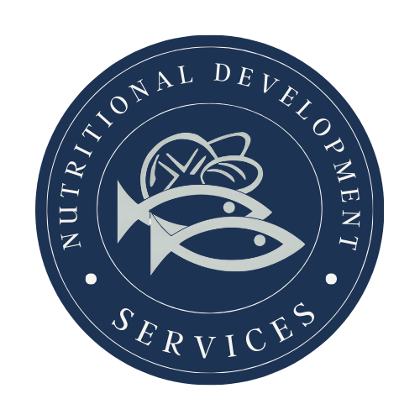
PLEASE READ CAREFULLY - Parents are strongly advised to review the menu completely to ensure that each of the food items is suitable for their children and will not trigger an allergic reaction OR related illness. The Archdiocese of Philadelphia, Nutritional Development Services, Inc. and your children’s school shall not be responsible for any allergic reaction OR related illness caused by any food item. Upon request and without charge, Nutritional Development Services will provide parents with information on any food item which has been provided by the supplier of the food item. To request product information please call (215) 895-3470 during
Nutritional Development Services
Archdiocese of Philadelphia
222 N 17th St, Philadelphia, PA 19103
215-895-3470, option 1

