

Monday | Tuesday | Wednesday | Thursday  Menu is subject to change and a variety of low fat OR skim milk is offered daily, condiments offered daily, fruit & vegetable juices are 100% juice, grains are whole grain. All Items are pork free. | Friday
31  312 Fruit Loops Pouch  748 Grape Juice  670 Fresh Fruit | 1  328 Chocolate Chip Muffin  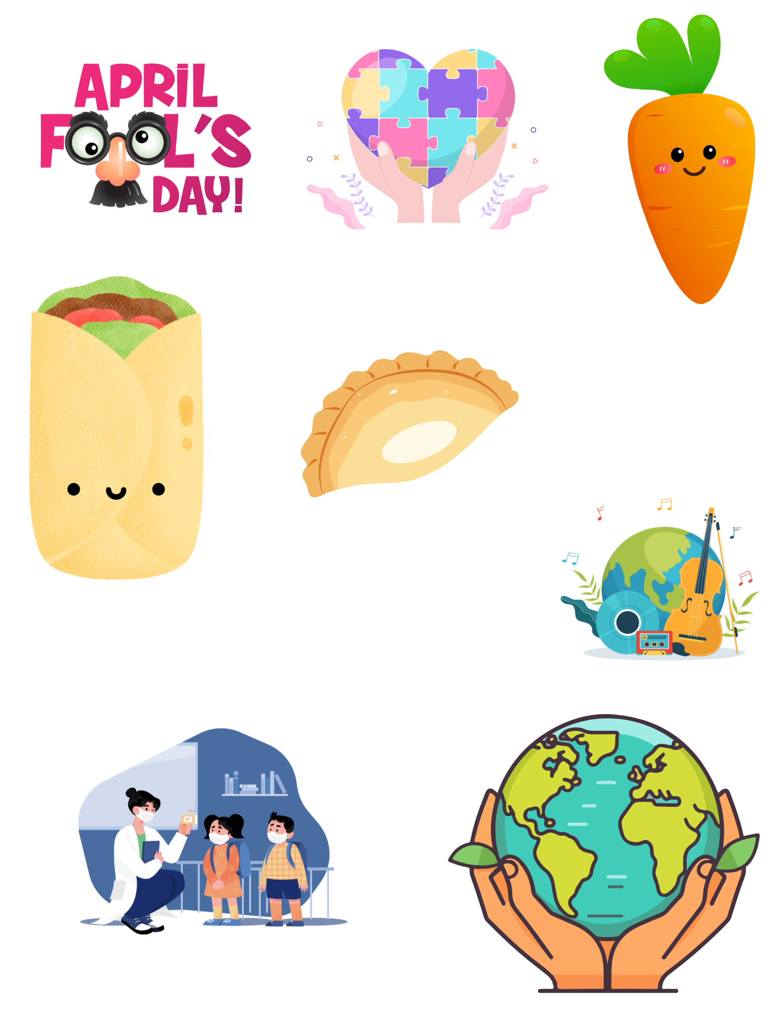  749 Apple Cherry Juice  648 Strawberry Gel Cup | 2  329 Honey Cheerios Cup  750 Apple Juice  688 Orange Mango  Applesauce  World Autism Awareness Day | 3  138 Blueberry Yogurt & 922 Cinnamon Granola  753 Orange Juice  659 Watermelon Craisins | 4  317 Confetti Mini Pancakes  752 Fruit Punch Juice  670 Fresh Fruit  International Carrot Day
7  365 Mini Cinni Caramel  Pull-A-part  750 Apple Juice  670 Fresh Fruit | 8  320 Corn Muffin  749 Apple Cherry Juice  697 Sliced Apples  National Empanada Day | 9  369 Trix Mini French Toast  752 Fruit Punch Juice  School Nurse Day  670 Fresh Fruit | 10  National Burrito Day  329 Honey Cheerios Cup  753 Orange Juice  608 Tropical Fruit Cup | 11  321 Banana Muffin  748 Grape Juice  659 Watermelon Craisins
14  391 Blueberry Muffin Kit | 15  364 Mini Cinni Pull-A-Part  World Art Day  749 Apple Cherry Juice  670 Fresh Fruit | 16  NO SCHOOL    National Banana  Day | 17  NO SCHOOL  HOLY THURSDAY  Holy Thursday | 18  NO SCHOOL  GOOD FRIDAY  Good Friday
21  NO SCHOOL | 22  Earth Day  383 Cheerios BK Kit | 23  136 Vanilla Yogurt & 312  Fruit Loops Pouch  748 Grape Juice  670 Fresh Fruit | 24  317 Confetti Mini Pancakes  752 Fruit Punch Juice  648 Strawberry Gel Cup | 25  364 Mini Cinni Pull-A-Part  753 Orange Juice  670 Fresh Fruit
28  334 Cinnamon Toast  Crunch Cup  748 Grape Juice  654 Raspberry Lemonade  Craisins | 29  327 Maple Mini Waffles  International Dance Day  750 Apple Juice  698 Strawberry Applesauce | 30  321 Banana Muffin  752 Fruit Punch Juice  670 Fresh Fruit | 1  329 Honey Cheerios Cup  749 Apple Cherry Juice  690 Apple Crisp | 2  390 Chocolate Chip Muffin BK Kit
V= Vegetarian Options
PLEASE READ CAREFULLY - Parents are strongly advised to review the menu completely to ensure that each of the food items is suitable for their children and will not trigger an allergic reaction OR related illness. The Archdiocese of Philadelphia, Nutritional Development Services, Inc. and your children’s school shall not be responsible for any allergic reaction OR related illness caused by any food item. Upon request and without charge, Nutritional Development Services will provide parents with information on any food item which has been provided by the supplier of the food item. To request product information please call (215) 895-3470 during normal business hours.
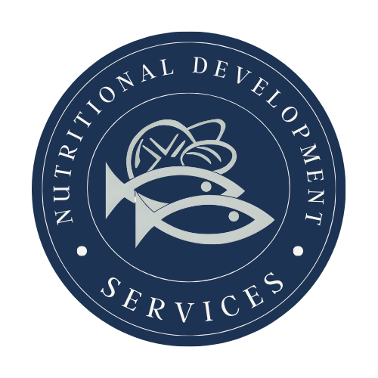
Nutritional Development Services
Archdiocese of Philadelphia
222 N 17th St, Philadelphia, PA 19103
215-895-3470, option 1

