Data Quality Checklist
- Do I Have Open Batches and/or Defaulted Donations?
  - Please make sure to review, edit and finalize pending batches under ContributionsBatches1. Not Yet Finalized Batches. If you leave manually entered batches unfinalized, this will not post to the donor’s record to appear on their giving statement at end of year.
  - If there are unfinalized batches from an e-giving integration, these batches need to be reviewed for defaulted donations to assign to the correct donor. If these are not reassigned, the donations will not appear on the donor’s giving statement. Please review donations that are awaiting reassignment here under Donations 0. Reassign DonorSelect allTools, Assign Donor Tool. Here is a guide for how to reassign donations to the appropriate donor.
- Do My Families Have Too Many Heads of Household?
  - When generating a mailing report, heads of households will appear on the report. If there are more than two heads of household listed in a family, it will pull the top two in alphabetical order. Please review this view, Fix: Too Many Heads, to identify families that have too many heads of household and update their family position accordingly.
- Have I Reviewed My Fix Views?
  - There are a series of Fix Views on the contacts page that help identify common data quality issues such as missing/incorrectly assigned prefixes, family positions that need updating, names missing etc. If you are in doubt about what a fix view does, click on the down arrow for a brief description.
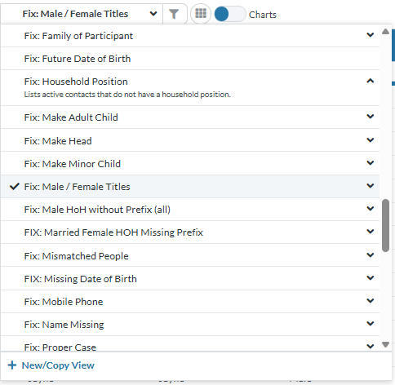
- Do I Have Duplicates Member Records?
  - Duplicates cause issues/inaccuracies with giving statements, parishioner log in via widget, and when retrieving sacrament history. Please clean up your duplicates by using the combine contacts tool under Contact RelationshipsDuplicates – Same ParishSelect duplicate records, go to ToolsCombine Contacts Tool. Here is a guide for how to combine duplicate contacts.
- Have I Deceased Members Properly?
  - Please ensure you are using the Decease Person Tool to mark someone as deceased. A guide for how to do so is located here under Procedures.
- Have I Upkept Active/Registered Families?
  - We encourage all parishes to review their parishioner activity using this view: FIX: Active Status Clean Up. Please keep in mind that the activity logs mentioned below are logs made on the records each time someone gives, is a part of a group, has a care log entered for them, etc. Activity logs are only as good a measure of activity as the consistency of entry in the database. Using this view, here are a few considerations we encourage.
    - If member has >3 activity logs in the last year and is listed as “inactive”, consider making that individual’s contact status = active.
    - If member has 0 activity logs in the last year and is listed as active, consider marking them “inactive” using the Inactivate Tool. You can use the tool en mass, but please make sure to use it very cautiously as you are affecting many records at once.
    - If member has date registered and activity logs within the last year but not marked as “registered member”, to consider marking them as such.
    - If you use the mass assign or inactivate function on families that you did not mean to affect, please immediately reach out to MP Support through the Support Portal or email mpsupport@acst.com to request data restoration. Data restoration fees vary depending on what work needs to be done.

