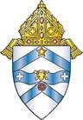
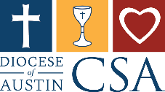
CSA Follow Up weekend
Pastor Email

Dear Parish Family,

Thank you to everyone who participated in Commitment Weekend for the Catholic Services Appeal (CSA). Your support is already bringing hope to countless individuals and families across our diocese.

If you could not pledge last weekend, there’s still time. I invite you to prayerfully reflect on how you can help bring hope to your brothers and sisters in Christ — especially the most vulnerable among us. The needs are real, and your support makes a profound difference. This weekend’s Gospel reminds us of God’s deep love for the humble and contrite. The tax collector’s prayer, “O God, be merciful to me, a sinner,” teaches us that humility opens the door to grace — and generosity is one way we respond to that grace.

Your gift to the CSA supports:

- Formation for future priests and deacons
- Catholic school tuition assistance
- Evangelization and retreats for youth and families
- Food, shelter, and emergency assistance for those in need
- Parish ministries — including our own!

You can still make your gift by:

- Visiting www.austindiocese.org/give
- Scanning the QR code on your pledge card or pew sign
- Returning your completed pledge envelope next weekend

Your generosity reflects Christ’s love, and I am so grateful for your continued commitment to the Church. Let us continue working together — because Together we bring hope.

With gratitude and blessings,

[PASTOR’S NAME]
Pastor, [PARISH NAME]

