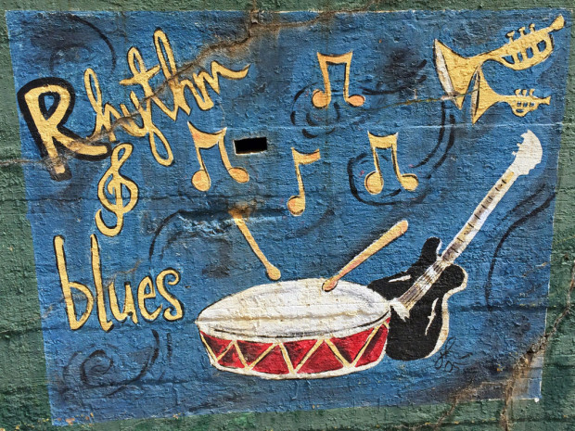
St. Joachim Church 2nd Annual
Renovation Rhythm and Blues
Fundraiser Dinner

November 3, 2017
KC Hall
4520 Sixth St.
Marrero, Louisiana 70072
6:30 PM - 9:30 PM

$25.00 per person in advance Patron tables:
$30.00 per person at the door Silver Table(seats 6) - $300.00
Platinum Table (seats 6) - $500.00

Band: "Classic American Swing and Jazz" by Jeanne-Marie Harris Trio
Menu: Delicious food, drinks and desserts
Everyone receives surprise gift at dinner.

Contact Debbie for more information or tickets (504)914-2156

