February 7, 2021

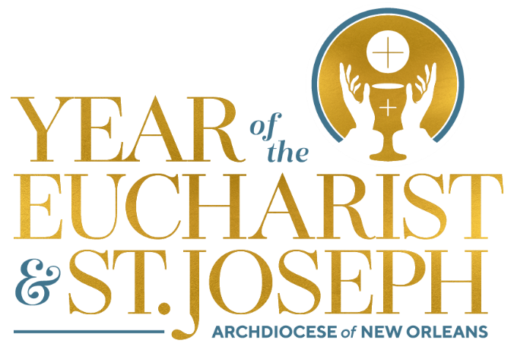

Monthly Explanation of the Mass

Did You Know?

- The Procession: The priest and ministers (representing
the whole people of God) symbolically move from the
ordinary (the world) to the extraordinary (the sanctuary,
which is a symbol of heaven itself) – from the secular
to the sacred, from the everyday to the eternal.

- The Altar: The altar represents Christ himself. When
we see the priest kiss the altar, we should reverence
Christ in our heart. The altar is the center, where the
mystery of our faith is celebrated.

- Sign of the Cross: We begin Mass with the Sign of
the Cross. This is not an introduction to prayer, but is
in fact a prayer in and of itself. It is a prayer! It affirms
our faith in the Triune God: Father, Son, and Holy Spirit.
We recall our baptism and are reminded of the great act
of love of Christ, who suffered and died for us.

