March 14, 2021

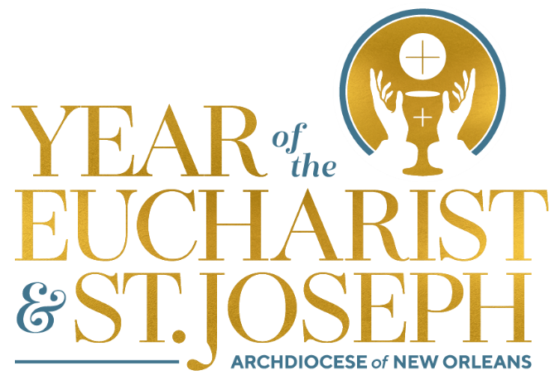

Monthly Explanation of the Mass

The Penitential Act and the Gloria

- At the beginning of each Mass, we take time to prepare ourselves through the Penitential Act to enter into the sacred liturgy and encounter Christ. We ask God to help us that by acknowledging our sins we may prepare ourselves to listen to his Word and share in the Body and Blood of Christ. We recognize our need for God’s help – our need to be saved – so we ask his mercy upon us: “Lord, have mercy. Christ, have mercy. Lord, have mercy.”

- Immediately following this (on Sundays outside of Advent and Lent and on solemnities, feasts, and at other solemn celebrations) we join the angels and saints in heaven and sing the Gloria – the same hymn sung by the angels to the shepherds heralding the birth of Jesus (Christmas). The incarnation is God’s response to our sinfulness! During Lent and Advent, we do not sing the Gloria due to the penitential nature of the seasons and the emphasis on expectancy.

- In these seemingly routine moments of the Mass that we can become all too familiar with, the Lord invites us to bring our minds and hearts into the deep mystery of our faith – God so loves us that he sent his Son. Jesus has come not to condemn the world, but to save the world.

